The SuperValu Inclusive Communities Award

This award is to recognise examples of sustainable inclusion by TidyTowns Committees in their local community.

Prize €2,000

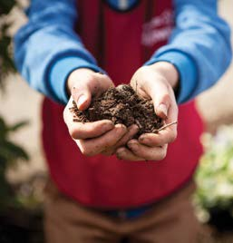

At SuperValu, we believe the very best communities, include everyone.
Every age, ethnicity, and ability have something to bring
in making our communities better places to live, work, and play.

This award aims to recognise TidyTowns committees who are
making positive changes to promote and facilitate inclusivity for everyone
by embracing and including all members of their community.

A prize of €2000 will be awarded to the TidyTowns committee that best demonstrates
how they promoted the inclusion of all community members
through inclusive projects and initiatives.

Examples of these can be from one off events activities, communications or changes made to their community.

Who can enter the competition?
Any TidyTowns Committee, Junior TidyTowns Committee, subcommittee or group working closely with a TidyTowns committee. Only one entry from each town or village will be accepted.

How will the winner be chosen?
A panel of independent adjudicators will assess all entries. All entrants must have an appropriate Child Protection Policy in place. This is the responsibility of the TidyTowns committee.

Closing date

The closing date is 5pm, Wednesday 25th June 2025

Entry
Electronic entry only, by email to tidytowns@musgrave.ie

Application
Village / Town / City / Island:

Contact Name:

Address:

Contact Details:

TidyTowns Committee name:

Are you a member of the TidyTowns committee?
If not, what is your role with TidyTowns?
What is the population of your community?

How many members on your TidyTowns Committee?

Age profile of members – both committee and those who volunteer to carry out work for TidyTowns;

under 18
18-40
40+

What steps has your committee taken to foster inclusivity? How has your group evolved to become more inclusive?

Can you share further information of an event or project or activity your group organized that demonstrated inclusivity?

In what ways have you promoted awareness of this event, activity, or project within your local community? Please provide photos etc

