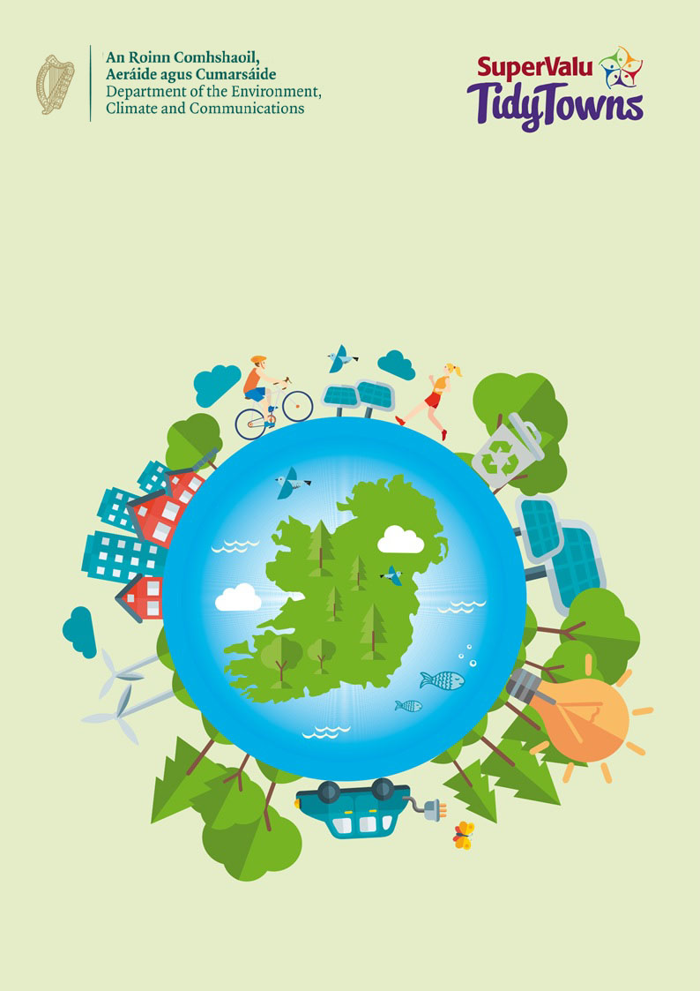
The “Climate Action” Award
The ‘Climate Action’ Award

About the award
The ‘Climate Action Award’ Tidy Towns Special Award is sponsored by the Department of Environment, Climate and Communications. The overall aim of this award is to recognise the impact local communities can make in addressing climate change. The purpose of this award is to celebrate communities who have taken climate action, raised awareness within their communities and worked collaboratively across their and other communities to cocreate solutions to taking climate action.

Climate change is a key issue for all of us. We must ensure that what we do today does not compromise our environment, but instead enhances it and makes it a place where all generations, current and future, can live sustainable and healthy lives. Each committee should highlight climate actions they have taken within their community and how they have spread awareness of these actions with the wider community. Committees should also highlight efforts made to engage other local community organisations in their efforts.

Competition
We are looking for Tidy Town committees to demonstrate steps you have taken to solve a climate action concern in your community, how you have shared these steps with the community and what other groups across your and other communities you engaged with. With our ‘Climate Action’ Tidy Towns Special Award we are interested to hear about initiatives where you have:

- Taken proactive climate action in your community. This can range from planting a pocket forest, to initiatives to improve active travel in your locality.

- Spread awareness of your actions throughout the community. Did you spread the word through social media, local or national media? Did your committee visit other community groups to discuss your initiatives?

- Engaged with other groups in the community or outside your Tidy Towns. Did you work with other community groups to deliver your project such as a local school, sports club, or youth organisations?

Prize
Two prizes of €2,000 will be awarded to two TidyTowns Committees, one from a large town/urban centre and one from a village/small town and one overall runners up prize for €1,000.

It is also important to recognise the key role of the younger generation which is represented by an additional award of €1,000 for the greatest contribution from either a large or small town on the same theme. Marks will be awarded for the scale of action taken, for the methods used to raise awareness within your community and externally, and efforts made to engage with groups outside of the Tidy Towns organisation. This can include within your area or across the country.

Application Process
Entry Process
Entries must be submitted by 5 p.m. on Wednesday June 5th 2024. Late entries will not be accepted. Entries should be emailed to climateawards@DECC.gov.ie

Further Information
Further information can be obtained by emailing climateawards@DECC.gov.ie.

About You

Name of Tidy Towns Committee
County
Contact Name
Phone number
Email address

Category
Please indicate which award you are applying for:
Village/Small Town
(Tidy Town main category A, B, C or D)
Large Town/Urban Centre
(Tidy Town main category E, F, G or H)

Terms and conditions
All entries must be submitted on this official entry form. Supplementary materials such as photographs, screenshots of social media posts (ideally showing levels of engagement), and digital or printed copies of leaflets, posters, etc., can be sent separately by e-mail to climateawards@DECC.gov.ie.
Late entries will not be accepted.
The decision of the judges will be final, and no correspondence will be entered into.
The judges reserve the right not to award one or more prizes if entries are not of a sufficiently high standard.

About Your Entry

Overall Planning and Vision (40 points)
Please give a summary of the action you have taken within your community to promote climate initiatives. (Max 400 words).

Raising Awareness (30 points)
Please give a summary as to how your group raised awareness within the community, and encouraged members of the community to become involved in your initiatives and actions. (Max 400 words)

Network Building (30 points)
Please highlight how you worked with other groups in your community to help deliver this action. Did you engage with local schools, sports clubs, Local Authorities, Men’s Sheds etc. (Max 400 words)

