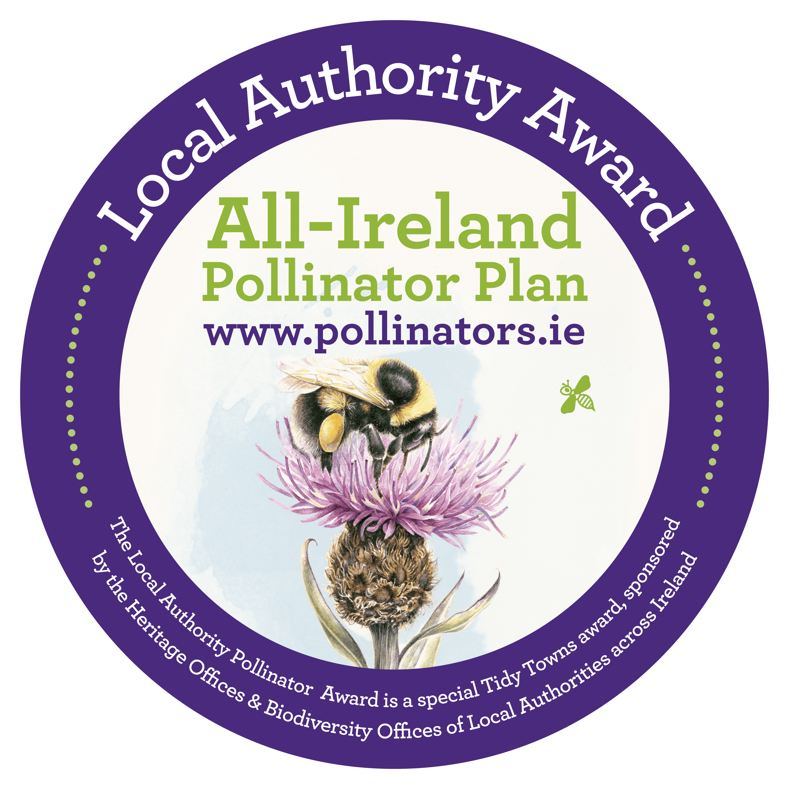
All-Ireland Pollinator Plan: Local Authority Pollinator Award 2024
ENTRY FORM

Name of Tidy Towns Group and County: ...............................................................................................
Tidy Towns Region (as per your national Tidy Towns application form): ...............................................
Tidy Towns Population Category (A-H) (as per your national Tidy Towns application form):……………..
Has your group entered this Pollinator Award before? Yes……………. No…………………..
If Yes, please state which year(s) ................................................................................................................................................................
Nominated contact in Tidy Towns Group: ..............................................................................................
Postal Address: .......................................................................................................................................
.................................................................................................................................................................
Phone number: ................................................. Email:........................................................................
Data Protection
I confirm that my contact details as above may be used in communications relating to the All-Ireland Pollinator Plan Local Authority Award. Any personal information which I provide in this way is not made available to any third parties, save as required by law, and is used by the National Biodiversity Data Centre and Local Authority Heritage Officers/Biodiversity Officers only in line with the purpose for which I provided it. Any personal information which I provide will be treated in accordance with the General Data Protection Regulation.
Please tick your consent to process your data for this application ____

About the Local Authority Pollinator Award & €10,000 prize money
The Local Authority Pollinator Award aims to encourage Tidy Towns groups to implement pollinator-friendly actions in their towns and villages as part of the Tidy Towns competition. Wild Irish bees, crucial to the pollination of our plants, trees and vegetables, are in decline - this is because we’ve drastically reduced the areas where they can nest and the amount of food our countryside provides for them. The aim of the award is to reverse this trend by encouraging Tidy Towns groups to take simple pollinator-friendly measures in their local area. The Local Authority Pollinator Award supports the All-Ireland Pollinator Plan and is sponsored by the Heritage Offices & Biodiversity Offices of Local Authorities across Ireland.
The award categories and prizes are listed below. Awards will be given in all categories subject to satisfactory criteria. For more details see www.TidyTowns.ie or www.pollinators.ie
Category | Large Town or Urban Centre | Village or Small Town
National | €1000 (either population category)
Midlands and East | €1000 | €1000
North West and West | €1000 | €1000
South and Mid-West | €1000 | €1000
South East | €1000 | €1000
Best Newcomer Award | €1000 (either population category)

What types of activities are we looking for?
Local communities can lead the way in driving a better and more sustainable balance for pollinators and bringing more networks of pollinator-friendly habitats back into our landscape. A guidance document is available – ‘Local communities: Actions to Help Pollinators’, which outlines 23 actions you can take to help pollinators in your local community. Please refer to this when filling out your application form. See https://pollinators.ie/resources/ so download a free PDF of the guide.
A partnership approach to supporting pollinators is important. We encourage you to work with your local authority and other groups in your area. Please provide examples of this in your application form.
On our website, www.pollinators.ie, you will find lots of useful resources, including pollinator-friendly planting lists and signage templates. We highly recommend you take the time to look at these resources, as the recommendations of the All-Ireland Pollinator Plan have been used to develop the assessment criteria of this award. You can also find advice for other sectors, such as Schools and Businesses, which may give you ideas on how you can get everyone involved in your town or village.
We particularly encourage a whole-town/village approach, rather than isolated project areas – this is a more effective way to help pollinators and will have a greater positive impact for biodiversity. The evidence-based actions offered by the All-Ireland Pollinator Plan are either zero or low-cost. They range from changing your mowing regime; to planting pollinator-friendly trees and shrubs; and raising awareness. You can identify which actions are the most appropriate for your community. The more actions you can do, the more pollinator friendly your local area can become.
INSTRUCTIONS FOR ENTERING THE POLLINATOR AWARD
- Please take a ‘whole town/village’ approach, rather than a single project in one area.
- Please fill in the attached application form to let us know in no more than 3,000 words how your community is implementing pollinator-friendly actions.
- Within the application, please provide dates for each project mentioned, focusing on work undertaken in the past 12 months.
- Only ONE application will be accepted per group, and applications must come from an official Tidy Towns group (as agreed with the National Tidy Town Unit) which has entered the Tidy Towns competition in 2024.
- The questions on the application refer directly to Pollinator-friendly Actions (A-G) outlined in the guidance document ‘Local Communities: Actions to help pollinators’, which can be downloaded from the Pollinator Plan website https://pollinators.ie/resources/ It is advised you refer closely to this document when planning your town’s actions, and filling in this application form.
- Points are allocated for each question on this application form. All questions must be answered, using this form only.
- Your entry must consist of a single PDF file (comprising the application form, with your photos and map embedded) and this file must be less than 10MB in size. We cannot consider extra documents with further information, including biodiversity action plans. Please include all relevant information on your application form, summarising where necessary.
- Please provide captioned photographs to help demonstrate your work. Photos must be embedded within the application form.
- Email your entry to pollinatoraward@biodiversityireland.ie with “Pollinator Award 2024: Your Town/Village name” in the subject line.
- Please read and tick the Data Protection paragraph above.
Closing Date: Wednesday 5 June 2024

Judging the Award: All entries will be assessed by a panel of suitably qualified judges including representatives of Local Authority Heritage Officers, Biodiversity Officers, and National Biodiversity Data Centre staff.

All-Ireland Pollinator Plan: Local Authority Pollinator Award 2024
A. Identify and protect existing areas that are good for pollinators. (See Action A. in guidelines: Local Communities: Actions to help pollinators
1. Provide a map of pollinator-friendly areas in your town or village, highlighting and labelling areas of existing habitat e.g. native flowering trees, hedgerows, and wild areas. (2 points)

2. Outline how you are managing these existing areas for pollinators. (5 points)

3. Provide a list of pollinators that have been recorded in your area. Carry out an area-based search on Biodiversity Maps (https://maps.biodiversityireland.ie/). Any pollinators recorded in your area will be listed under the datasets: Bees of Ireland; Hoverflies of Ireland. (3 points)

4. Have you had an ecologist/ Biodiversity Officer conduct a biodiversity survey in your community and give advice on how to manage it? If so, give details of their suggested actions and which ones you have undertaken. (Note: the survey doesn’t have to have taken place in the past 12 months)
(5 points)

B. Mow less in grassy areas to help local, native wildflowers grow naturally (Action B)
Note: The All-Ireland Pollinator Plan does not recommend the use of wildflower seed mixes in natural or semi-natural areas. Studies have shown these mixes can contain non-native species and inadvertently introduce invasive species. Reducing mowing is the best way to encourage local, native wildflowers to appear naturally. For more information, see https://pollinators.ie/wildflower-seed/
5. Create a long-flowering meadow. Describe how you have managed grassy areas in your community as long-flowering meadows (one cut and lift per year). This can include more than one location. Include the area in m². (8 points)

6. Create a short-flowering meadow. Describe how you have managed some areas as short-flowering meadows (cut every 4-6 weeks starting in mid-April). Include the area in m². (8 points)

7. Let Dandelions Bloom. Describe how you have managed grassy areas so that Dandelions are allowed to bloom in spring (first grass cut of the year in April after they have flowered). Include the area in m². (4 points)

C. Pollinator-friendly Planting. Tell us about pollinator-friendly planting you have done in your community. Native plants (trees, shrubs, wildflowers) are always the best choice for our pollinators. They have evolved alongside our pollinators, so are perfectly adapted to give them what they need. But in some areas of parks, non-native ‘ornamental’ species can help provide additional sources of food. These species should never be planted in natural or semi-natural areas, or the wider landscape.
Native planting
8. Maintain or plant a native flowering hedgerow. Describe how you manage or have planted native flowering hedgerow. Include the length of the hedgerow in m. This could be on public or private land. (5 points)

9. Plant native pollinator-friendly trees. Provide a list of the native pollinator-friendly trees in your community (e.g. Hawthorn, Blackthorn, Willow, Rowan, Wild Cherry, and Crab apple). Ensure there is a range flowering from March through to October. This could be on public or private land.
(4 points)

Ornamental planting
10. Plant an orchard of flowering fruit trees. Provide a list of pollinator-friendly fruit trees in your community, or describe how you have created fruit tree orchards (one orchard = five fruit trees).
(3 points)

11. Add pollinator-friendly bedding plants to containers & hanging baskets. If you have any containers or hanging baskets, provide a list of pollinator-friendly plants you have added to them.
(1 point)

12. Plant pollinator-friendly bulbs. Provide a list of pollinator-friendly bulbs you have planted in your community. If you can, tell us what percentage of bulbs are pollinator-friendly (aim for a minimum of 50%). (2 points)

13. Plant ornamental trees and shrubs. Provide a short list of key ornamental pollinator-friendly trees and shrubs in your community. (2 points)

14. Plant pollinator-friendly perennials. Tell us about pollinator-friendly perennial beds or planters. Ensure there is a range of species, flowering between February and October. (3 points)

D. Provide wild pollinator nesting habitat. Please refer to our ‘How to guide: Creating wild pollinator nesting habitat’ at http://pollinators.ie/resources/
15. Provide nesting habitat for bumblebees. Describe how you protect or manage areas of long grass as nesting sites for bumblebees and other insects. Include the area in m². (2 points)

16. Provide nesting habitat for mining solitary bees. Describe how you manage or have created areas of bare earth for mining solitary bees. Include the area in m². (2 points)

17. Provide nesting habitat for cavity-nesting solitary bees. Describe how you manage or have created nesting sites for cavity-nesting solitary bees. (1 point)

E. Eliminate or reduce the use of pesticides
Note: Please answer either 18 or 19, you do not need to answer both.
18: Tell us about how you have eliminated pesticide use (note that herbicides can still be used on invasive species). Please provide details of your strategy for eliminating pesticides, and any alternative methods you use for removing unwanted plants. (20 points)

19. If you haven’t eliminated pesticides, tell us about how you are reducing their use as a step towards total elimination, including the percentage of reduction. (10 points)

F. Raise awareness of pollinators in your local area
20. All-Ireland Pollinator Plan resources. Tell us how you have promoted All-Ireland Pollinator Plan advice and resources in your community. (1 point)

21. Run pollinator events. Tell us about a pollinator event you have organised in the past 12 months. (2 points)

22. Working with others. Tell us how you have worked with your local authority and other groups to help pollinators and biodiversity, and create wildlife corridors in the past 12 months. (5 points)

23. Put up pollinator signage or interpretation. Tell us about any signage or interpretation you have that raises awareness of pollinators and your actions to help them. (2 points)

G. Tracking progress and receiving recognition
24. Log your ‘Actions for Pollinators’ on the online mapping system. Have you added sites in your community to the Actions for Pollinators online map? If so, please include the username used to add your site. (5 points)

25. Submit annual Flower-Insect-Timed (FIT) Counts. Have you submitted an annual FIT Count? If so please provide the recorder name used to submit the data. (2 points)

26. Take part in the Bumblebee Monitoring Scheme. Have you taken part and submitted date to the Bumblebee Monitoring Scheme run by the National Biodiversity Data Centre? If so, please provide the name of your transect route. (3 points)

