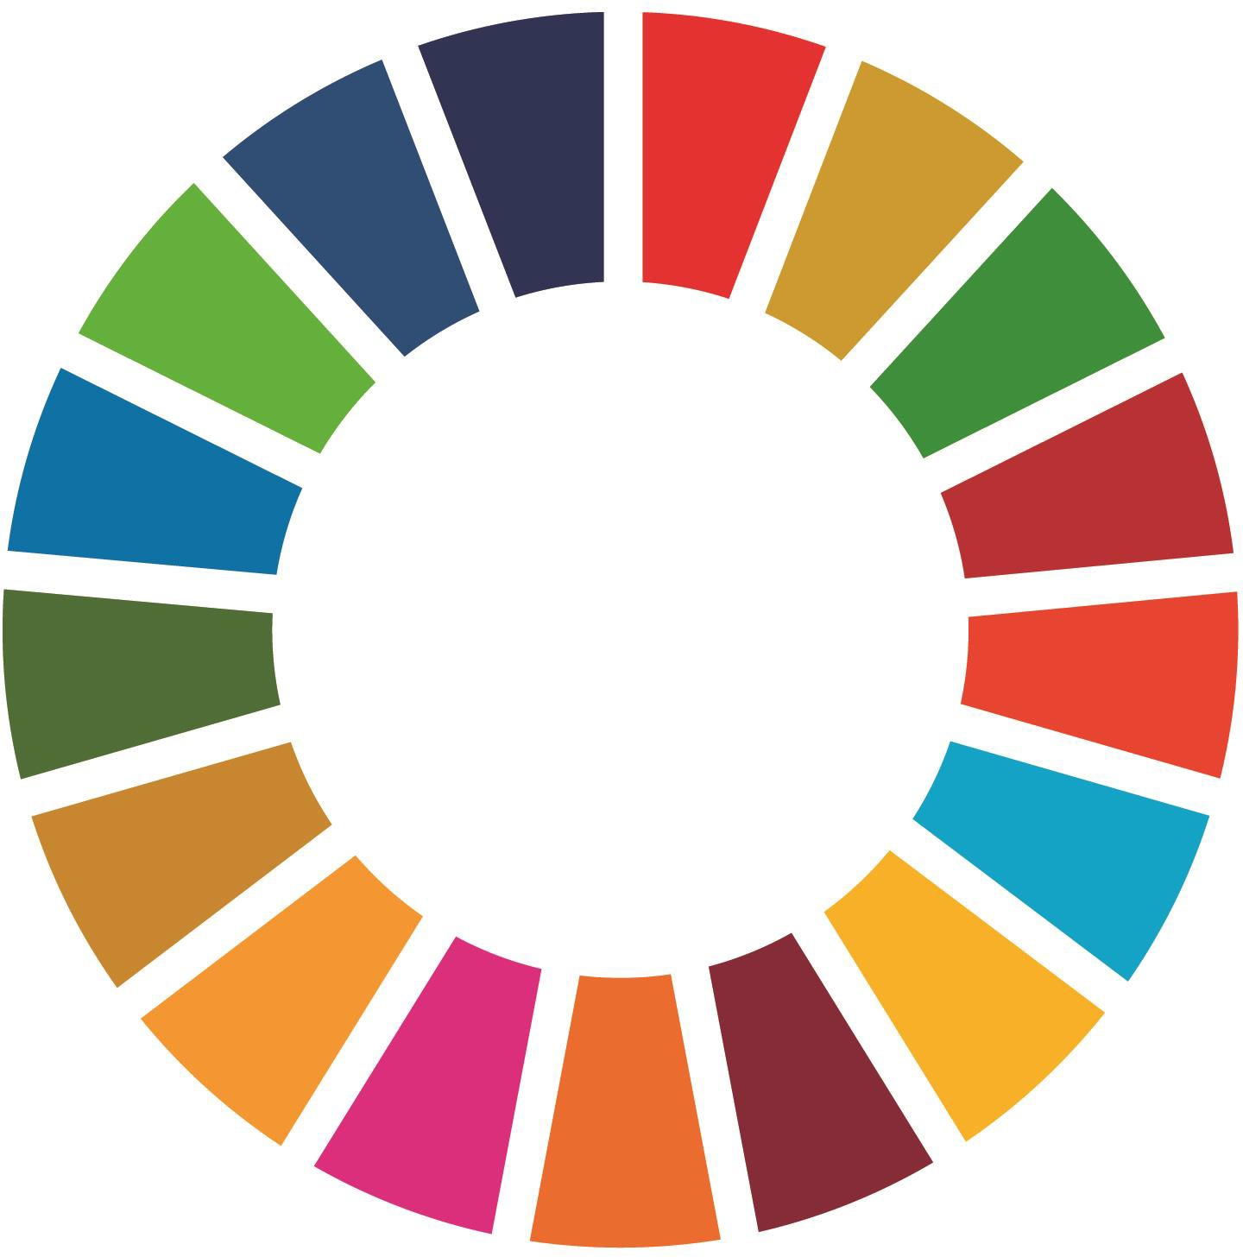
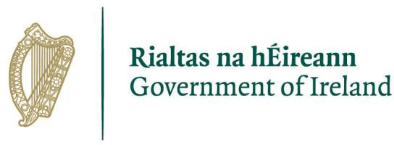

Sustainable
Development
Goals
TidyTowns
Special Award 2023

About the Sustainable Development Goals (SDGs) TidyTowns Special Award
The Sustainable Development Goals (SDGs) are a collection of 17 globally agreed goals to end poverty, protect the planet and secure peace and prosperity for all. The SDGs apply to all countries and belong to everyone. A key principle is that no one should be left behind.
To find out more see gov.ie/sdgs

The good news is that the work you are currently undertaking already contributes to the SDGs! We are encouraging groups to:

- Make links between their existing work and the SDGs;
- Use the framework provided by the SDGs to inform their work going forward;
- Promote the SDGs within their local communities.
This SDG Special Award aims to acknowledge the significant efforts and contributions that communities are already making towards promoting and implementing the SDGs.
The Award is sponsored by the Department of Environment, Climate and Communications.

The Prize
Four Prizes will be awarded:

1. €2,000 for the best entry from a village/small town (category A to D)
2. €2,000 for the best entry from a large town or urban centre (Category E to H)
3. One overall runner-up prize of €1,000
4. A special Youth Award of €1,000.

Applications
To apply for the SDG special award, applicants are asked to:

- Outline how they have promoted and raised awareness of the SDGs and/or the principle of Leaving No One Behind; and
- Demonstrate how their existing work links and contributes towards the achievement of the SDGs and/or the principle of Leaving No One Behind.

Tips for promoting the SDGs
- Link existing and future activities/campaigns to the SDGs and publicly highlight how your work is contributing to the SDGs.

- Incorporate SDG branding into your work and activities (use branding for ‘Non-UN entities found at this link).
- Promote the SDGs on social media and with stakeholders.
- Organise SDG specific events or activities to promote the SDGs (event ideas can be found here).
- Take part in SDG Week which takes place every September.

Tips for linking work and projects to the SDGs
- Consider how individual pieces of work and projects link with the 17 SDGs and whether the work is in keeping with the principle of “leaving no one behind”.

For example: hosting a biodiversity week would link with SDGs 13, 14 and 15
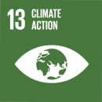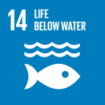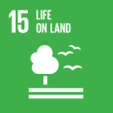

- Consider how your ongoing or annual work links/contributes to the SDGs. Use a table similar to that found in Appendix A to map your work against the SDGs. The table can also be used for responding to Question 2 in the application form.

- Reflect on what SDGs you are contributing to. You may find this informs your workplan and activities for next year, for example, would you like to continue to prioritise those SDGs that you are already contributing to or would you like to prioritise or introduce other SDGs that have not been prioritised before? There is no right/wrong here, using the SDG framework helps to inform decision-making.

How to apply?
- Complete the below entry form by responding to the 4 questions.
- We are accepting one application per community and this should come from the official TidyTowns Group.
- Your application can include photographs but please keep the image size small.

Please note
Entries are judged on an annual basis and previous scoring does not carry forward.
Applicants who are applying for the youth award can also have their application judged under the large town or small town categories. Only one prize will be awarded per entry.

Your completed application form will be marked out of 100.

Entry Process
Entries should be emailed to SDGs@decc.gov.ie

Sustainable Development Goals TidyTowns Special Award

Entry Form
Name of TidyTowns Committee and County:
Contact name:
Contact phone number:
Email Address:
Postal Address:

Section A

Data Protection
I confirm that my contact details as above may be used in communications relating to SDG Tidy Towns Award. Any personal information which I provide in this way is not made available to any third parties, save as required by law, and is used only in line with the purpose for which I provided it. Any personal information which I provide will be treated in accordance with the General Data Protection Regulation.

Please tick your consent to process your data for this application

Category
Please indicate which award(s) you are applying for

Village/Small Town
(Tidy Town main category A, B, C and D)
Large Town/Urban Centre
(Tidy Town main category E, F,G and H)
Youth Award

- Outline what actions you have taken to raise awareness of and promote the SDGs in your community (30 marks)
maximum word limit: 600 words

- How has the work you have undertaken contributed to the SDGs and/or the principle of Leaving No One Behind? (30 marks)
maximum word limit: 600 words
Please note: The template found at Appendix A may be used to respond to this question

- Outline how your committee engaged other organisations in the community i.e., business, volunteers to promote the SDGs and/or to deliver on the above work. (20 marks)
maximum word limit: 400 words

- Briefly highlight any future plans you have to incorporate the SDGs and/or the principle of Leaving No One Behind in your community. (20 marks)
maximum word limit: 400 words

Appendix A: Mapping your work against the SDGs
This template can be used for completing Question 2 in the application form.

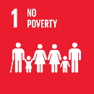 | SDG 1: End Poverty in All its Forms Everywhere
For Example:
- Support your local charities
- Local shoe box appeals
- Take one/leave one behind initiatives

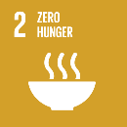 | SDG 2: End Hunger, Achieve Food Security and Improved Nutrition and Promote Sustainable Agriculture
For Example:
- Nutrition class
- Grow it yourself initiatives
- Food foraging workshops
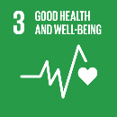 | SDG 3: Ensure Healthy Lives and Promote Well-Being for All at All Ages
For Example:
- Digital detox week
- Community walk in the woods/by the sea
- Support local mental health associations

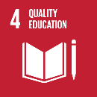 | SDG 4: Ensure Inclusive and Equitable Quality Education and Promote Lifelong Learning Opportunities for All
For Example:
- Book swaps
- Free community library
- Organise an outdoor reading experience

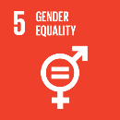 | SDG 5: Achieve Gender Equality and Empower all Women and Girls
For Example:
- Support domestic violence shelters
- Organise a period poverty initiative

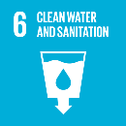 | SDG 6: Ensure Availability and Sustainable Management of Water and Sanitation for All
For Example:
- River/beach clean
- Awareness campaign
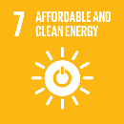 | SDG 7: Ensure Access to Affordable, Reliable, Sustainable and Modern Energy for All
For Example:
- Energy saving community initiatives
- Learn to read your bills workshops

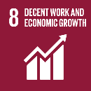 | SDG 8: Promote Sustained, Inclusive and Sustainable Economic Growth, Full and Productive Employment and Decent Work for All
For Example:
- Shop local campaign
- Skills-based Community workshops for job-seekers

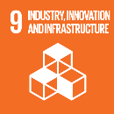 | SDG 9: Build Resilient Infrastructure, Promote Inclusive and Sustainable Industrialisation and Foster Innovation
For Example:
- Promote local markets
- Collaborate with industry in your communities
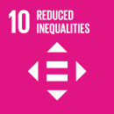 | SDG 10: Reduce Inequality Within and Among Countries
For Example:
- Join or start a befriending initiative
- Look at social inclusion in your area

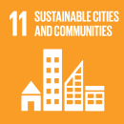 | SDG 11: Make Cities and Human Settlements Inclusive, Safe, Resilient and Sustainable
For Example:
- Develop a local village plan
- Develop and protect local heritage

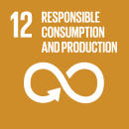 | SDG 12: Ensure Sustainable Consumption and Production Patterns
For Example:
- Hold a swap event
- Creative reuse community hub
- Repair workshops
- Recycling/upcycling exhibition

 | SDG 13: Take Urgent Action to Combat Climate Change and its Impacts
For Example:
- Organise a climate action week
- Reusable cup campaign
- Cycle to work initiative
 | SDG 14: Conserve and Sustainably Use the Oceans, Seas and Marine Resources for Sustainable Development
For Example:
- Beach clean
- Anti-dumping initiatives
- Workshops on Ireland’s marine wildlife

 | Goal 15: Protect, Restore and Promote Sustainable Use of Terrestrial Ecosystems, Sustainably Manage Forests, Combat Desertification, and Halt and Reverse Land Degradation and Halt Biodiversity Loss
For Example:
- Planting and craft workshop
- Seed exchange programme
- Harvest picnic
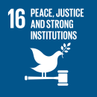 | SDG 16: Promote Peaceful and Inclusive Societies for Sustainable Development, Provide Access to Justice for All and Build Effective, Accountable and Inclusive Institutions at All Levels
For Example:
- Promote awareness or support charities working with vulnerable children and communities
- Ensure inclusive, participatory and representative decision-making within Tidy Town communities

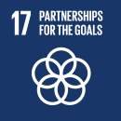 | SDG 17: Strengthen the Means of Implementation and Revitalize the Global Partnership for Sustainable Development
For Example:
- Partner up with stakeholders in your community to promote the SDGs and initiatives aimed at contributing to the SDGs
- Incorporate the SDGs into your work and promote awareness of

