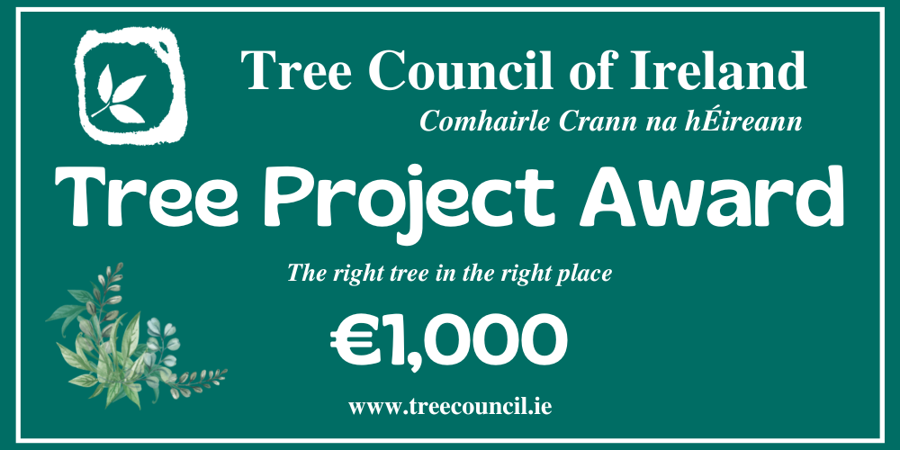

Supervalu Tidy Towns Competition 2023

This award is given to the Tidy Towns Committee which has demonstrated the greatest commitment to enhancing the town and its immediate environs with trees.

Trees can have a major impact in a city, town or village enhancing the visual aspect of the area. It is essential that careful thought is put not only into the planting but also the management of the trees over their lifespan. This award highlights this importance.

In addition, this award seeks, where appropriate, to raise awareness and promote initiatives to enhance the protection of old and established trees; trees that are of natural, historical, cultural, botanical or landscape significance within a community.
The following criteria will be considered for the award:
- Trees must be in a public place, eg: a street, an open space, a school, church grounds.
- The trees may be existing or newly planted. If new trees, they must be appropriate to the site in species, cultivar suitability, shape, size and colour.
- Trees must be located appropriately within the site.
- Trees must be well maintained with regard to watering, weed control, staking, tree ties, tree guards (if necessary) and appropriate surgery carried out where necessary.
- A clear plan for renewal of older trees should be in place.
- The project should contain an element of raising awareness of trees within the community.
How to Enter:
To enter the Tree Project Award, complete the Entry Form below. All entries should be forwarded by email only to: tidytowns@treecouncil.ie

Closing Date:
Please check the TidyTowns website (www.tidytowns.ie) for updates.
Tidy Towns Competition Terms and Conditions apply as appropriate.
ENTRY FORM

Please include at least 4 photographs of the area to be considered showing before the project commenced and after completion. (Additional images can be emailed separately if required.)

Nominated Area: | Click or tap here to enter text.
Specific Location: | Click or tap here to enter text.
Project Leader: (person/group/local authority, etc.): | Click or tap here to enter text.
Nominating Group/Person: | Click or tap here to enter text.
Contact Address: | Click or tap here to enter text.
Phone No: | Click or tap here to enter text.
Email: | Click or tap here to enter text.

Please give details of the tree project and explaining why it will benefit the local community including:
- Site description
- Details of tree species, sizes, numbers, suitability and works undertaken etc.
- Contribution of the tree project to the community and to the physical landscape of the town or village
- Activities to raise community awareness of the tree project.

Click or tap here to enter text.

