Tiny TidyTowns School Award Prize €5000
Sponsored by SuperValu
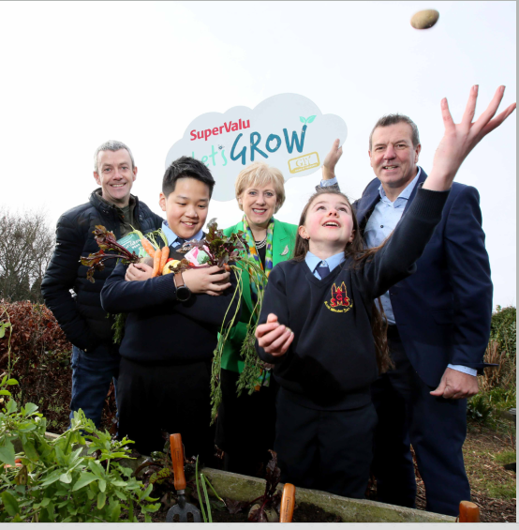

SuperValu are introducing a new primary school award called Tiny TidyTowns.

We all want our kids to understand and experience the wonder of growing their own food and the importance of protecting local biodiversity, so that they can grow up in a healthier world.
So, this year SuperValu are calling on all Primary schools to show all the great work they are doing to improve their school and classroom environments.
Does your primary school grow their own fruit and vegetables? Have you rewilded an area for bees and biodiversity? Have you a dedicated an area to pollinator friendly flowers?
We are also looking for you to share your food growing and biodiversity projects developed in the school and any future plans to further enhance this topic in the classrooms.
A finalist group from each of the four regions will be chosen, with each finalist group receiving €1,000. The overall winner will then receive an additional €1,000.
Entries to be sent to: tidytowns@drcd.gov.ie using this form. You can support your entry by sending in photographs.

SuperValu Let’s Grow, in partnership with GIY, is helping over 50,000 kids experience the wonder of growing their own food.

ENTRY FORM
School Name:

School ID Number:

School contact Name:

School contact address:

School contact email:

Do you consent to SuperValu sharing your videos/pictures on social media – Y/N

Background:

Actions we took:

Who was involved?

Results so far:

