TidyTowns Special Awards 2022
The RIAI Shopfront Award

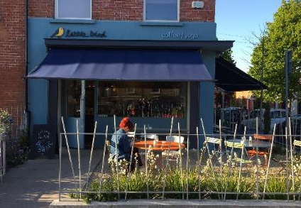
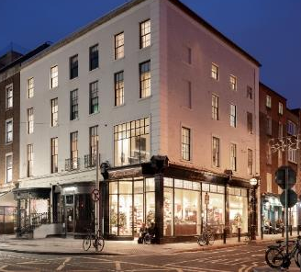
Top left: Shopfronts of County Cork, A Design Guide for the Historic Setting, John Hegarty MRIAI.
Top right: Little Bird Café, Dublin, Fitzpatrick Mays Architects.
Bottom left: Shopfront on Pearse Street, Dublin by Horan Rainsford Architects, Photo Artur Sikora.
Bottom right: No 51 Dawson Street, Dublin, RIAI Award Winner 2020 by PKA Architects.

About the Award

The RIAI Shopfront Award is a Special Award, designed to raise awareness and promote good shopfronts in Irish towns and villages. The RIAI Shopfront Collaboration Award aims to support a TidyTowns Committee who wish to provide guidelines for the design of shopfronts in an historic context with the help of a Registered Architect.
Well-kept historic shopfronts and well-designed modern shopfronts are equally valid.

Award Value: €2,000
The award consists of an architectural commission to the value of €2,000 for guidelines to support shopfronts in your locality. The commission will result in an illustrated Report, which will be made publicly available, and a presentation to the local TidyTowns Committee.

Who Can Apply
This competition is open to the Village, Small Towns and Large Towns categories.

How to Apply
Please reply by completing this document and returning it electronically or submitting by email to communications@riai.ie, subject line: RIAI Shopfront Award 2022.

In order to apply for the award, the local TidyTowns committee should also submit the following:
Photographs of the overall façade of two buildings with good shopfronts in your locality.
Well-kept historic shopfronts and well-designed modern shopfronts are equally valid.

Closing Date
Friday 10 June 2022, 4pm. Please check the TidyTowns’ website www.tidytowns.ie for updates.

Judging the Award
All entries will be assessed by an RIAI jury. TidyTowns’ Competition Terms and Conditions apply as appropriate.

Useful References
http://dublincivictrust.ie/conserve-your-building/protected-structure-advice--grants
https://www.gov.ie/en/press-release/5b269-minister-noonan-minister-martin-and-minister-chambers-collaborate-to-announce-additional-supports-for-irish-language-restoration-works-on-traditional-shopfronts/
https://lambstongue.ie/workshop/histories
https://www.buildingsofireland.ie/buildings-search/building/50080269/thomas-street-crane-street-dublin-8-dublin-city
https://www.corkcoco.ie/sites/default/files/2020-09/shopfronts-of-county-cork-20.10.17-compressed.pdf

Application Form for the TidyTowns RIAI Shopfront Award 2021
Name of Tidy Town or community group Main contact person’s name

Email: Phone No :

Tidy Towns Committee

Postal Address:

Address of Two Buildings with Good Shopfronts (with supporting photographs):

