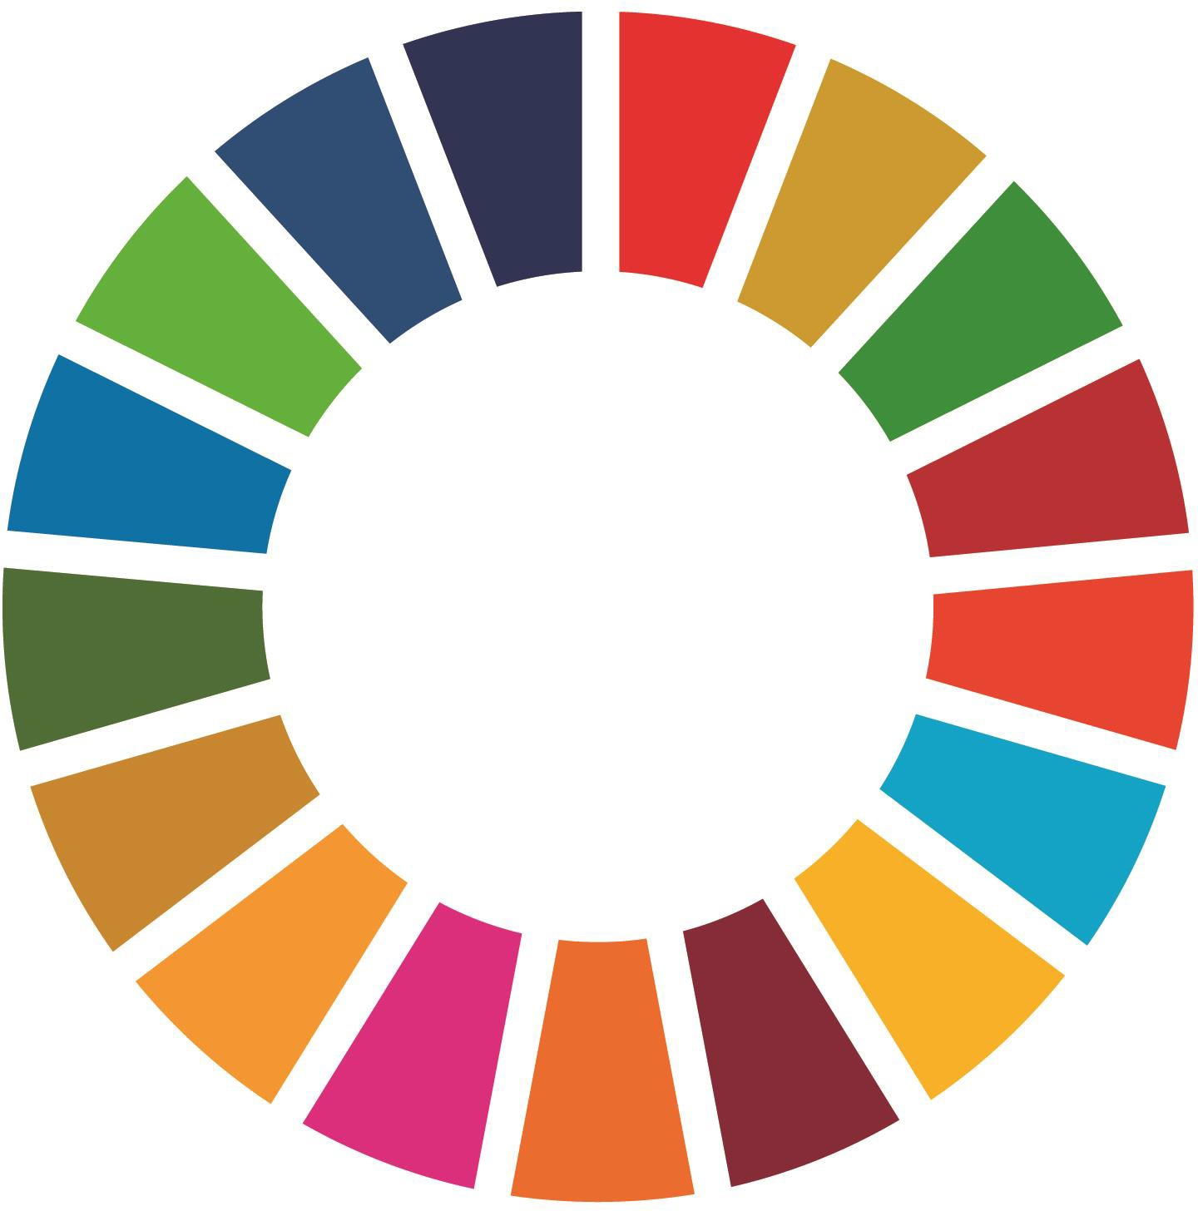
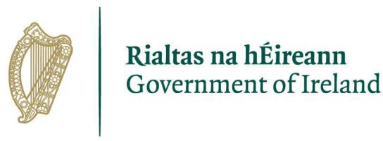

Sustainable Development Goals Special Award 2022

About the Sustainable Development Goals (SDGs) TidyTowns Special Award
The SDGs offer a plan of action for people, planet and prosperity and seek to strengthen universal peace in larger freedom. This SDG Special Award, aims to acknowledge the significant efforts and contributions communities do to increase awareness and engagement on the economic, social and environmental dimensions of sustainable development.
The Award is sponsored by the Department of Environment, Climate and Communications who have lead responsibility for this whole of Government approach.

The Prize

Two prizes of €2,000 will be awarded: one to the best entry from a large town/urban centre, and one for the best entry from a village/small town. There will also be three runner-up
prizes of €500 each. Also, recognising the key role of the younger generation, an additional prize of €500 will be awarded to the best entry that can demonstrate a sizable contribution by young people.
You don’t need to develop a new project to apply, just to demonstrate that the work you are already undertaking is achieving so many of these goals already. It is likely that you have projects entered in the main competition already. For example: Take a look at all the activities your TidyTowns committee have completed since June 2020.

Examples of initiatives include but are not limited to:

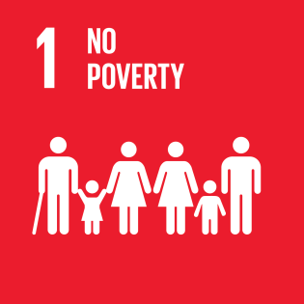 | - Support your local charities & voluntary groups  - Local shoe box appeals  - Take one/leave one behind initiatives  - Include marginalised individuals
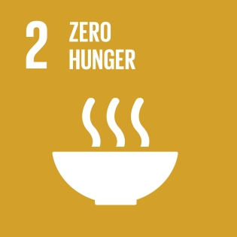 | - Develop edible landscapes  - Free nutrition classes  - Grow it yourself
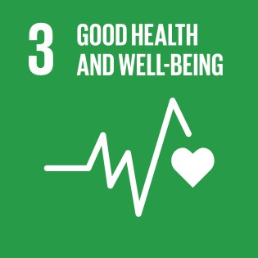 | - Walk in the woods, volunteering & connecting  - Support local mental health associations  - Connect with your community for change
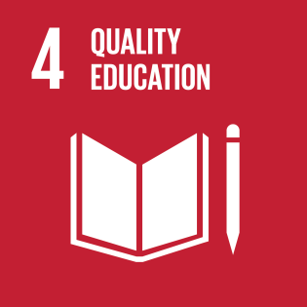 | - Book swaps  - Free community library  - Skill sharing

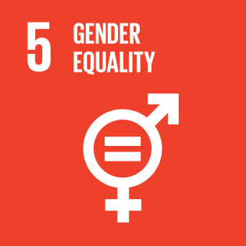 | - Peer support groups  - Men's emotional wellbeing  - Support domestic violence shelters
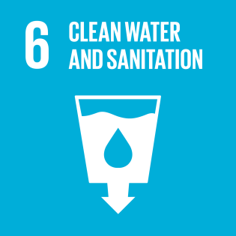 | - Drink form the tap !  - Visit refill.ie  - Ask the green school kids!  - Keep cup bottles
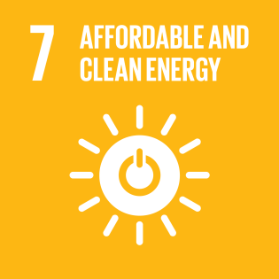 | - Ask the green school kids - Energy Vampires  - Energy saving community initiatives  - Learn to read your bills workshops  - Plug out, turn off
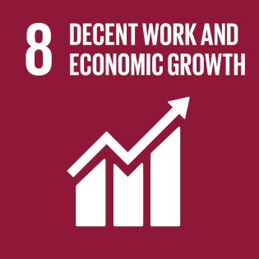 | - Shop local  - Community based workshops  - Community driven activities  - Community driven festivals
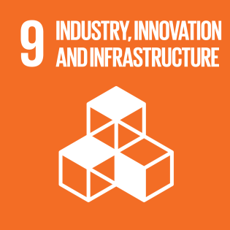 | - Local markets  - Energy Co-ops  - Work with industry in your communities

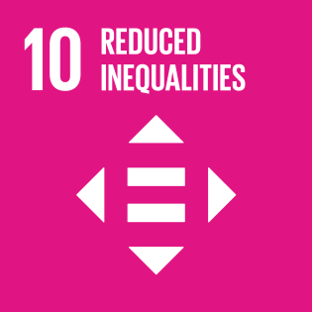 | - Look at social inclusion in your area  - Join or start a befriending initiative  - Local information points
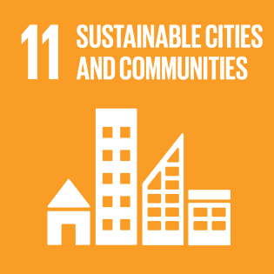 | - Future proofing your community  - Develop a local village plan  - Develop and protect local heritage
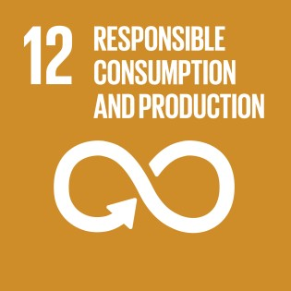 | - Stop food waste programmes  - Ditch the disposables  - Reduce, reuse, recycle  - Conscientious consumerism - think local
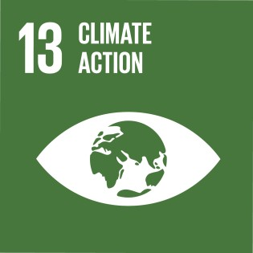 | - Local climate action plans  - Conscious cup initiatives  - Single use plastic free  ✓
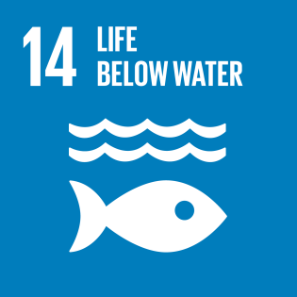 | - Save the fish !  - Pollution free rivers  - Protect our waterways

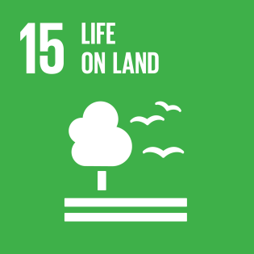 | - Tree planting  - Annuals Vs Perennials  - Traditional skills workshops  - Think native !
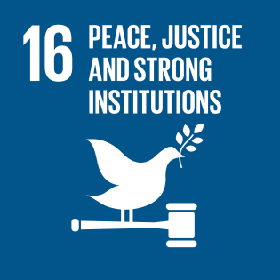 | - Support local community groups  - Comhairle Na nÓg  - Tidy Towns groups
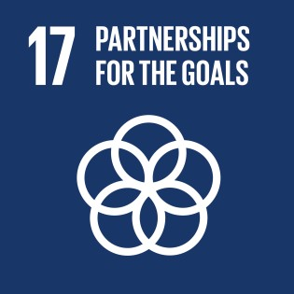 | - This is you talking to everyone else !  - Social  - Environmental  - Economic

How can you enter?

- Complete the attached application form, outlining in 2,000 words or less, how the SDGs are being promoted in your community. Give brief details of projects or campaigns completed highlighting awareness of the SDGs indicating which of the 17 goals it fall under, it may of course span more than one of the goals.
- We are accepting one application per community and this should come from the official TidyTowns Group.
- Your application can include photographs but please keep the image size small

Please note
Entries are judged on an annual basis and previous scoring does not carry forward. Previous entries are acceptable as long as work is ongoing and a prize has not been previously awarded. All applications may apply to be considered for up to two awards, large town or small town and the youth award on one application or submit on second form, on a different initiative, for consideration under youth award only. Only one prize will be awarded per entry.

Your completed application form will be marked out of 100.

Entry Process

Entries should be emailed to SDGs@DECC.gov.ie

Please note, we are unable to accept entries by post at this time.

Sustainable Development Goals TidyTowns Award 2020 Entry Form

Section A

Name of TidyTowns Committee and County:
Contact name:
Contact phone number:
Email Address:
Postal Address:

Data Protection
I confirm that my contact details as above may be used in communications relating to SDG Tidy Towns Award. Any personal information which I provide in this way is not made available to any third parties, save as required by law, and is used only in line with the purpose for which I provided it. Any personal information which I provide will be treated in accordance with the General Data Protection Regulation.

Please tick your consent to process your data for this application

Category - Please indicate which award you are applying for

Village/Small Town
(Tidy Town main category A, B, C and D)
Large Town/Urban Centre
(Tidy Town main category E, F,G and H)
Is your entry also eligible for the Youth
Award?

Section B
1. Outline what actions have been taken in your community to raise awareness of the SDGs in your area. (30 marks)

2. Outline how your committee engaged other organisations in the community i.e., business, volunteers to deliver the above actions. (20 marks)

3. What impact have your activities promoting the SDGs had on your community? How has your community promoted this? (30 marks)

4. Briefly highlight any future plans you have to incorporate the SDGs in your community. (20 marks)

