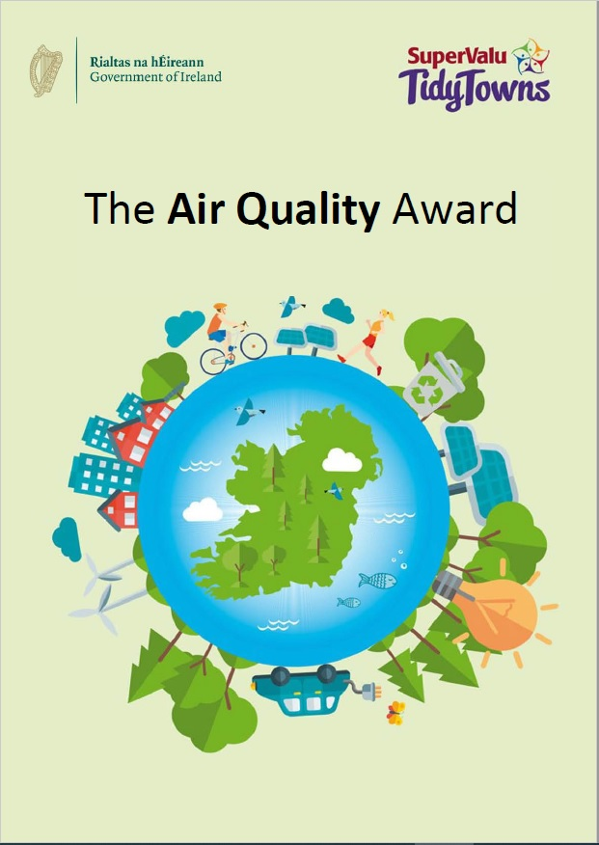
The Air Quality Award

About the Award
The Air Quality Tidy Towns Special Award is sponsored by the Department of the Environment, Climate and Communications. The overall aim of this award is to recognise the positive contribution your local community is making to raise awareness and take positive actions to address the challenge of air pollution and bringing about improved air quality, for the benefit of all.

Air quality is a key issue for all of us. We must ensure that what we do today does not compromise our environment, but instead enhances it and makes it a place where all generations, current and future, can live sustainable and healthy lives. This Special Award will reward Tidy Towns groups who conduct awareness initiatives and carry out actions in their community to make lasting and positive contributions to meeting the air quality challenge.

Competition
The theme of this year’s competition is raising awareness of the air quality and health impacts of using the most polluting solid fuels for domestic heating, and taking actions to counter them. We are asking Tidy Towns committees to demonstrate innovative ways in which they have achieved this, and which could be replicated by other communities in order to spread the benefits even wider. Points will be awarded for:

- Your overall planning and vision – i.e. the central reason why your group’s specific actions were chosen, and the impact you hoped they would have (20 points)
- The levels of awareness raising and community involvement that your group achieved (30 points)
- The levels of changes in action in your community that resulted from your group’s efforts (30 points)

Up to 20 bonus points may also be awarded per entry.

Prizes
There will be two first prizes of €1,000 each – one for the best entry from a village/small town (Categories A to D of the main Tidy Towns competition), and one for the best entry from a large town/urban centre (Categories E to H). In addition, there will be two runner-up prizes of €500 each. These may be awarded to entries from any category.

Entry Process
Entries must be submitted by 5 p.m. on Friday June 10, 2022. Late entries will not be accepted. Entries can be emailed to airquality@decc.gov.ie or posted to:

Tidy Towns Awards,
Air Quality Division,
Department of the Environment, Climate and Communications,
Newtown Road,
Wexford, w
Y35 AP90

Further Information
Further information can be obtained by emailing airquality@decc.gov.ie

About You

Name of Tidy Towns Committee
County
Contact Name
Phone number
Email address

Category
Please indicate which award you are applying for:
Village/Small Town
(Tidy Town main category A, B, C or D)
Large Town/Urban Centre
(Tidy Town main category E, F, G or H)

Terms and conditions
All entries must be submitted on this official entry form. Supplementary materials such as photographs, screenshots of social media posts (ideally showing levels of engagement), and digital or printed copies of leaflets, posters, etc., can be sent separately by e-mail to airquality@decc.gov.ie or by post to the address given above.
Late entries will not be accepted.
The decision of the judges will be final, and no correspondence will be entered into.
The judges reserve the right not to award one or more prizes if entries are not of a sufficiently high standard.

Useful links
Solid Fuel Regulations and The ABC for Cleaner Air - https://www.gov.ie/en/publication/e3da2-air-quality/
EPA information on air quality - https://www.epa.ie/environment-and-you/air/
Latest readings and historic data from Ambient Air Quality Monitoring Programme - https://airquality.ie/

About Your Entry

Overall Planning and Vision (20 points)
Please give a summary of the planning process your group used to start awareness raising within your community, to include details of the methods considered and reasons for your ultimate choice of campaign. This could include surveys, door to door calls, leaflet drops, social media, and more. What methods did you choose to use or not use, and why?
Please also tell if you gathered information on the levels of solid fuel use in your area, and how you proposed to measure changes in awareness and/or choices. (Max 400 words)

Raising Awareness & Community Involvement (30 points)
Please tell how your group raised awareness within the community, and encouraged members of the community to become involved in your initiatives and actions.
Examples could include lectures, workshops, promotional campaigns, and more. Community involvement could include engagement with a wide range of local groups including sports clubs, social clubs, men’s sheds, schools, local authorities or other community groups. (Max 400 words)

Actions for Change (30 points)
Describe how your actions helped to bring about change in your community. Examples could be showing how more people are switching to less polluting methods of heating their homes, or how retailers are making greater efforts to promote low smoke fuels. Before and after surveys may be useful here. (Max 400 words)

Bonus Marks (20 points)
Up to 20 bonus points may be awarded by the judges for innovative and effective projects which could easily be replicated by other communities, in order to bring the same benefits to other areas. Bonus points may also be awarded for secondary actions or initiatives which were run in conjunction with the main item described above. Any comments you feel might help your entry to earn bonus points may be entered in the box below. (Max 400 words)

