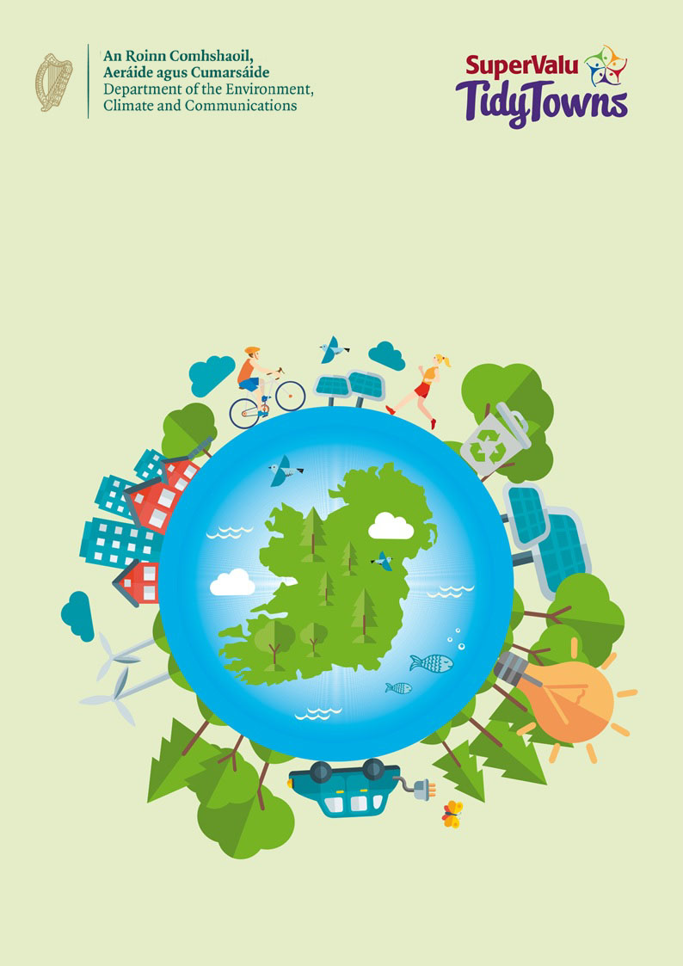
The “Climate Action” Award
The ‘Climate Action’ Award

About the award
The ‘Climate Action Award’ Tidy Towns Special Award is sponsored by the Department of Communications, Climate Action and Environment. The overall aim of this award is to recognise the input local communities can make in addressing climate change. The purpose of this award is to raise awareness of climate action, enable local communities to deliver change at a local level, and promote behaviour change in the wider community.

Climate change is a key issue for all of us. We must ensure that what we do today does not compromise our environment, but instead enhances it and makes it a place where all generations, current and future, can live sustainable and healthy lives. Each committee should highlight one key awareness initiative or action in their community which makes a lasting and positive contribution to the challenges of climate change.

Competition
We are looking for Tidy Town committees to demonstrate innovative ways in which you have raised awareness to address the challenges of climate change and which could be easily replicated by other communities. With our ‘Climate Action’ Tidy Towns Special Award we are interested to hear about initiatives where you have:

- Demonstrated how you raised awareness within the community. This could involve enhancing your community’s links and co-operation with initiatives such as the Green Schools Programme, Climate Ambassadors or other approaches to tackling climate change. It could feature thematic lectures, workshops, promotional campaigns etc.

- Encouraged your community to improve the impact of the everyday choices they make. Promoting smarter travel, raising awareness of issues such as food waste, food miles, recycling and upcycling are examples of lifestyle changes with climate change benefits.

- Supported the sustainable use of local resources and a considered approach to protecting the environment. This could, for example, include innovative waste management activities or tree planting.

- Show how working together with the wider community has influenced behaviour change to more environmentally sustainable practices. Tidy Town committees can engage with a wide range of local groups including sports clubs, social clubs, men’s sheds, schools, local authorities or other community groups.

Prize
Two prizes of €2,250 will be awarded to two TidyTowns Committees, one from a large town/urban centre and one from a village/small town and one overall runner ups prize for €1,000. Also recognising the key role of the younger generation, there is an additional award of €500 for the greatest contribution from either a large or small town on the same theme. Marks will be awarded for community involvement, raising community awareness, lasting effects, continued action ongoing with sustainability objectives and replicability in other similar communities.

Application Process
Entry Process
Entries must be submitted by 5 p.m. on Friday June 10th 2022. Late entries will not be accepted. Entries can be emailed to climateawards@DECC.gov.ie.
or posted to:

Tidy Towns Climate Action Awards,
Department of the Environment, Climate and Communications,
29-31 Adelaide Road,
Dublin
D02 X285

Further Information
Further information can be obtained by emailing climateawards@DECC.gov.ie.

About You

Name of Tidy Towns Committee
County
Contact Name
Phone number
Email address

Category
Please indicate which award you are applying for:
Village/Small Town
(Tidy Town main category A, B, C or D)
Large Town/Urban Centre
(Tidy Town main category E, F, G or H)

Terms and conditions
All entries must be submitted on this official entry form. Supplementary materials such as photographs, screenshots of social media posts (ideally showing levels of engagement), and digital or printed copies of leaflets, posters, etc., can be sent separately by e-mail to climateawards@DECC.gov.ie.
or by post to the address given above.
Late entries will not be accepted.
The decision of the judges will be final, and no correspondence will be entered into.
The judges reserve the right not to award one or more prizes if entries are not of a sufficiently high standard.

About Your Entry

Overall Planning and Vision (40 points)
Please give a summary of the planning process and stratigies your group used to start raising awareness of climate change within your community. (Max 400 words).

Raising Awareness & Community Action (40 points)
Please give a summary as to how your group raised awareness within the community, and encouraged members of the community to become involved in your initiatives and actions. (Max 400 words)

Bonus Marks (20 points)
Up to 20 bonus points may be awarded for innovative and effective projects which could easily be replicated by other communities allowing the same benefits to be achieved in other areas. (Max 200 words)

