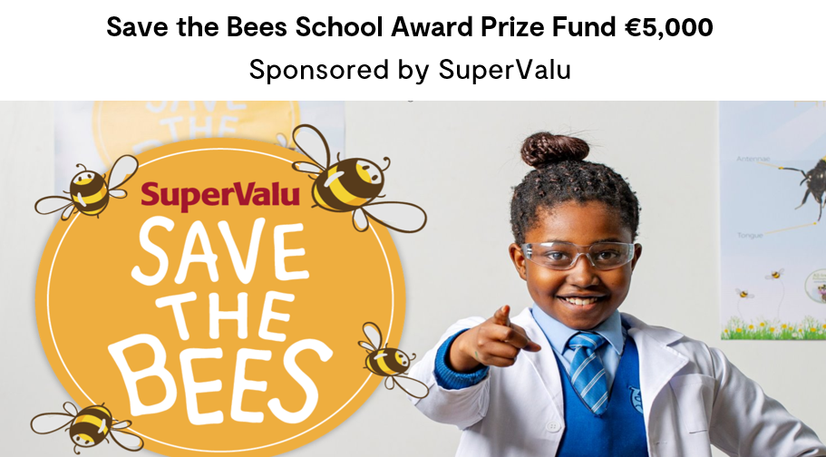
The Save the Bees School Award is an initiative by SuperValu which encourages schools to share what they have implemented in Biodiversity projects in their school.
This year SuperValu are looking for Primary schools that showcase the significant contribution to biodiversity projects developed in the school and to also share any future to further enhance this topic in the classrooms.
A finalist group from each of the four regions will be chosen, with each finalist group receiving €1,000. The overall winner will then receive an additional €1,000.
Entries to be sent to: savethebees@supervalu.ie, using this form. You can support your entry by sending in photographs.
ENTRY FORM
School Name:

School ID Number:

School contact Name:

School contact address:

School contact email:

Please enter text and or photos below:

