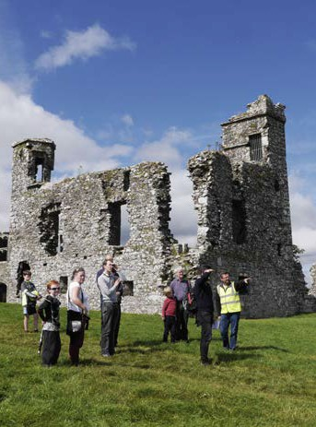
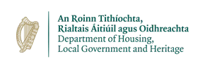
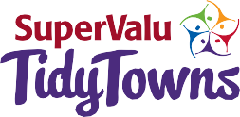
TIDYTOWNS
COMPETITION
2022
heritage award

application form

TIDYTOWNS COMPETITION 2022
heritage award
The Heritage Award, sponsored by the Heritage Council, seeks to promote a greater awareness of the value of heritage to social cohesion, wellbeing and sustainable economic development.
Passed on to us from previous generations, our heritage encompasses not just buildings, monuments and museum pieces, but also our distinctive landscapes, native wildlife and woodlands, seascapes, geology, heritage gardens and parks, inland waterways, folklore and crafts. The Heritage Council seeks to recognise those who work at local level to benefit an aspect
of our heritage and to promote its value to a wider audience.
Benefit: enjoyment, conservation and/or identification Promote: any action that communicates the value of heritage to a wider audience.

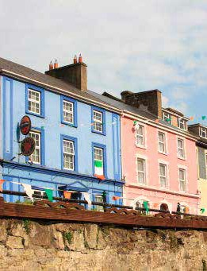
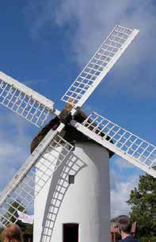
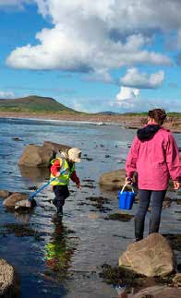
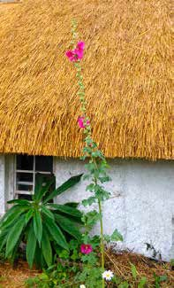
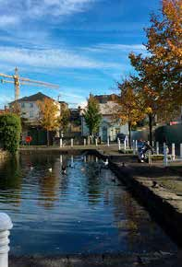
Projects not considered
- New buildings or modern refurbishment of older buildings.
- New public or commemorative sculptures.
- Amenity works and environmental improvements. This includes works such as seating, spot-lighting, landscaping, curbing, provision of rubbish bins etc.
•

On a separate sheet please provide information on the following:
- A short description of your project its aims.
- An outline of the community involvement.
- The long-term benefits of the project.
- How the project promotes the value of heritage to the wider community.
- If the project follows the principles of best conservation practice?
- If the project is part of a management plan or is generally well thought out?
- Please be sure to include 3-4 photographs of the project and clip or staple the photos to the application form. Maps locating the project are especially welcomed where relevant.
•

Completed Entry Forms should be returned by email to:
vkelly@heritagecouncil.ie

Closing date for entries: Friday 10th June 2022.

All entries will be assessed by a panel of judges appointed by the Heritage Council.

For more details
please consult www.heritagecouncil.ie or call 076 100 6938
or email: TidyTowns@drcd.gov.ie or check out www.tidytowns.ie

TidyTowns Competition Terms and Conditions apply as appropriate.

Nominated Project:

Name of Lead Person/Group in Project:

Specific Address/Location (where applicable):

Nominating Group/Person:

Contact Address:

Telephone:

Email:

Website (if applicable):

Please affix your photos here

