TidyTowns Special Awards 2022
The RIAI Good Windows Award

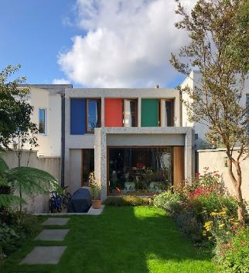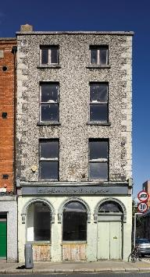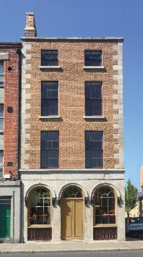
Window Examples: Left: Vavasour Square, RIAI Awards 2019, GKMP Architects, Photo: Alice Clancy.
Right: Dublin Civic Trust Offices, 18 Ormond Quay, Dublin. Dublin Civic Trust/Kelly & Cogan Architects. Photos: Ros Kavanagh (before) and Graham Hickey (after).

About the Award
The RIAI Good Windows Award is a Special Award to promote appropriate windows in Irish towns and villages. The streets of Irish towns and villages are composed of both historic and modern buildings. Well-kept historic windows and well-designed modern windows are equally valid.

Award Value
There is a prize of €500 for the town with the most appropriate windows as follows:
• An example of a well-kept historic window in an urban street
and
• An example of a good modern window or fully glazed opening in an urban street.

Who Can Apply
This competition is open to the Village, Small Towns and Large Towns categories.

How to Apply
In order to apply, the local TidyTowns committee will complete the entry form and submit photographs of two buildings which are located in a street and have appropriate windows.

The photographs should clearly show the building and the windows.

The awarding committee may share the award between more than one town as appropriate.

Please reply by completing this document and returning it with the photographs by email to communications@riai.ie, subject line: RIAI Good Windows Award 2022.

Closing Date
Friday 10 June 2022, 4pm. Please check the TidyTowns’ website www.tidytowns.ie for updates.

Judging the Award
All entries will be assessed by an RIAI jury. TidyTowns’ Competition Terms and Conditions apply as appropriate.

Useful References
https://www.riai.ie/work-with-an-architect/working-with-an-older-building
https://lambstongue.ie/workshop/histories
http://www.dublincivictrust.ie/learn/dublin-civic-trust-studies--reports
https://shop.igs.ie/products/windows-a-guide-to-the-repair-of-historic-windows
https://www.riai.ie/discover-architecture/architecture-galleries/georges-place
http://www.plusarchitecture.ie/swancastlewood.html
https://www.odosarchitects.com/work#/grangegorman/

Application Form for the TidyTowns RIAI Good Windows Award 2022
Name of Tidy Town or community group Main contact person’s name

Email: Phone No :

Tidy Towns Committee

Postal Address:

Address of Building with Historic Windows:

Address of Building with Modern Windows:

Please also include at least two photographs of each building/window as set out above.

