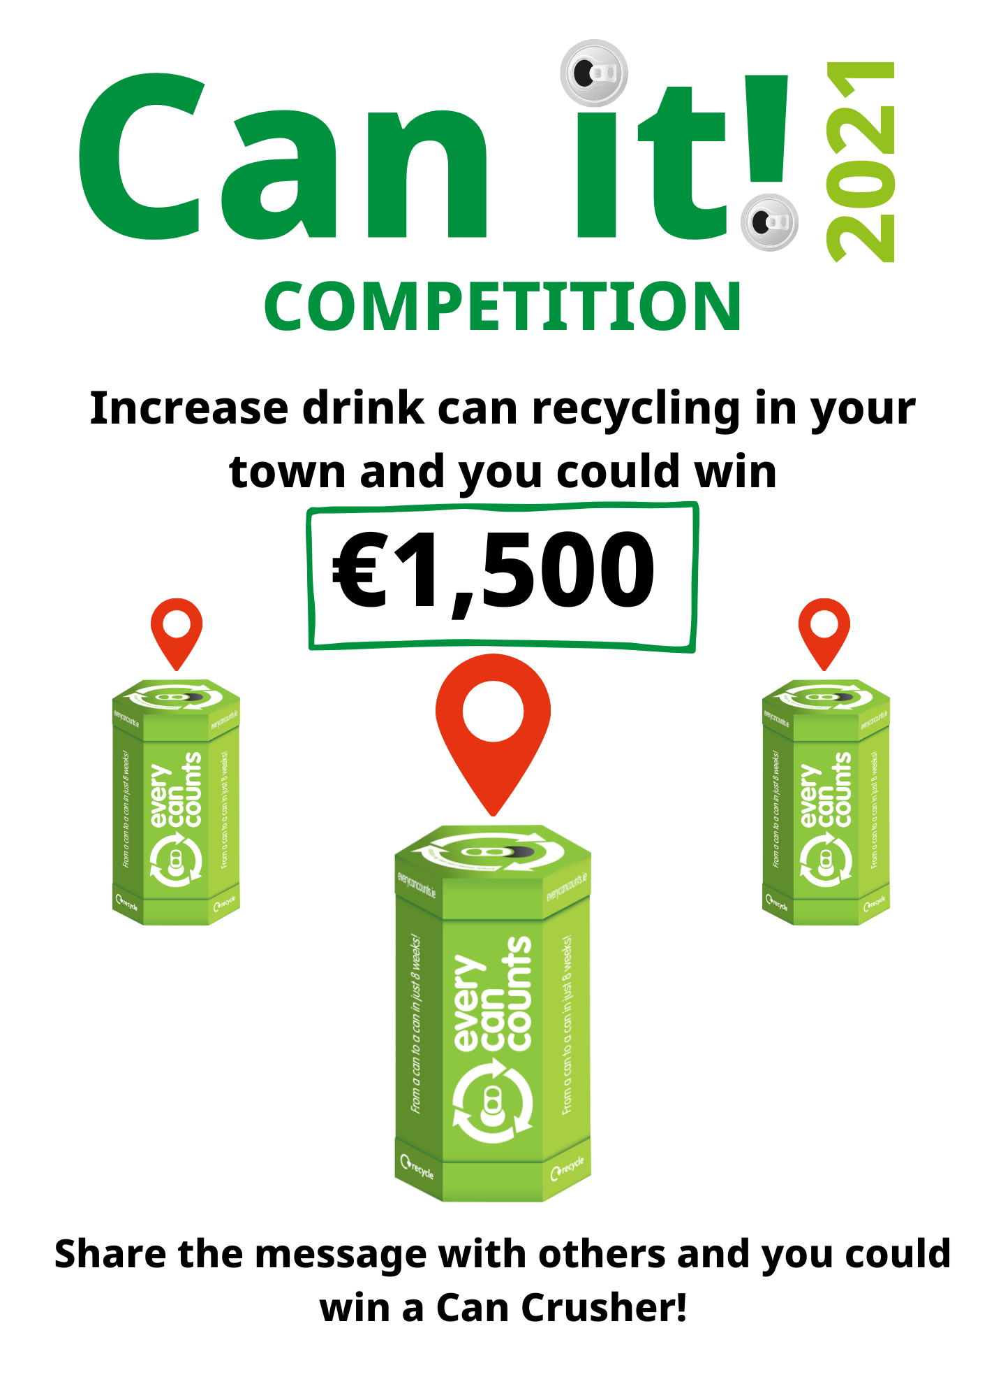

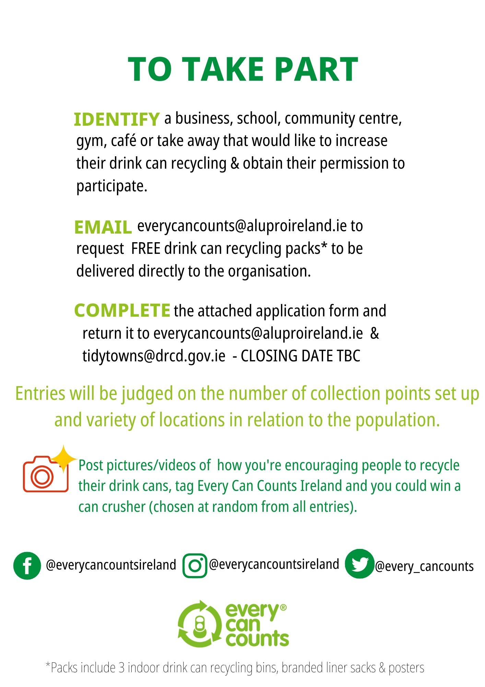

NAME: TIDY TOWNS GROUP:
ADDRESS:

PHONE: EMAIL:

POPULATION OF AREA:
HOW MANY DRINK CAN RECYCLING POINTS HAVE YOU SET UP?
LIST THE LOCATION AND POINT OF CONTACT FOR EACH LOCATION BELOW

Post photos on social media channels and tag Every Can Counts Ireland so we can share the great work you're doing and place you in a draw for some more great prizes.

I understand and agree to be bound by the rules of the Tidy Town competition

Signed ____________________________ Date _____________

