TidyTowns Special Awards 2021
The RIAI Town Challenge

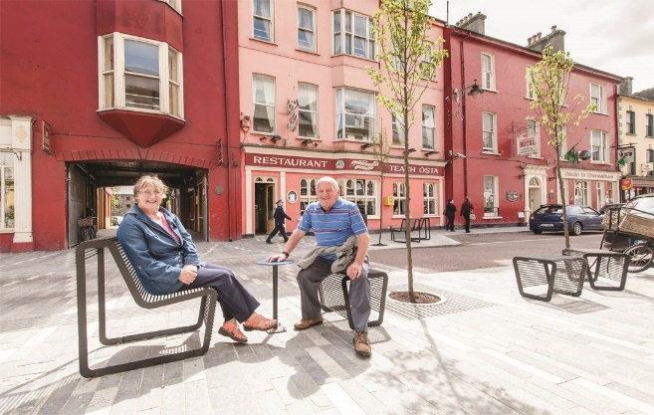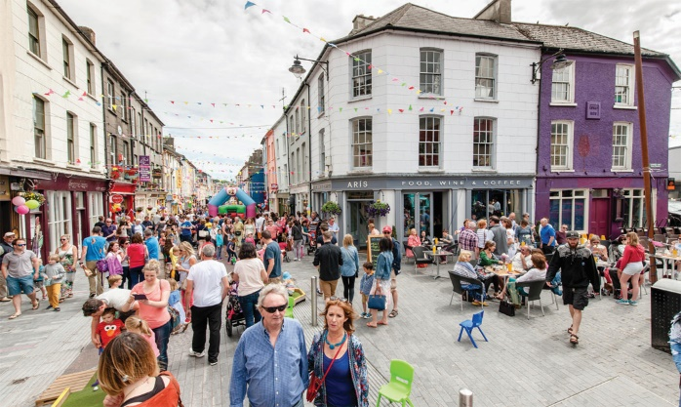
Left & right: Clonakilty, Winner of the RIAI Best Place Award (2017), Cork County Council Architects’ Department

The RIAI Town Challenge is a Special Award, designed to give a TidyTowns Committee practical support in form of architectural expertise in addressing a public realm problem in your town or village.
Registered Architects are trained to develop and deliver solutions for our built environment. If your town or village has difficulties for example with derelict sites, signage, lack of public space, traffic or parking issues, this RIAI Award will give you the opportunity to work with a Registered Architect to develop an urban design solution that can solve a problem and enhance your town or village.

The RIAI Town Challenge Special Award will provide the winning TidyTowns Committee with the expertise of a Registered Architect for up to 5 days and to a value of €5,000.

About the Award
The Royal Institute of the Architects of Ireland (RIAI) is providing the services of a Registered Architect to work with a local TidyTowns Committee to create a visionary urban design solution to a problem in your town. The award consists of an architectural commission.

The commissioned Registered Architect will provide an analysis of the problem as initially identified by the local TidyTowns Committee, in addition to developing a concept to address it. The commission will result in an illustrated Report, which will be made publicly available and a presentation to the local TidyTowns Committee.

This is an RIAI sponsored Special Award to promote good urban design in Irish towns and villages.

Award Value
The value of the award will be €5,000. The architectural commission will be awarded by the RIAI in accordance with criteria which will include relevant skills in urban realm design.

Who Can Apply
This competition is open to the Village, Small Towns and Large Towns categories.

How to Apply
Please reply by completing this document and returning it electronically or submitting by email to TidyTowns@drcd.gov.ie, subject line: RIAI Town Challenge.

Closing Date
The closing date for the RIAI Town Challenge is 23 July 2021 at 5pm.

Judging the Award
All entries will be assessed by an RIAI jury. TidyTowns’ Competition Terms and Conditions apply as appropriate.

Useful References

https://www.riai.ie/whats-on/news/creating_places_for_people_riai_town_and_village_toolkit
https://www.heritagecouncil.ie/content/files/Ballybrilliant.pdf
https://www.heritagecouncil.ie/advice-and-guidance/renewing-your-historic-town-or-village
https://www.heritagecouncil.ie/ga/projects/podcast-series-putting-town-centres-first

Application Form for the TidyTowns RIAI Town Challenge 2021
Name of TidyTowns or community group Main contact person’s name

Email: Phone No :

Postal Address:

- What opportunities do you see for improvement in your town or village?

- What problems relating to public realm and the built environment are evident
in your town or village?

- Are there any Local Area, Development or other Plans in place for your town
or village?

4. Are there any traffic management and parking control plans in your town or village?

Please submit your description on one A4 page (please note that additional text will not be considered) and include photographs or video to illustrate your description.

