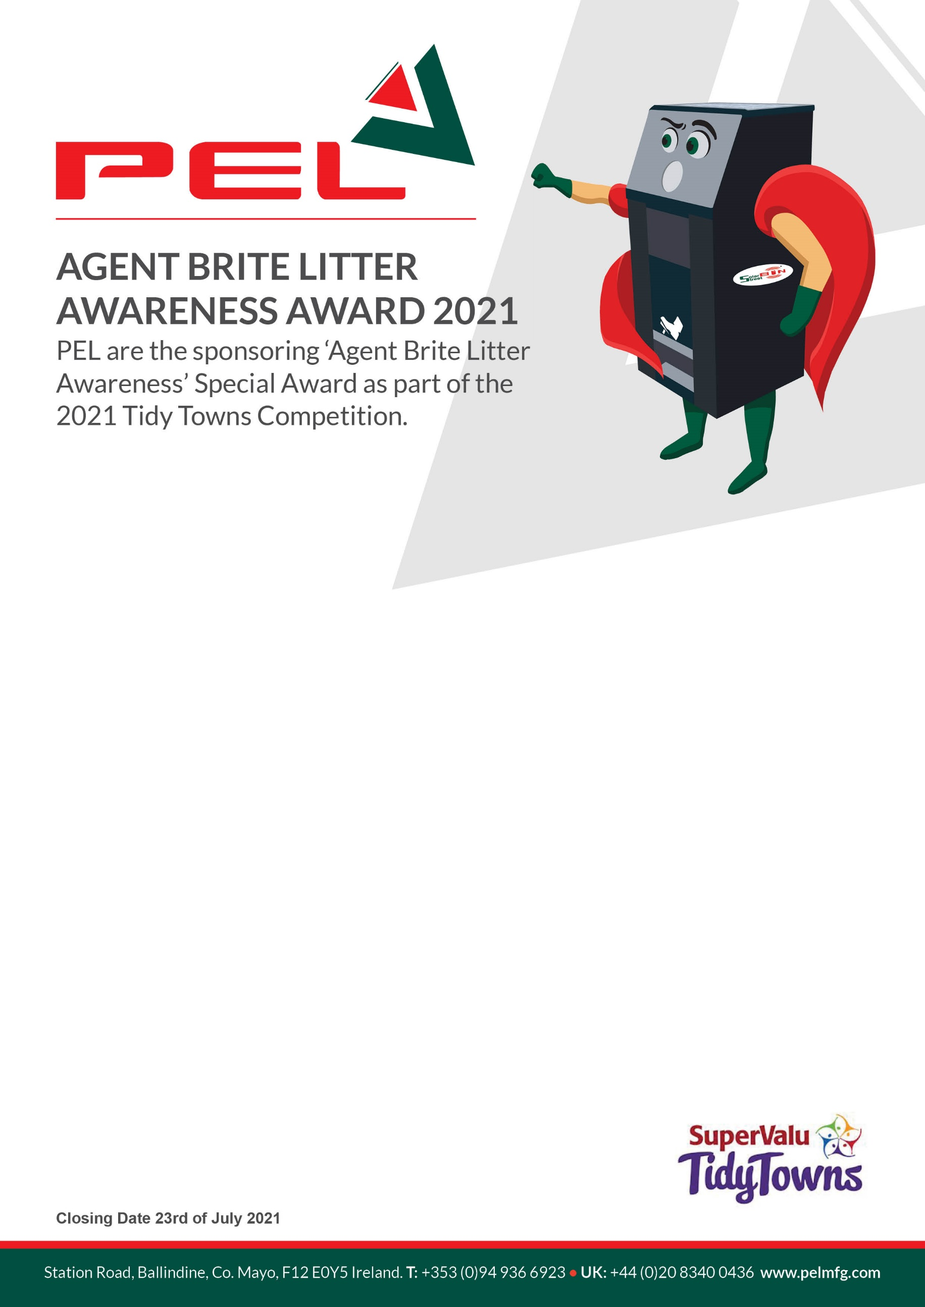

ENTRY FORM
Entry by email only - Please return your completed application form to tidytowns@drcd.gov.ie
TOWN NAME:
FULL ADDRESS:
POINT OF CONTACT: PHONE:
EMAIL:
TOWN POPULATION: NO. OF LITTER BINS IN TOWN:
LITTER BIN COLLECTION FREQUENCY: DAILY □ WEEKLY □ BY-WEEKLY □ MONTHLY □

WHY DOES YOUR TOWN DESERVE TO WIN THE ‘AGENT BRITE’ AWARD (250 words max)

