Waters and Communities Award

TidyTowns Competition 2021

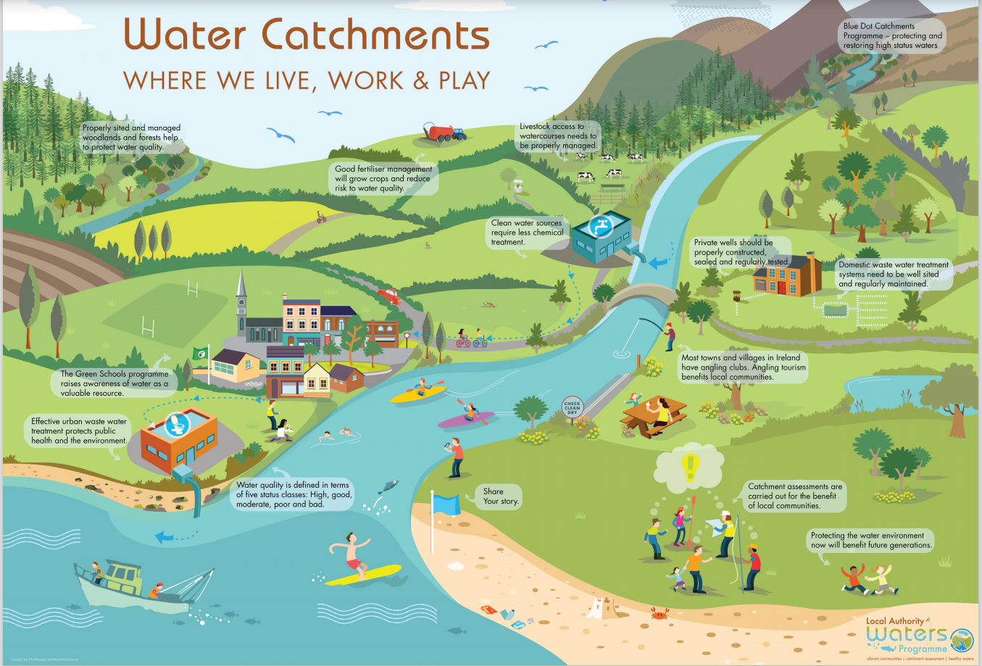

*Community groups can play a vital role in the protection and improvement of our natural water environment. Together, we can protect our waters for future generations to enjoy.*

**Please stay safe while working close to water and adhere to Covid-19 restrictions**

**For more information see:**

<http://www.iws.ie/>

https://www2.hse.ie/coronavirus/

This competition is open to community groups who have shown an appreciation for their water environment and water heritage by undertaking innovative initiatives or projects during Covid-19.

**Waters and Communities Special Award Prize Fund 2021**

Four Regional Award Winners Four Regional Runner Up Award Winners  
 €1,000 each €500 each  
  
 *There will also be an additional prize of €1,000 for the overall winner of the four regions*

The Waters and Communities Award is run in conjunction with the SuperValu TidyTowns competition

Closing Date: 23 July 2021

See [www.tidytowns.ie](http://www.tidytowns.ie) for more details about the main awards or other special awards

**Background to the Waters and Communities Award**

The Waters and Communities Special Award was first introduced in 2017 and did not run in 2020 due to Covid-19. The award is to recognise communities who are taking positive steps towards raising awareness and showing appreciation of their local rivers, lakes, streams, canals and coast. The Award is sponsored by Inland Fisheries Ireland [www.fisheriesireland.ie](http://www.fisheriesireland.ie) (responsible for the protection, conservation and promotion of Fisheries); Waterways Ireland [www.waterwaysireland.org](http://www.waterwaysireland.org) (responsible for the management of inland navigable waterways) and the Local Authority Waters Programme [www.watersandcommunities.ie](http://www.watersandcommunities.ie) (working with communities to get involved in the management of natural waters).

|  |
| --- |
| **Application Form for the TidyTowns Waters and Communities Award 2021**  ***(only projects or initiatives carried out during the Covid-19 pandemic in 2020 and in line with Covid-19 restrictions will be considered)***  Name of TidyTown or other community group Main contact person’s name    Email: Phone:  Postal Address: |
| 1. **Awareness Raising (15 Marks)**   Please demonstrate how your community group has helped raised awareness of your local water body (eg. clean up, development of amenity area(s), water heritage projects, biodiversity projects such as signage, information leaflets, habitat surveys, bird boxes, outdoor classrooms, developing of safe access, control of invasive species, instream measures, promotion of angling etc). *Max 200 words.* |
| 1. **Community Involvement (20 Marks)**   Please outline how your project involved the wider community? (eg. did you work with schools, landowners or other groups?). *Max 100 words.* |
| 1. **Stakeholder Engagement (15 Marks)**   Did you engage with your Local Authority or Local Development Company or any public agencies in developing your project? If so, please provide details. *Max 100 words.* |
| 1. **Project Benefits (40 Marks)**   Please outline the long-term benefits of your project to the environment and local community.  *Max 200 words.* |
| 1. **Lessons Learned and Plans for the Future (10 Marks)** *Max 100 words.* |

**Judging the Award**

All entries will be assessed by a panel of judges appointed by Inland Fisheries Ireland, Waterways Ireland and the Local Authority Waters Programme. The panel of judges reserve the right to contact you to clarify any details submitted.

|  |  |
| --- | --- |
| How to Apply: | Please type in this document and return it by email to [tidytowns@drcd.gov.ie](mailto:tidytowns@drcd.gov.ie)  Type ‘Waters and Communities Awards’ in the subject box.  Photographs to accompany your application are welcome. |

TidyTowns Competition Terms & Conditions apply as appropriate.

By entering this competition, you are giving permission to the sponsors to use information provided for any promotional purposes.

**Closing date: 23 July 2021**

**See** [**www.tidytowns.ie**](http://www.tidytowns.ie) **for details of the main competition and other Special Awards**

|  |  |  |
| --- | --- | --- |
| |  |  | | --- | --- | | cid:image005.png@01D4DE3D.10FA2FB0 | [https://encrypted-tbn2.gstatic.com/images?q=tbn:ANd9GcT3-30_vV20-aUvi1SfNd7QytKUUdp0mLHJOWntxcG6kq12Fktc0MPm9Muv](https://www.google.ie/url?sa=i&rct=j&q=&esrc=s&source=images&cd=&cad=rja&uact=8&ved=0ahUKEwjG3deeu4PSAhUoCMAKHZxIBY4QjRwIBQ&url=https://en.wikipedia.org/wiki/Tidy_Towns_(Ireland)&psig=AFQjCNE6O_QytkIIdIgH2gUTjT--tKZVsw&ust=1486745102083734) | |