LEAVE NO TRACE IRELAND TIDYTOWNS SPECIAL AWARD 2021

About the Leave No Trace TidyTowns Special Award
Now in its second year, the Leave No Trace TidyTowns Special Award recognises communities for their significant efforts to protect and enhance the natural environment and the promotion of responsibility in the outdoors. Through recognising these communities, Leave No Trace Ireland seeks to inspire other communities to take extraordinary actions to protect and promote responsible outdoor recreation.
The Award is sponsored by Leave No Trace Ireland whose mission is to promote and inspire responsible outdoor recreation through education, research and partnerships. Leave No Trace Ireland is a Company Limited by Guarantee (465628) and a Registered Charity (20082178).
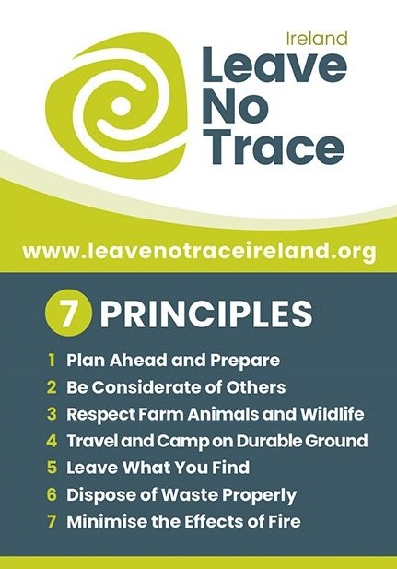
Apply today and tell us what your group has achieved from June 2019 to May 2021.
The Prize
Leave No Trace Ireland are offering educational training to the value of €1000 for the winning community group.
The educational training includes a Leave No Trace Outdoor Workshop where a Leave No Trace trainer will bring our outdoor classroom to your community. The event will deliver short interactive activities and the Trainer will coordinate a key action for the community area. This action can include a clean-up, pollinator planting, invasive species removal and will be discussed with the winning community. The prize includes promotion across social media of the event. In addition, the winners will receive a specially designed sign for their community to erect in the local park or amenity with the Leave No Trace Ireland Principles.

Examples of initiatives include but are not limited to:
- Efforts to transition to sustainable events
- Nature conservation projects/plans
- Use of technology to provide a local solution to an outdoor recreation problem
- Improvements to local biodiversity
- Youth project promoting the Leave No Trace 7 Principles
- Educational campaigns spreading the Leave No Trace message. These can include biodiversity, littering or community involvement to name a few
- Responsible dog ownership campaign
- Development of a new outdoor recreational area or activity encouraging responsibility in the outdoors

You don’t need to develop a new project to apply, you most likely have projects entered in the main competition already. For example: Efforts to transition to sustainable events could be one of your projects in the category “Sustainability: Doing more with less”. Similarly, Nature Conservation projects could already be included in the Biodiversity Category of the main competition. Take a look at all the activities your TidyTowns committee have completed since June 2019, or perhaps another group in your community that are doing great work following the Leave No Trace principles.

Great reasons to enter this year to the Leave No Trace TidyTowns Special Award
- The Leave No Trace TidyTowns Special Award is open to communities of all sizes from the very small to the very large
- Boost your community’s morale and gain valuable coverage of the great work taking place
- Win educational training up to the value of €1,000 for your community
- Be honoured by receiving the coveted Leave No Trace TidyTowns Special Award

Submit your application and be a part of the most recognised community event in Ireland!

How can you enter?
- Complete the attached application form, outlining in 2,000 words or less, how Leave No Trace is promoted in your community. Give brief details of projects or campaigns completed highlighting awareness of the Leave No Trace Ireland and the 7 Principles.
- We are accepting one application per community and this should come from the official TidyTowns Group.
- Your application can include photographs but please keep the image size small.
NOTE: Your completed application form will be marked out of 100.

Closing Date
To be confirmed, please check the TidyTowns’ website www.tidytowns.ie for updates

Entry by email ONLY
TidyTowns@drcd.gov.ie

Leave No Trace Ireland TidyTowns Award 2021
Entry Form
Section A
Name of TidyTowns Committee and County:
Contact name and phone number:
Email address:
Postal Address:
Population of your town:
Data Protection
I confirm that my contact details as above may be used in communications relating to the Leave No Trace Ireland Tidy Towns Award. Any personal information which I provide in this way is not made available to any third parties, save as required by law, and is used only in line with the purpose for which I provided it. Any personal information which I provide will be treated in accordance with the General Data Protection Regulation.
Please tick your consent to process your data for this application
Please tick your consent here if you wish to receive updates from Leave no Trace Ireland

Section B
1. Outline what actions have been taken in your community to raise awareness of the Leave No Trace Ireland principles in outdoor areas or events. (30 marks)

2. Outline how your committee engaged other organisations in the community i.e., business, volunteers to deliver the above actions. (20 marks)

3. What impact have your activities promoting the ethos of Leave No Trace in your community had on the local environment? How has your community promoted this? (30 marks)

4. Briefly highlight any future plans you have to incorporate Leave No Trace Principles in your community. (20 marks)

