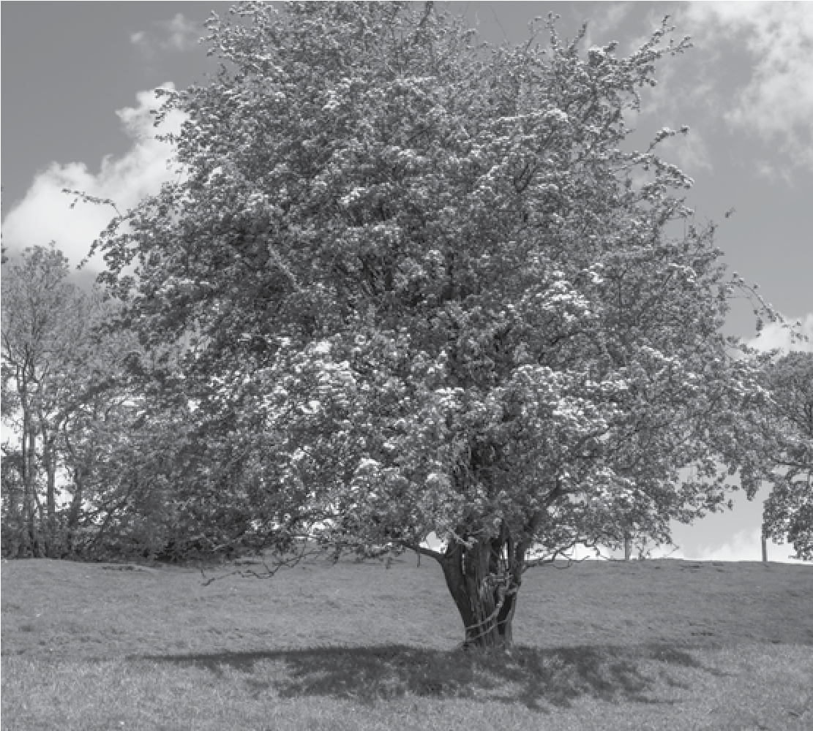
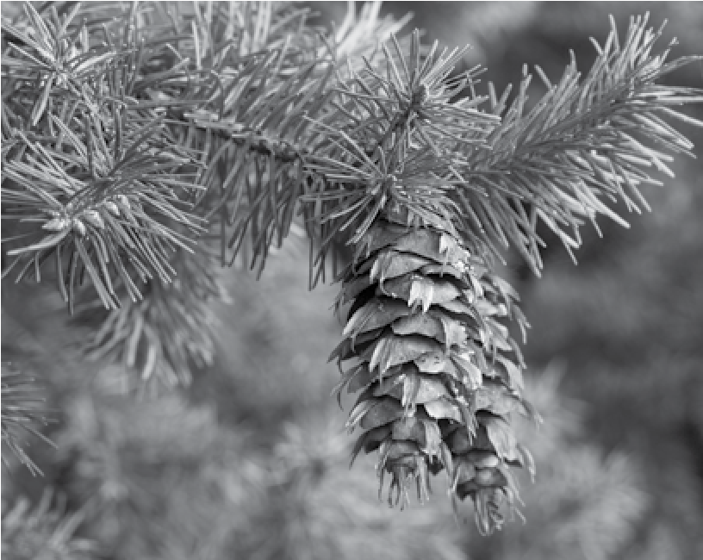
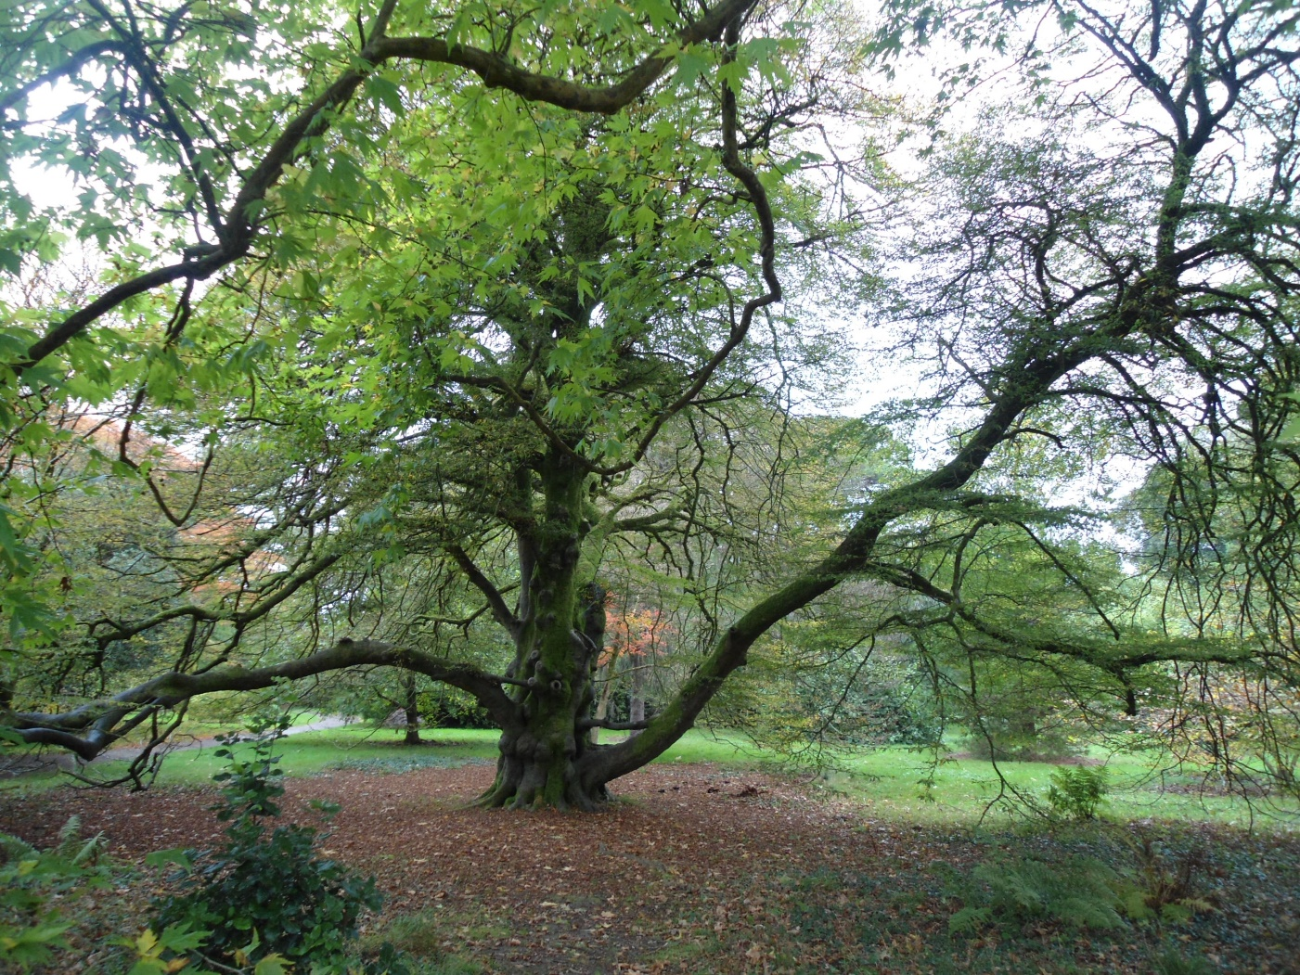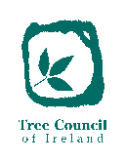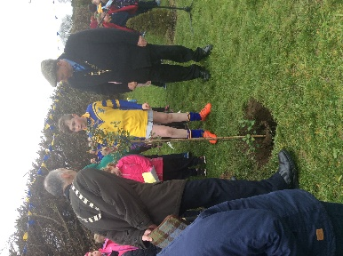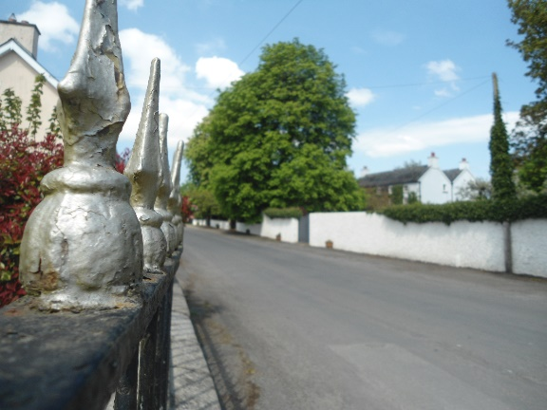

The TidyTowns Tree Project Award is a special competition sponsored by the Tree Council of Ireland. This award recognises the huge impact that properly positioned trees can have in a town or village along with the whole visual enhancement of the area. The importance of having the right tree in the right place. For example, planting a series of fast growing trees for instant effect could have long term implications for footpath or street management.
It is essential, therefore, that careful thought is put into not only the planting but also the management of the trees over their life-span. This award also seeks, where appropriate, to raise awareness and promote initiatives to enhance the protection of old and established trees that are of natural, historical, cultural, and botanical or landscape significance within a community.
Such trees may include those listed in the Tree Council of Ireland’s Register of Heritage Trees. The following criteria will be considered for the award:
• Trees must be in a public place, street, open spaces, school and/or church grounds;
• The trees may be existing or newly planted;
• If new trees, they must be appropriate to the site, i.e. species or cultivar suitability, shape, size, colour;
• Trees must be located well within the site;

Nominated Area:

Specific Location:

Project Leader: (person/group/local authority, etc.):

• Trees must be well maintained i.e. watering, weed control, staking, tree ties etc., tree guards (if necessary), appropriate surgery carried out where necessary;
• A clear plan for renewal of older trees should be in place;
• The project should contain an element of awareness raising about trees within the community. A certificate and a prize of €1,000 are awarded to the TidyTowns Committee which has demonstrated the highest tree placement and maintenance standards.

To enter the Tree Project Award, complete the entry form and attach details of the project under the headings:
Site Description, Project Description (include details of tree species, sizes, nos., suitability for the site and works undertaken etc.), Activities to Raise Community Awareness of Your Tree Project, Contribution of your Tree Project to the Community and to the Physical Landscape of your Town or Village.
Include at least 3 photographs of the area to be considered which illustrate the context of the project. Entries should be forwarded to:
The Tidy Towns Unit
Department of Rural & Community Development
Government Offices
Ballina
Co. Mayo.
F26 E8N6
For more details, please consult www.treecouncil.ie

Short description of what work has been done on your project in the last 12 months:

Nominating Group/Person:

Contact Address:

Phone no:

Email:

TidyTowns Competition Terms and Conditions apply as appropriate.
Closing Date is Friday May 17th, 2019

