RIAI Town Challenge
Tidy Towns Competition 2019

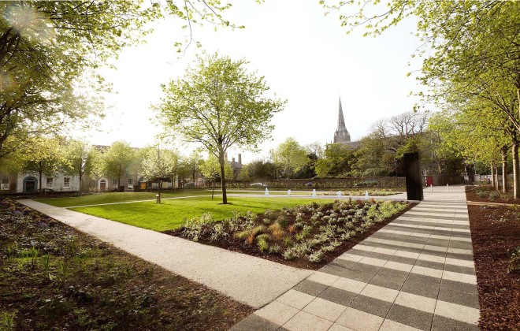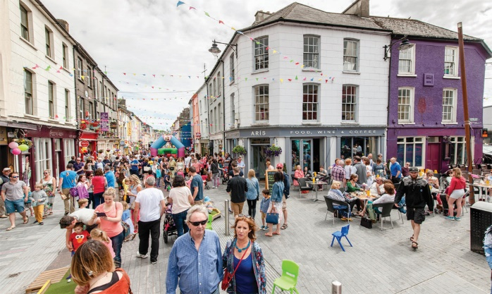

The RIAI special award is designed to give a Tidy Towns Committee help in addressing a public realm problem in your town or village.

If your town or village has difficulties with derelict sites, signage, lack of public space, traffic or parking issues, etc, the RIAI Award will give you the opportunity to work with an Architect to develop exciting new solutions which can create a new vision for your town or village.

Architects are trained to develop and deliver solutions for our built environment and this RIAI Award will provide the winning Tidy Towns committee with the expertise of an architect for up to 5 days.

The quality of the urban environment is central to our lives. Quality of place contributes to the wellbeing of all who live, work and visit our villages and towns. Each town its own unique characteristics, which should be valued and celebrated. Well planned and executed urban design, is a means to improve our environment for all to enjoy
About the RIAI Town Challenge Award
This competition is open to the small and large towns categories, with populations from 1,001 to 15,000

The Royal Institute of the Architects of Ireland would like to offer the services of an architect to work with local committees to create a vision for their town. To apply let us know about the problems that affect your town. For more details see www.riai.ie

The award will consist of an architectural commission. The commissioned architect will provide an analysis of the problems associated with the public realm as initially identified by the local Tidy Towns committee, in addition to generating ideas on how to address them. The commission will result in a report, which will be made publicly available, and a presentation to the local Tidy Towns committee.

The value of the award will be €5,000. The architectural commission will be awarded by the RIAI in accordance with criteria which will include relevant skills in urban realm design.
Application Form for the Tidy Towns RIAI Town Challenge 2019
Name of Tidy Town or community group Main contact person’s name

Email: Phone No :

Postal Address:

- What opportunities do you see for improvement in your town or village?

- What problems relating to public realm and the built environment are evident
in your town or village?

3. What current or former Local Area or Development or other Plans are in place for your town or village? What is the current status of these Plans

4. Are there any traffic management and parking control plans in your town or village?

Applicants may wish to view the newly launched RIAI Town Toolkit for information purpose when preparing their applications.
Please submit your description on one A4 page (please note that additional text will not be considered). Please include photographs or video to illustrate your description.

Judging the Award
All entries will be assessed by an RIAI jury.

How to Apply: | Please reply by writing/typing in this document and returning it electronically or submitting by post.
Email: tidytowns@drcd.gov.ie | Please insert “RIAI Town Challenge” in the subject line.
By Post to: | TidyTowns RIAI Town Challenge  TidyTowns Unit  Department of Rural and Community Development  Government Offices  Ballina  Co. Mayo  F26 E8N6.

TidyTowns Competition Terms and Conditions apply as appropriate.
Closing date: 17 May 2019

