RIAI Appropriate Fenestration
Special Award 2019

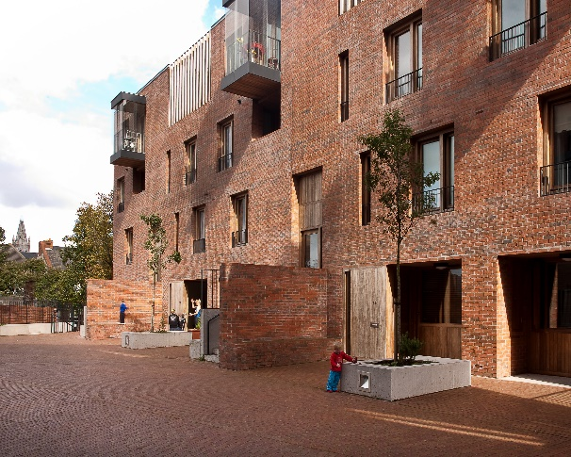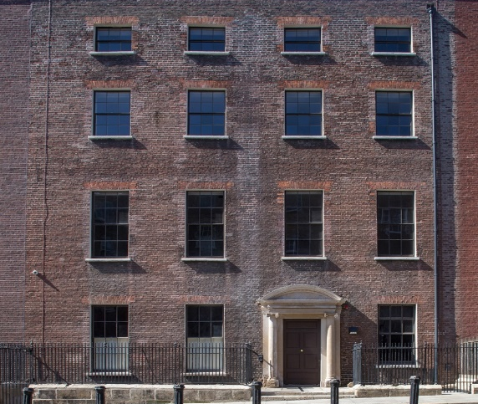
From LR: Timberyard Social Housing – O'Donnell + Tuomey, Photo Credit Alice Clancy;
No 14 Henrietta Street, Tenement Museum Dublin by Shaffrey Architects 2018 RIAI Architecture Award Winner: Conservation / Restoration and the Special Jury Award
The RIAI Appropriate Fenestration special award is designed to reward the town or village with the most appropriate windows in an urban context.

This is a new RIAI sponsored, special award to promote appropriate windows in Irish towns and villages. The streets of Irish towns and villages are composed of architecture from differing periods, with both historic and modern buildings. Depending on local context, both conservation of historic windows, and well-designed modern windows are equally valid, with both approaches likely to be necessary in any urban environment.
This competition is open to is open to the Village, Small Towns and Large Towns categories

There is a prize of €1,500 for the town with the most appropriate fenestration in an urban street context.

The submittal will consist of photographs of the buildings, showing all of the buildings in a chosen, single, street. The awarding committee may share the award between more than one town as appropriate.

Application Form for the Tidy Towns RIAI Appropriate Fenestration Award 2019
Name of Tidy Town or community group Main contact person’s name

Email: Phone No :

Postal Address:

- Please identify the street which is the subject of the application

Please submit a photograph of each building on the street to illustrate your application.

Judging the Award
All entries will be assessed by an RIAI jury.

How to Apply: | Please reply by writing/typing in this document and returning it electronically or submitting by post.
Email: tidytowns@drcd.gov.ie | Please insert “RIAI Appropriate Fenestration Award” in the subject line.
By Post to: | TidyTowns RIAI Appropriate Fenestration Award  TidyTowns Unit  Department of Rural and Community Development  Government Offices  Ballina  Co. Mayo  F26 E8N6.

TidyTowns Competition Terms and Conditions apply as appropriate.
Closing date: 17 May 2019

