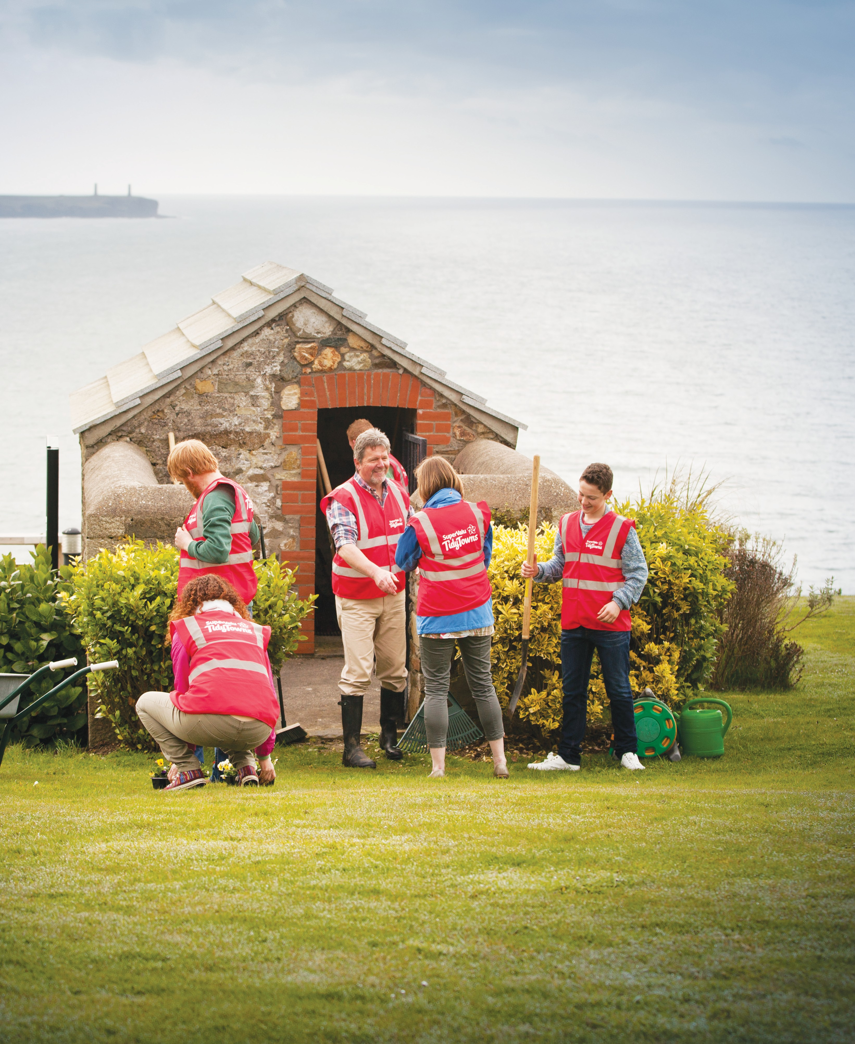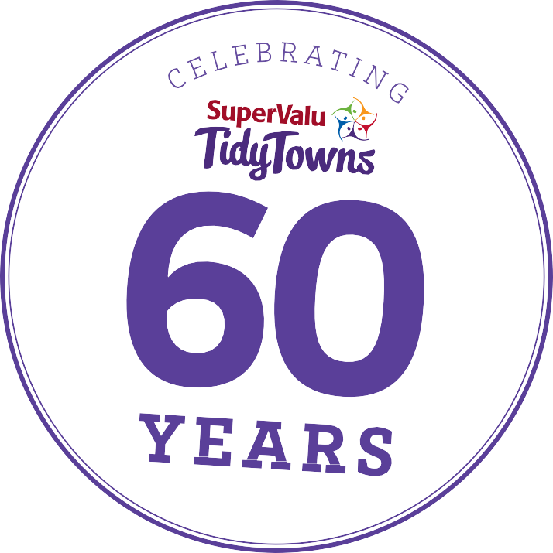

SuperValu TidyTowns Entry Form 2018
Your pack includes:
- A welcome message from Minister Michael Ring and Martin Kelleher Managing Director, SuperValu
- Entry Form with Special Awards Information
- Terms and Conditions

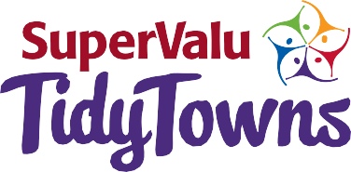
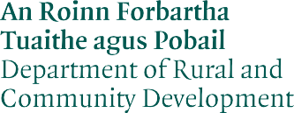

How to complete your SuperValu TidyTowns Entry Form

The following notes are intended to assist TidyTowns Committees in the completion of the 2018 Entry Form.

Adjudication Period:
The adjudicator will examine new or continuing projects which have been completed between 1st June 2017 and 31st May 2018. Adjudications commence in June and are completed by mid August.

Clarity of information:
This may be the adjudicator’s first visit to your town or village so please ensure that your entry form and especially the map are very clear. Pay close attention to clearly showing your TidyTowns adjudication boundaries.

Identifying Projects:
Please number each new or continuing project for 2018 on your Entry Form under the correct category. These numbers should be shown on the legend to the town or village map where relevant. If you have no new work in any adjudication category please do not leave that category blank, just state ‘no new work for this year’. If any adjudication category is left blank this may affect marks under the Community - Your Planning and Involvement adjudication category.

Size of the entry:
Marks are awarded for the quality of your entry form.
The form should be concise and should clearly reference new works undertaken since June 2017. With regard to your new or continuing projects, identification and location details are important. Accordingly please ensure that;
  - The location of each separate project is marked on the map where this is appropriate. Obviously, this requirement may not apply to some items - for example survey work.
  - Provide a brief description of the project with appropriate details.
  - Indicate when the work started and when it finished, or the proposed completion date for on-going or long-term projects.

Your Map
A good town or village map is essential to your entry. A hand-drawn map is perfectly acceptable if a formal printed map is not available or suitable. The map should be of a manageable size, A4 or A3 depending on the layout of your town or village. On the map please name all streets and roads as necessary and mark the key public buildings and landmarks. You are advised not to use Google mapping as this is often unclear/inaccurate. You may find the Ordnance Survey Ireland Urban (or Rural as applicable) ‘Place’ Maps most useful. A clear legend is an essential part of a map and you are recommended to include a legend on the map sheet itself. When numbering projects, your first project under Streetscape & Public Places should be numbered 1, and carry this numeric sequence into subsequent categories.
Numbers should not be replicated. Failure to include an adequate map may affect marks under the Community - Your Planning and Involvement adjudication category.

Back-Up Information
Backup information should be as concise as possible and should only relate to this year’s entry. All additional
information should be clearly referenced to the appropriate category in the entry form. Do not use ring binders as these can come apart. ‘Poly-pocket’ file folders are acceptable.
Do not laminate additional documents as this prevents an adjudicator making notes on these pages. Adjudicators may not always be able to refer to websites or social media for further information. We recommend you do not include loose documents or photographs with your application but if you do, mark them all clearly with village or town name and the date of when the photograph was taken.

Photographs
Photographs can be of great assistance to your adjudicator. Before and after photographs are helpful, just a pair of photographs of each new project is recommended. If you are including photographs we recommend you use the Word version of the entry form, with the photographs electronically inserted under the appropriate category.

Submitting your Entry Form
You can submit your TidyTowns entry using either this Entry Form booklet or the electronic format Word document available on www.TidyTowns.ie. Use one version only.
If submitting material in addition to this entry form please post your entire entry in one envelope.
The inclusion of CDs/DVDs etc. is not recommended.

Special Awards
Details of all the Special Awards and how to enter them are included at the end of this booklet. Please do not insert Entry Forms to the Special Awards into your TidyTowns Entry Form as these are separate competitions and are judged by the Special Awards sponsors. They can, of course, be posted in the same envelope. If you have entered one or more of the Special Awards which is relevant to a TidyTowns category you should also record this as a project on your TidyTowns Entry Form.

Closing date
It is important that completed Entry Forms are posted to reach the TidyTowns Unit before the closing date of May 23rd, 2018. Late Entries or additional material sent after that date may not be accepted once adjudication has commenced. A copy of the competition Terms & Conditions are contained in your TidyTowns Pack.

Completed Entry Forms should be returned to: TidyTowns Unit,
Department of Rural and Community Development, Government Offices,
Ballina, Co. Mayo, F26 E8N6

Closing Date Wednesday 23rd May 2018

About You!
Name of your Town / Area / Village / Island

County Select your Region* Midlands & East, North West & West, South West & Mid-West, South East Last Year of Entry Organisation Name Contact Name Address

Estimated Location
Your adjudicator may not have visited your area before so please describe briefly where your town or village is located within your county, e.g. Xkm north/south etc. of the nearest large town, or give the road number along which your town is situated. Absolute clarity is of key importance.

Phone Email Internet or Social Media address

Population Category

*See list of counties per Region at no.15 of Terms & Conditions enclosed.

Please tick your population category and enter your actual population (based on the latest census). If you are unsure please check with the central statistics office, www.cso.ie or your Local Authority. Your adjudicator may check you have entered the correct category.
Please enter your actual population here e.g. 19,999 Prize Category Population

Village A (Under 200)
B (201 to 1,000)
Small Town C (1,001 to 2,500)
D (2,501 to 5,000)
Large Town E (5,001 to 10,000)
F (10,001 to 15,000)
Large Urban Centre G (15,001 to 25,000)
H (25,001 and over)

By signing below, I understand and agree to be bound by the terms and conditions of SuperValu TidyTowns and agree to our details being released to; INWK Printers, Railway House, The Waterways, Sallins, Co. Kildare for the purpose of posting invitations, entry forms, results books or other documentation for the purpose of organising and promoting the SuperValu TidyTowns Competition and other related initiatives and also to the TidyTowns Adjudicators as part of the Entry Form upon which their adjudication is based.

Signed (on behalf of entrant) Date

Community - Your Planning and Involvement 60 Marks
Marks are awarded for the overall quality of the Entry Form, town/village map and appropriateness of backup material submitted with your entry. Other key issues are the participation of the local community, businesses, schools and youth in general; working partnerships with local civic agencies; works carried out and appropriate projects completed; existence of an achievable updated TidyTowns Plan. Consideration will be given to social inclusion, whole of community approach, the role of volunteers and new residents in activities.

Please indicate:
Number involved in your Committee: Number not on committee but who volunteer:
Please indicate the level of voluntary commitment (number of TidyTowns meetings, community meetings, general involvement of the community, new residents, etc.):

Please list all of the agencies, bodies and businesses that have supported your activities through sponsorship, resources, funding, advice, etc.

How do you communicate with your community (newsletter, newspapers, public meetings, email, social media, website)?

How do you engage with your local schools, youth clubs, etc.? How do you involve youth in your work, do you have a Junior TidyTowns, is there youth representation on your committee?

Identify any specific project where particular effort was applied since June 1st, 2017. (This can include ongoing maintenance work or new project)

Approximately how many years has your community entered the competition? How has your community benefited from involvement in the competition?

Please summarise how you see your group’s work contributing to the development of your community.

Streetscape & Public Places 50 Marks
Buildings: Conservation and presentation of heritage buildings and quality of shop-fronts will be considered, taking account of the design, sustainability, accessibility, usability and suitability of new structures or civic amenity buildings for all people, regardless of age, size, ability or disability. Please highlight the efforts made to address derelict sites and unoccupied buildings even if unsuccessful.
Public Spaces: Consideration will be given to; squares, parks, streetscape, paving, landscaping and street furniture mindful of sustainability and access for all. Condition of street lighting, building facade lighting, appropriately designed signage and way-finding relating to streets and place nameplates. Attention will be given to the presentation of parking locations, historical trails, walkways and access points to local amenities
or facilities and the general use of the Irish language.

Please refer to Note 3 on Page 1 and state if you have entered a Special Award relevant to this category.
List projects undertaken since June 1st, 2017 including, new projects (N) completed this year, previous projects that you have improved or maintained (M) and future projects (FP) you are proposing to develop.
It would be helpful if you could number your project descriptions and include date project was initiated and completed, where applicable. Note: Please ensure all priority projects are uniquely referenced on your map and legend using the reference numbers assigned below.

Green Spaces and Landscaping 50 Marks
Communities should demonstrate the following: The planning, design and management of green spaces. The Selection and appropriate siting of trees and their ongoing maintenance, including formative pruning,
watering and attention to the stakes and ties. Presentation of landscaping of all entrances to your town/village/ locality in consultation with your local authority, where appropriate. The use of suitable plants for hedges
and shrubs for year round effect is important as is the siting of seasonal bedding schemes where you wish to highlight important areas. The use of plant containers can provide impact where it is not possible to plant directly into the ground. To reduce maintenance tasks limit the use of containers. To demonstrate the year
round impact of the landscape works in your community, you are encouraged to provide dated photographs of, for example, daffodil schemes which are not evident in summertime.
Please refer to Note 3 on Page 1 and state if you have entered a Special Award relevant to this category.
List projects undertaken since June 1st, 2017 including, new projects (N) completed this year, previous projects that you have improved or maintained (M) and future projects (FP) you are proposing to develop. It would be helpful if you could number your project descriptions and include date project was initiated and completed, where applicable. Note: Please ensure all priority projects are uniquely referenced on your map and legend using the reference numbers assigned below.

Nature and Biodiversity in your locality 50 Marks
Show your understanding and awareness of nature and biodiversity in your locality. This may include protected areas and/or areas important for conservation e.g. waterways, field boundaries, coastal features etc.
Show an appreciation of how your local species and habitats should be best managed and protected. Evidence of co-operation with expert groups and relevant authorities, especially in carrying out work in sensitive areas is desirable.
Please refer to Note 3 on Page 1 and state if you have entered a Special Award relevant to this category.
List projects undertaken since June 1st, 2017 including, new projects (N) completed this year, previous projects that you have improved or maintained (M) and future projects (FP) you are proposing to develop. It would be helpful if you could number your project descriptions and include date project was initiated and completed, where applicable. Note: Please ensure all priority projects are uniquely referenced on your map and legend using the reference numbers assigned below.

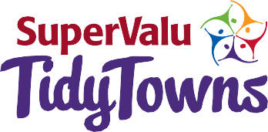

Sustainability - Doing more with less 50 Marks
Describe how your activities help to make your centre more sustainable and reduce your environmental impact. For example, consider how you use your resources (e.g. methods or materials you use), in your project work under one or more of the following key themes: sustainability, water, transport, waste, energy, and climate action. Describe awareness raising activities carried out across your community and detail any involvement with other Community Groups in this category.
Please refer to Note 3 on Page 1 and state if you have entered a Special Award relevant to this category.
List projects undertaken since June 1st, 2017 including, new projects (N) completed this year, previous projects that you have improved or maintained (M) and future projects (FP) you are proposing to develop. It would be helpful if you could number your project descriptions and include date project was initiated and completed, where applicable. Note: Please ensure all priority projects are uniquely referenced on your map and legend using the reference numbers assigned below.

Tidiness and Litter Control 90 Marks
Tidiness: General lack of clutter, blocked footpaths, redundant poles, unsightly overhead electric cables, absence of graffiti and fly-posting, and evidence of control of weed growth at kerbs. Absence of unsightly and or inappropriate advertising, such as that on gables of buildings and mass produced advertising banners in shop fronts. Please note that although general tidiness is evaluated and marked in this category, tidiness is also considered under other categories including the Streetscape & Public Places, Approach Roads, Streets & Lanes.
Litter: The adjudicator will assess the absence of litter and dumping, evidence of litter control strategy, including regular litter patrols, segregation of collected litter during clean-ups and promotion of anti-litter awareness throughout community.
Please refer to Note 3 on Page 1 and state if you have entered a Special Award relevant to this category.
List projects undertaken since June 1st, 2017 including, new projects (N) completed this year, previous projects that you have improved or maintained (M) and future projects (FP) you are proposing to develop.
It would be helpful if you could number your project descriptions and include date project was initiated and completed, where applicable. Note: Please ensure all priority projects are uniquely referenced on your map and legend using the reference numbers assigned below.

Residential Streets & Housing Areas 50 Marks
Residential streets that include Town Houses are integral parts of towns and villages and should be treated in a similar fashion to public and private housing developments. Consideration is given to proper presentation and maintenance of all properties with due cognisance given to maintenance of frontages, boundary and gable end walls. Gardens, where applicable, should be presented to a good standard. In housing developments green areas should be cut regularly. Children’s play areas to be considered with equipment maintained to best standards. Where possible individual estates should have suitable name signs - stones, plaques, sign posts, etc. preferably bilingual. Unfinished estates will not reflect badly on the efforts of any community but examples of how the community is addressing this issue should be highlighted.
Please refer to Note 3 on Page 1 and state if you have entered a Special Award relevant to this category.
List projects undertaken since June 1st, 2017 including, new projects (N) completed this year, previous projects that you have improved or maintained (M) and future projects (FP) you are proposing to develop. It would be helpful if you could number your project descriptions and include date project was initiated and completed, where applicable. Note: Please ensure all priority projects are uniquely referenced on your map and legend using the reference numbers assigned below.

Approach Roads, Streets & Lanes 50 Marks
Appropriate presentation of approach roads, including the roadside verges and their boundary treatment. The appearance of town and village streets, connecting roads, laneways, bridges and cycle lanes. Provision for inclusive access and pedestrian connections.
Please refer to Note 3 on Page 1 and state if you have entered a Special Award relevant to this category.
List projects undertaken since June 1st, 2017 including, new projects (N) completed this year, previous projects that you have improved or maintained (M) and future projects (FP) you are proposing to develop. It would be helpful if you could number your project descriptions and include date project was initiated and completed, where applicable. Note: Please ensure all priority projects are uniquely referenced on your map and legend using the reference numbers assigned below.

Mapping your town or village
Please draw or attach a sketched or printed map of your town/village/area with street and place names and prominent landmarks. The locations of your new work for this year’s competition should also be marked.
Ensure each project is clearly listed in the legend.
Please see advice at Note 5 of ‘How to complete your SuperValu TidyTowns 2018 Entry Form’ at the beginning of this booklet.
Please note the following advice;
- A hand-drawn map is perfectly acceptable if a formal printed map is not available or suitable.
- Map should be a manageable size, A4 or A3 depending on the layout of your town or village.
- Please name priority streets/roads as necessary and mark the key public buildings/landmarks.
- You are advised not to use Google mapping.
- You may find Ordnance Survey Ireland Urban (or Rural as applicable) ‘Place’ Maps most useful.
- A clear legend is essential; please ensure that a unique numbering sequence is applied.

Special Awards
Don’t forget to download your entry form to our Sponsored Special Awards at www.TidyTowns.ie or at the sponsors website

Our Sponsored Special Awards are organised in parallel to the main competition and look to reward initiatives focused on improving your community. Entry is open to all TidyTowns committees as well as other interested individuals or
groups. This year to reduce paper use we are providing all the application forms for download at www.TidyTowns.ie or the Sponsors website outlined below or by contacting the TidyTowns Unit.
Entry into the Special Awards is purely voluntary and non-entry will not affect performance in the main competition.
Please return all your completed application forms to: TidyTowns Unit, Department of Rural and Community Development, Government Offices, Ballina, Co. Mayo, F26 E8N6.
We are delighted to announce some new sponsors under our Special Awards category for 2018. Please visit www. tidytowns.ie to keep updated on these special awards. If you
encounter any difficulties accessing any of the special awards application forms, please contact the TidyTowns unit and we will post the relevant forms to you for completion. Best of luck to you all.
Closing Date: Same as TidyTowns Competition

NEW THIS YEAR
RIAI Special Award
Prize Fund: Architectural services to the value of €5,000
The Royal Institute of the Architects of Ireland would like to offer the services of an architect to work with local committees to create a vision for their town. The award will consist of an architectural commission. The commissioned
architect will provide an analysis of the problems associated with the public realm as initially identified by the local TidyTowns committee, in addition to generating ideas on how to address them. The commission will result in a report, which will be made publicly available, and a presentation to the local TidyTowns committee, as well as to the wider TidyTown organisation.
The value of the award will be €5,000. The architectural commission will be awarded by the RIAI in accordance with criteria which will include relevant skills and proximity to the town or village.
For more details see www.tidytowns.ie or www.riai.ie
NEW THIS YEAR
The Big Scoop Award – Dogs Trust Prize Fund –Materials to the value of
€2,000
Dogs Trust, Ireland’s largest dog welfare charity, wants to make Ireland the best country in the world for dogs and their owners. As part of this goal, we want to encourage dog owners to take responsibility and pick up after their dogs, thus reducing the amount of dog poop being
left in public spaces. The winning community will have demonstrated the most creative and sustainable ways of dealing with the issue of dog fouling in their area.
Materials to the value of €2,000 will be provided to the winning Towns/Villages to help them continue with their endeavours.
For more details see www.tidytowns.ie or
www.dogstrust.ie

NEW THIS YEAR
School Award Prize Fund €5,000
Sponsored by the Department of Rural & Community Development Award Sponsored by SuperValu
The New School Award is an initiative by SuperValu which encourages schools in each and every community to get involved with their local committees and play their part towards creating a better community.
This year SuperValu are looking for either a National or Secondary school that showcases a significant contribution to their local TidyTowns activities, to encourage greater youth involvement with TidyTowns
initiatives. The award will be given to the committee who increases the participation of young people within their local TidyTowns group through working together with a school to deliver benefits to their local community.
For more details see www.tidytowns.ie and
www.supervalu.ie

The Waters and Communities Award Prize Fund €7,000
Sponsored by Inland Fisheries Ireland, Waterways Ireland and the Local Authority Waters and Communities Office.
The Waters and Communities Special Award 2018 aims to encourage community groups to get more involved with their local waterbodies by helping to preserve, promote and fully utilise their local natural water heritage. The award is open
to any community group who has shown an appreciation for their water environment and water heritage by showing examples of initiatives undertaken between June 2017
and May 2018 (examples include: clean ups; provision or upgrading of amenities; support to biodiversity and heritage; promotion of angling; awareness raising; etc).
For more details see www.tidytowns.ie

All Ireland Pollinator Plan:
Local Authority Pollinator Award 2018 Prize Fund: €9,000
The Local Authority Pollinator Award aims to encourage TidyTowns groups to implement pollinator friendly actions in their towns and villages as part of the TidyTowns competition. Irish bees, crucial in the pollination of our plants, trees and vegetables, are in decline. This is because we’ve drastically reduced the areas where they can nest and the amount of food our countryside provides for them. The aim of the award is to reverse this trend by encouraging TidyTowns groups to take simple measures such as leaving wildflowers to grow along roadsides, field margins, and/or
using more pollinator friendly plantings in parks and gardens. The award supports the All Ireland Pollinator Plan 2015-2020 and is co-ordinated and sponsored by the Heritage Offices
& Biodiversity Offices of Local Authorities across Ireland, in partnership with the National Biodiversity Data Centre.
There are two award categories:
- Village or Small Town
- Large Town or Urban Centre
A prize of €1,000 will be awarded to the four Regional winners in each of the two categories.
Out of these eight regional winners, one overall national winner will receive an additional €1,000. Awards will be given to all categories, subject to satisfactory standard being reached.
For more details see www.tidytowns.ie or www.pollinators.ie

Our Community Climate Action Award Prize Fund: €5,000
Sponsored by the Department of Communications, Climate Action and Environment.
Climate change presents key challenges for all of us. We must ensure that what we do today does not compromise our environment, but instead enhances it and makes it a place where all generations, current and future, can live in a sustainable way. Through the “Our Community Climate Action Award”, we are aiming to promote leadership
in communities in addressing the challenges posed by climate change and to encourage all of the community to take positive action to reduce greenhouse gas emissions and protect their community from the impacts of climate change.
This year, we are looking for you to tell us about one key initiative underway in your community which makes a positive contribution to the climate challenge
– Our Community Climate Action. The action should be innovative and easily replicated in other local communities. Recognising the key role of the younger generation in the climate challenge, an award is also available this year for a Young TidyTowns committee on the same theme.
For more details see www.tidytowns.ie or
www.dccae.gov.ie

Sustainable Development Award Prize Fund €5,000
Sponsored by the Department of Communications, Climate Action and Environment
Sustainable development is about an inclusive community that respects all the elements that make up our community, biodiversity, social diversity and most of all our own diversity.
We would like you to either create a new community walkway or build on an existing one in your community. The goal for this project is to create a place where people can meet friends and get some light exercise. Ideally the walkway would be created in an area which was in need of regeneration.
The newly created portion of walkway should be at least 300 metres with items of interest all along the route and a seating area at about 150 metre intervals. We would like you to plan a route, create a map, encourage walkers with attractions and provide a place to rest. The positioning
of the seating areas should allow people of all ages and physical fitness to participate.
For more details see www.tidytowns.ie or
www.dccae.gov.ie

Closing Date Wednesday 23rd May 2018

Clean Air Award Prize Fund €3,000
Sponsored by the Department of Communications, Climate Action and Environment
The Clean Air Award aims to encourage communities to promote awareness of the importance of clean air for human health and the environment, and of the interaction between local choices and local air quality. To be in with
a chance of winning let us know how your committee has raised awareness of the importance of clean air and of the potential impact that local choices, such as choice of home heating fuel, can have on the air we breathe in our towns and our communities.
For more details see www.tidytowns.ie or
www.dccae.gov.ie

SuperValu Diversity Award Prize Fund €2,000
Sponsored by SuperValu
The SuperValu Diversity Award aims to recognise the way TidyTowns committees who include all of their community, on an inter-generational and inter-cultural basis, in the work that they do.
This award recognises the benefits that embracing diversity and working across the generations brings to your community. It rewards the intergenerational and
intercultural aspects of your committee. Strong communities work together to gain the most from what all members of their community have to offer, regardless of age, ethnicity
or ability. As our communities become more diverse the need to understand and appreciate other cultures becomes increasingly important. This award is to recognise all that you, as TidyTowns committees, do to encourage involvement from members of your community.
For more details see www.tidytowns.ie and
www.supervalu.ie

Can It! 2018 - Every Can Counts Prize Fund €2,000
Every Can Counts aims to make it easier to recycle your drink cans and make a difference. The partnership between drink can manufacturers and the recycling industry, aims to encourage you to recycle more whether at work, college, a festival or just out and about.
The Can It! award demonstrates what a great resource aluminium packaging is, we’re asking TidyTowns groups to give old beverage cans a whole new life by producing something entirely original. Let your imagination run wild, and embrace the endless possibilities. Past entrants have
made bring bank signs, dragons, flowers and windmills. We look forward to seeing more incredible entries in this years competition.
For more details see www.tidytowns.ie or
www.everycancounts.ie
Heritage Award - Heritage Council Prize Fund €1,000
The Heritage Award aims to encourage awareness of the central role of heritage in driving local economies, inspiring creativity and social cohesion and encouraging a sense
of belonging. Passed on to us from previous generations, heritage encompasses not just buildings, monuments and museum pieces, but also our distinctive landscapes, native wildlife and woodlands, literature, folklore, and crafts.
During this European Year of Cultural Heritage (EYCH) 2018, the Heritage Council seeks to recognise those who work at local level to nurture promote and inspire new connections with natural, cultural or built heritage.
For more details see www.tidytowns.ie or www. heritagecouncil.ie and www.eych2018.com and click ‘Heritage Award’

Tree Project Award. Tree Council of Ireland Prize Fund €1,000
The Tree Project Award recognises the huge impact that properly positioned trees can have in a town or village and the importance of having the right tree in the right place. It is essential that careful thought is put into not only the planting but also the management of the trees over their life-span.
The award rewards the TidyTowns Committee which has demonstrated the highest tree placement and maintenance standards.
For more details see www.tidytowns.ie or
www.treecouncil.ie

Gum Litter Taskforce (GLT) Competition Prize Fund €5,000
The GLT would like to reward communities that are implementing environmental awareness initiatives to eliminate chewing gum litter in their area.
For more details see www.tidytowns.ie or
www.gumlittertaskforce.ie/tidy-towns-awards.

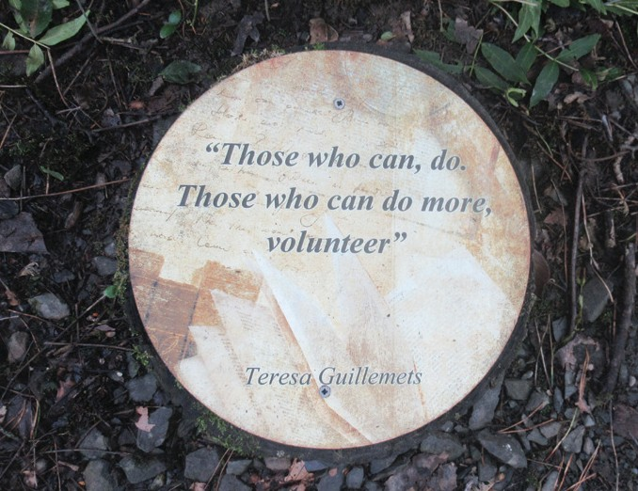
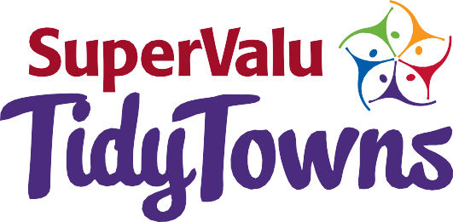

CELEBRATE
THE WINNERS

1958 | Glenties, Co. Donegal | 1980 | Newtowncashel, Co. Longford | 1996 | Ardagh, Co. Longford
1959 | Glenties, Co. Donegal | 1981 | Mountshannon, Co. Clare | 1997 | Terryglass, Co. Tipperary
1960 | Glenties, Co. Donegal | 1982 | Dunmanway, Co. Cork | 1998 | Ardagh, Co. Longford
1961 | Rathvilly, Co. Carlow | 1983 | Terryglass, Co. Tipperary | 1999 | Clonakility, Co. Cork
1962 | Glenties, Co. Donegal | 1984 | Trim, Co. Meath | 2000 | Kenmare, Co. Kerry
1963 | Rathvilly, Co. Carlow | 1985 | Kilkenny City, Co. Kilkenny | 2001 | Westport, Co. Mayo
1964 | Virginia, Co. Cavan | 1986 | Kinsale, Co. Cork | 2002 | Castletown, Co. Laois
1965 | Virginia, Co. Cavan | 1987 | Sneem, Co. Kerry | 2003 | Keadue, Co. Roscommon
1966 | Ballyjamesduff, Co. Cavan |  |  | 2004 | Lismore, Co. Waterford
1967 | Ballyjamesduff, Co. Cavan |  |  | 2005 | Ennis, Co. Clare
1968 | Rathvilly, Co. Carlow |  |  | 2006 | Westport, Co. Mayo
1969 | Tyrrellspass, Co. Westmeath |  |  | 2007 | Aughrim, Co. Wicklow
1970 | Malin, Co. Donegal |  |  | 2008 | Westport, Co. Mayo
1971 | Ballyconnell, Co. Cavan |  |  | 2009 | Emly, Co. Tipperary
1972 | Trim, Co. Meath |  |  | 2010 | Tallanstown, Co. Louth
1973 | Kiltegan, Co. Wicklow | 1988 | Carlingford, Co. Louth | 2011 | Killarney, Co. Kerry
1974 | Trim, Co. Meath | 1989 | Ardagh, Co. Longford | 2012 | Abbeyshrule, Co. Longford
 | & Ballyconnell, Co. Cavan | 1990 | Malahide, Co. Dublin | 2013 | Moynalty, Co. Meath
1975 | Kilsheelan, Co. Tipperary | 1991 | Malin, Co. Donegal | 2014 | Kilkenny City, Co. Kilkenny
1976 | Adare, Co. Limerick | 1992 | Ardmore, Co. Waterford | 2015 | Letterkenny, Co. Donegal
1977 | Multyfarnham, Co. Westmeath | 1993 | Keadue, Co. Roscommon | 2016 | Skerries, Co. Dublin
1978 | Glaslough, Co. Monaghan | 1994 | Galbally, Co. Limerick | 2017 | Birdhill, Co. Tipperary
1979 | Kilsheelan, Co. Tipperary | 1995 | Glenties, Co. Donegal

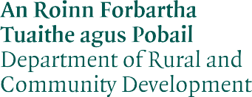

Printed on Recycled Paper

