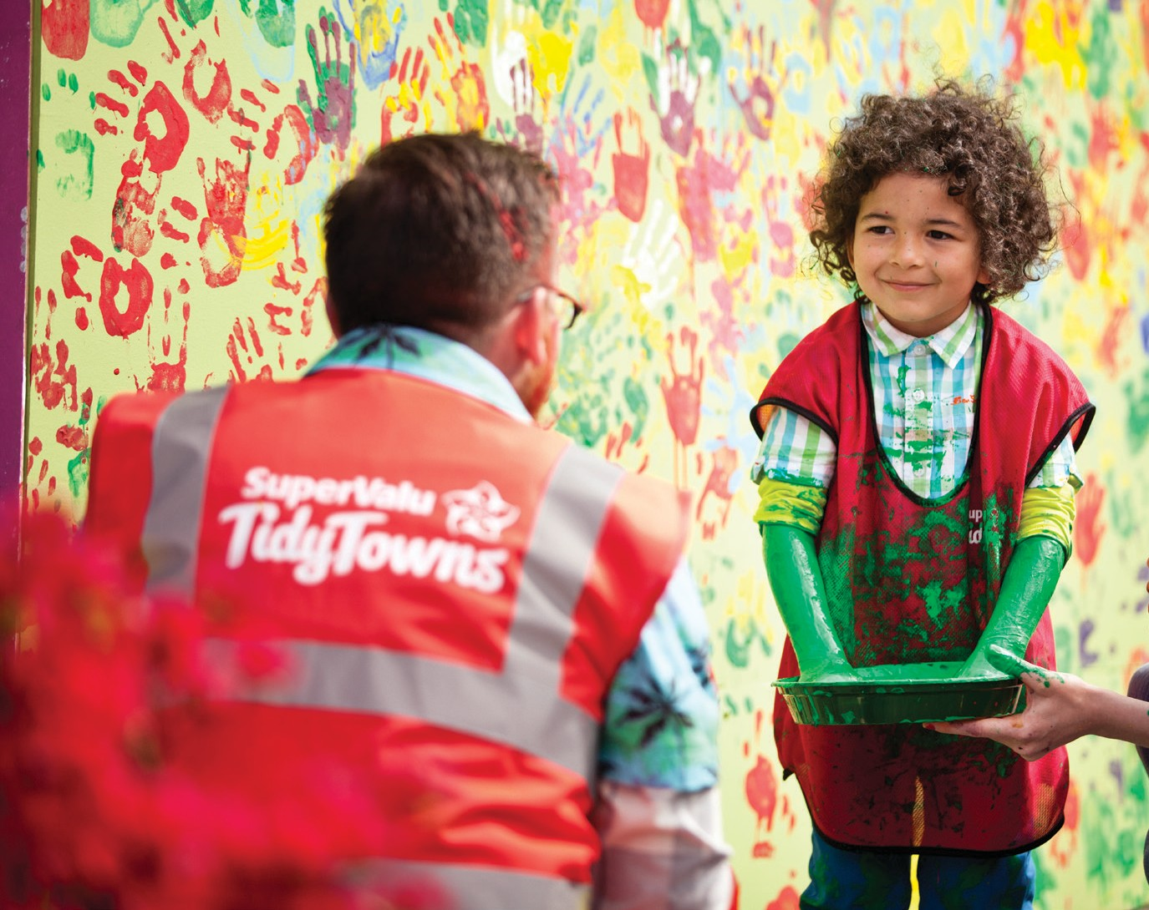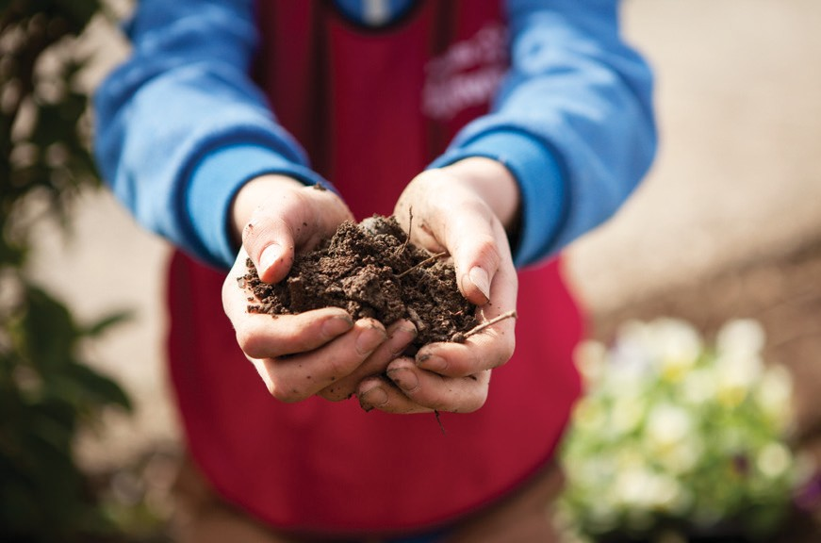The New School Award is an initiative by SuperValu which encourages schools in each and every community to get involved with their local committees and play their part towards creating a better community.
This year SuperValu are looking for either a National or
Secondary school that showcases a significant contribution to
their local TidyTowns activities, to encourage greater youth involvement with TidyTowns
initiatives. The award will be given to the committee who increases the participation of young people within their local TidyTowns group through working together with a school to deliver benefits to their local community.

Eligibility Criteria:
The project must come under at least one of the categories in the main SuperValu TidyTowns
Competition. It can also be listed as a project on the Entry Form of the local Tidy Towns group. The project must be for the current Tidy Towns year and must be led by youth with the support of their local TidyTowns group. Projects completed in previous years are not eligible. It must be capable of being adjudicated upon during the current TidyTowns adjudication period.
Adjudication will be carried out by the TidyTowns adjudicators. The project cannot be entered for any of the other Special Awards.
Award: The awards are being sponsored by SuperValu. There will be four Regional Awards of €1,000.
The overall winner will receive an additional award of
€1,000. The Regions are the same as for the SuperValu TidyTowns Competition.

Terms & Conditions:
The Terms & Conditions of the SuperValu TidyTowns competition apply.
This initiative is to be led by youths aged under 18 and should be supervised by adult TidyTowns members. All entrants to the competition must have appropriate Child

Protection Policy in place. This is the responsibility of the TidyTowns committee.

For Child First guidelines and training information please contact Túsla at 01 6352854 or the Department of Children and Youth Affairs website. The winners will be chosen on the basis of the extent of youth involvement and the benefits that the project delivers for
the community. Marks will be awarded for unique and innovative projects.

Please return your entry form to TidyTowns Unit, Department of Rural and Community Development, Government Offices, Ballina, Co. Mayo, F26 E8N6
If you have any queries please contact the TidyTowns Unit at 096 24309
Closing date: Thursday 23rd May 2018.
Late entries will not be accepted. For further information see www.tidytowns.ie

Nominated project name:

Name of School:

Postal address:

Nominated contact in the School:

Phone number: Email:

Number of youth members involved:

By submitting an application you are confirming that you are adhering to child protection legislation. For further information on your responsibilities to safeguard your underage volunteers please contact Túsla at 01 6352854 or the Department of Children and Youth Affairs website.

Please submit a brief outline of your project, in no more than 1000 words (approximately two A4 sheets).

Your application should refer to the following:
- How your school project makes a physical contribution to the community
- Partnership with your local TidyTowns Group
- Work plan and design
- Media coverage of school project, including any public event held
- Maintenance plan for long term impact of the project
- The benefits of your project to the local community

Completed entry forms should be concise and must be submitted as one document. Additional information, such as photographs (particularly before and after) and scanned
newspaper articles, should be inserted into the application form.
If you have links to videos or other multimedia on websites or social media such as Facebook or Twitter, please also include these links on the entry form. This form is the basis of your application, any links to multimedia or social media will only be assessed in the final stages of adjudication.

Printed on Recycled Paper

