Waters and Communities Award
TidyTowns Competition 2018

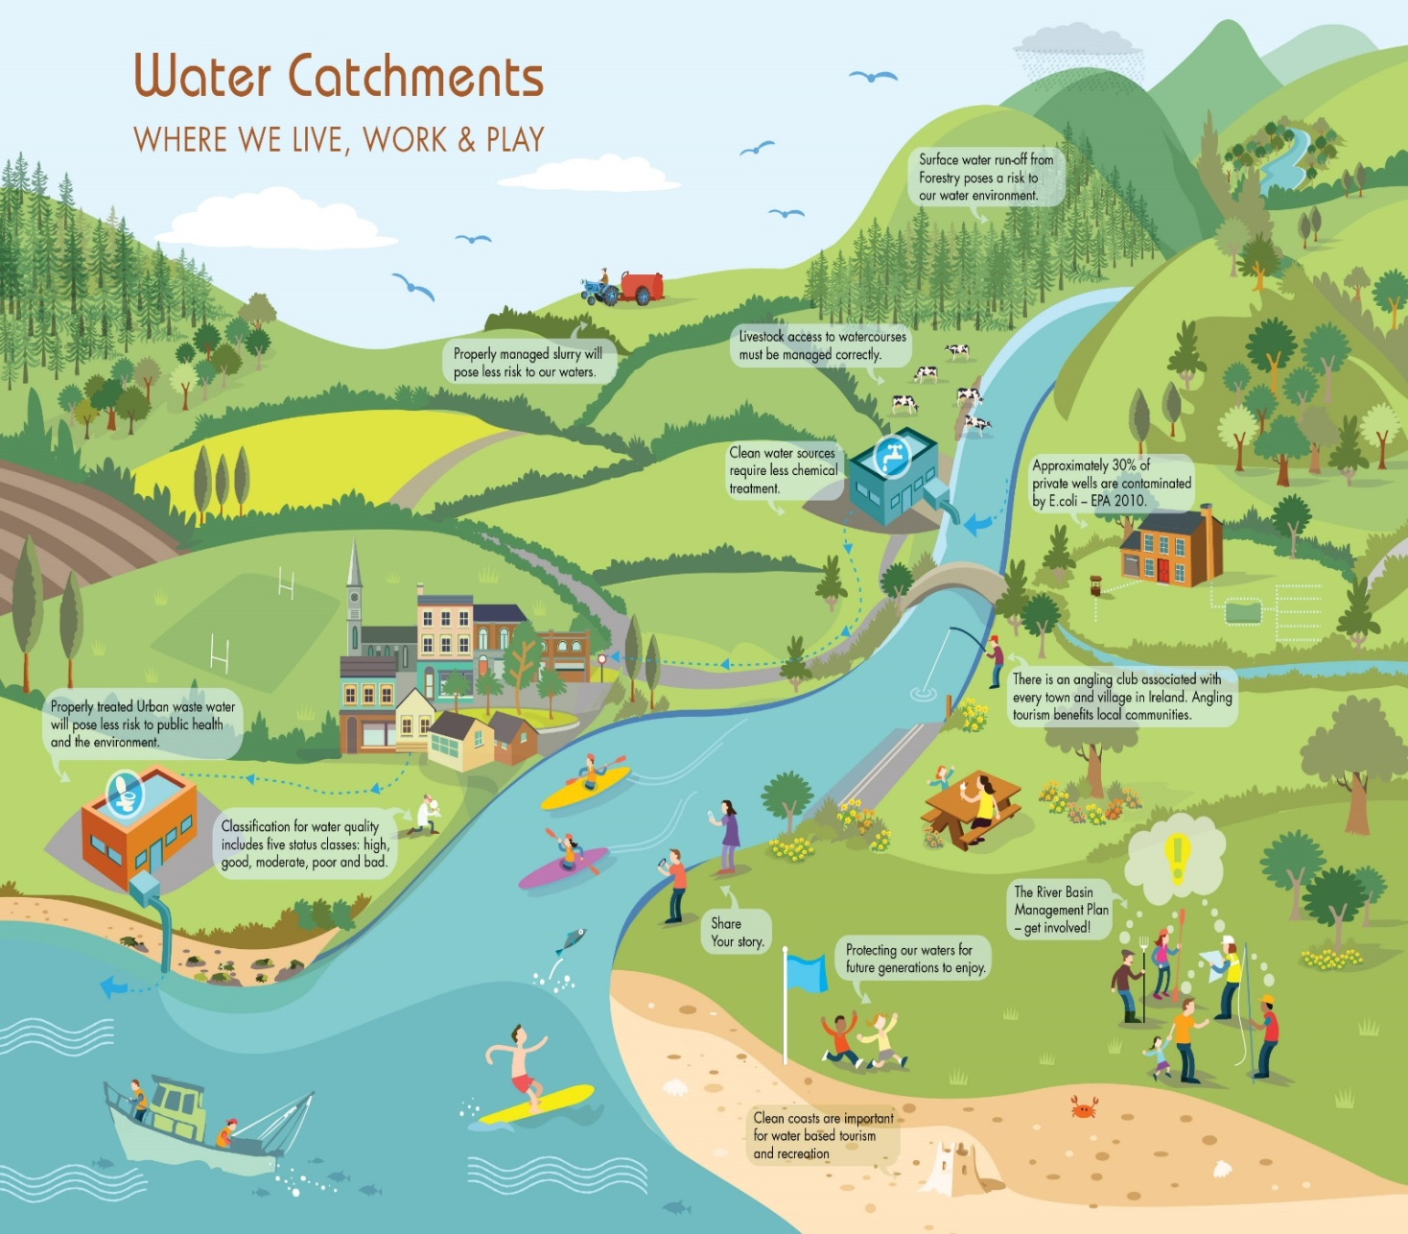
Community groups can play a vital role in the protection and improvement of our natural water environment. Together, we can protect our waters for future generations to enjoy.

Please stay safe while working close to water.
For more information see http://www.iws.ie/

This competition is open to Community Groups who have shown an appreciation for their water environment and water heritage by undertaking relevant initiatives or projects during the timespan
from June 2017 to May 2018.
Waters and Communities Special Award Prize Fund 2018
Four Regional Award Winners Four Regional Runner Up Award Winners
€1,000 each €500 each
There will also be an additional prize of €1,000 for the overall winner of the four regions
The Waters and Communities Award is run in conjunction with the SuperValu TidyTowns competition which this year celebrates its 60th years of encouraging and rewarding community effort.

Closing Date: Tuesday, 23rd May 2018

Background to the Waters and Communities Award

The Waters and Communities Award was first introduced in 2017. The award is to recognise communities who are taking positive steps towards raising awareness and showing appreciation of their local rivers, lakes, streams, canals and coast. The Award is sponsored by Inland Fisheries Ireland www.fisheriesireland.ie (responsible for the protection, conservation and promotion of Fisheries); Waterways Ireland www.waterwaysireland.org (responsible for the management of inland navigable waterways) and the Local Authority Waters & Communities Office www.watersandcommunities.ie (working with communities to get involved in the management of natural waters).

Application Form for the TidyTowns Waters and Communities Award 2018
(only projects or initiatives carried out during the timespan from
June 2017 to May 2018 will be considered)
Name of TidyTown or other community group Main contact person’s name

Email: Phone:

Postal Address:

- Awareness Raising (15 Marks)
Please demonstrate how your community group has helped raised awareness of your local water body (eg. clean up, development of amenity area(s), water heritage projects, biodiversity projects such as signage, information leaflets, habitat surveys, bird boxes, outdoor classrooms, developing of safe access, control of invasive species, instream measures, promotion of angling etc). Max 250 words.

- Community Involvement (20 Marks)
Please outline how your project involved the wider community? (eg. did you work with schools, landowners or other groups?). Max 100 words.

- Stakeholder Engagement (15 Marks)
Did you engage with your Local Authority or Local Development Company or any public agencies in developing your project? If so, please provide details. Max 100 words.

- Project Benefits (40 Marks)
Please outline the long-term benefits of your project to the environment and local community.
Max 250 words.

- Lessons Learned and Plans for the Future (10 Marks) Max 150 words.

Photographs to accompany your application are welcome
Judging the Award
All entries will be assessed by a panel of judges appointed by Inland Fisheries Ireland, Waterways Ireland and the Local Authority Waters and Communities Office. The panel of judges reserve the right to contact you to clarify any details submitted.

How to Apply: | Please reply by writing/typing in this document and returning it electronically or submitting by post.
Email: tidytowns@ahg.gov.ie | Please insert ‘TidyTowns Waters and Community Awards’ in the subject line.
By Post to: | TidyTowns Waters and Communities Award  TidyTowns Unit  Department of Rural and Community Development  Government Offices  Ballina  Co. Mayo  F26 E8N6.
TidyTowns Competition Terms and Conditions apply as appropriate.
Closing date: Wednesday, 23rd May 2018

