Tiny TidyTowns School Award Prize €5000
Sponsored by SuperValu
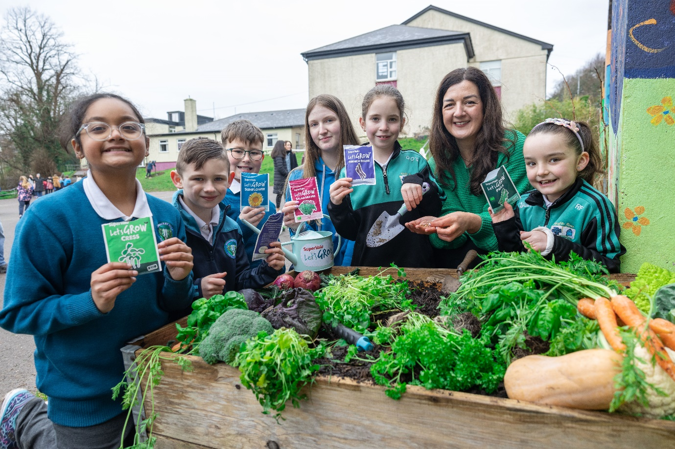
Tiny TidyTowns – Primary School Award
SuperValu is inviting all primary schools to showcase the fantastic initiatives they are undertaking to enhance their school and classroom environments.
We all want children to discover the joy of growing their own food and to understand the importance of protecting local biodiversity - so they can look forward to a healthier, more sustainable future.
Does your school grow its own fruit and vegetables? Have you created a rewilded space to support bees and biodiversity? Is there an area dedicated to pollinator-friendly plants?
We’d love to hear about the food-growing and biodiversity projects you’ve developed, as well as any future plans to continue enriching these themes within your classrooms.
A finalist group from each of the four regions will be chosen, with each finalist group receiving €1,000. The overall winner will then receive an additional €1,000.

The closing date is 12noon, Monday 8th June 2026
Entries to be sent to: tidytowns@musgrave.ie using this form.
You can support your entry by sending in photographs.

ENTRY FORM
School Name:

School ID Number:

School contact Name:

School contact address:

School contact email:

Do you consent to SuperValu sharing your videos/pictures on social media – Yes / No (please select )

Background:

Actions we took:

Who was involved?

Results so far:

