The SuperValu Inclusive Communities Award

This award is to recognise examples of sustainable inclusion by TidyTowns Committees in their local community.

Prize €2,000

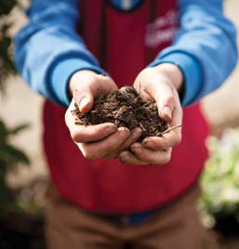

At SuperValu, we believe that truly great communities are built when everyone is included.
People of all ages, backgrounds, and abilities have something valuable to contribute to making our communities better places to live, work, and play.

This award celebrates TidyTowns committees that are driving positive change by promoting and enabling inclusivity, welcoming and supporting every member of their community.

A prize of €2,000 will be awarded to the TidyTowns committee that best demonstrates how they have championed inclusion through meaningful, inclusive projects and initiatives.

Examples of these can be from one off events activities, communications or changes made to their community.

Who can enter the competition?
Any TidyTowns Committee, Junior TidyTowns Committee, subcommittee or group working closely with a TidyTowns committee. Only one entry from each town or village will be accepted.

How will the winner be chosen?
A panel of independent adjudicators will assess all entries. All entrants must have an appropriate Child Protection Policy in place. This is the responsibility of the TidyTowns committee.

Closing date

The closing date is 12noon, Monday, 8th June 2026

Entry
Electronic entry only, by email to tidytowns@musgrave.ie

Application
Village / Town / City / Island:

Contact Name:

Address:

Contact Details:

TidyTowns Committee name:

Are you a member of the TidyTowns committee?
If not, what is your role with TidyTowns?
What is the population of your community?

How many members on your TidyTowns Committee?

Age profile of members – both committee and those who volunteer to carry out work for TidyTowns;

under 18
18-40
40+

What steps has your committee taken to foster inclusivity? How has your group evolved to become more inclusive?

Can you share further information of an event or project or activity your group organized that demonstrated inclusivity?

In what ways have you promoted awareness of this event, activity, or project within your local community? Please provide photos etc

