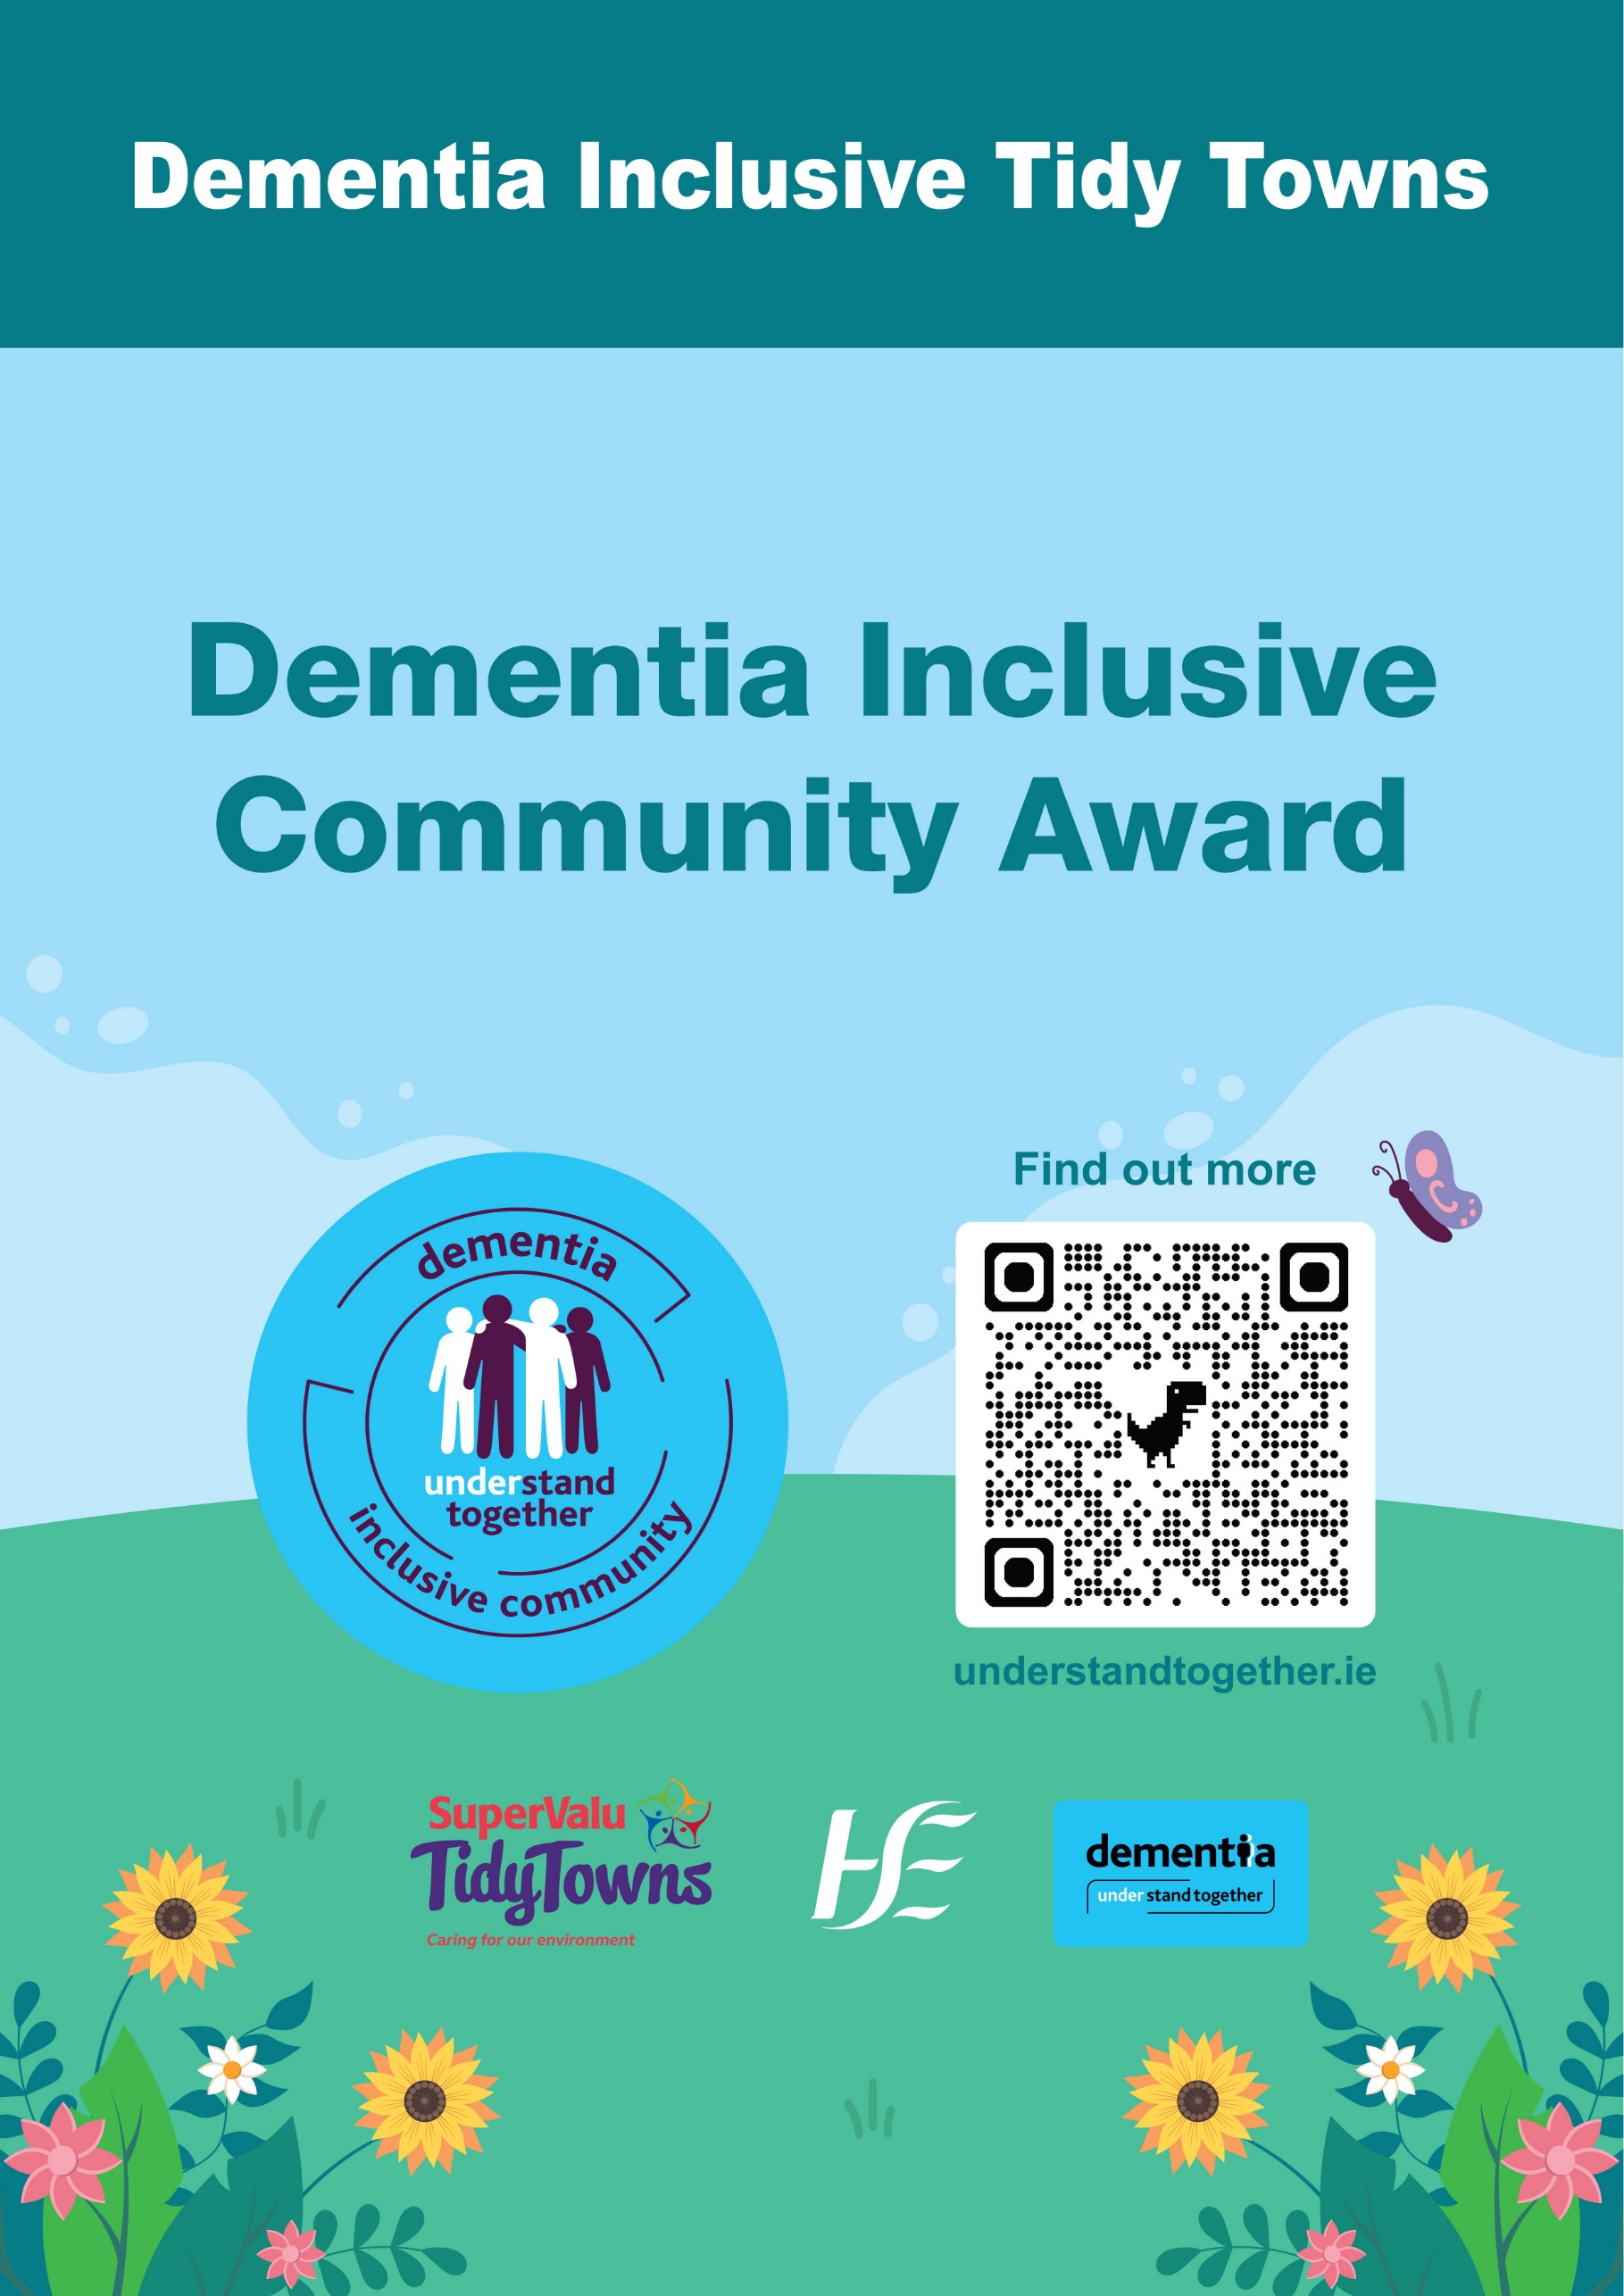
Dementia Inclusive Community Award

About the award
For people living with dementia and their families, small things often make a big difference.

The HSE’s Dementia: Understand Together campaign is tackling misunderstanding, loneliness and isolation by raising awareness of dementia and inspiring individuals, businesses and community groups to take simple actions to ensure that our communities are respectful, supportive and inclusive of people with dementia and their families.

Competition
We are looking for TidyTowns committees to demonstrate how they are making positive changes within the community to promote and facilitate inclusivity for people living with dementia. We would like to know how you have kept the local community informed of these changes and if you have engaged with other community groups to attain your goals.

With our ‘Dementia Inclusive Community’ TidyTowns Special Award we are interested in hearing about initiatives where you have:

- Created welcoming and inclusive spaces in which members of the community can experience a sense of place and reminisce.

- Integrated people affected by dementia in your planning and activities.

- Spread awareness of your actions throughout the community, be it by engaging with other community organisations, or through social media or local media.

Marks will be awarded for the sustainability of actions taken, for the methods used to raise awareness of dementia within your community and externally, and efforts made to engage with groups outside of the TidyTowns organisation. The groups or organisations can be local or national.

Key elements to consider:

- Show consultation with people affected by dementia

- Include photos, testimonials or quotes

- Demonstrate sustainability of actions taken

- Show that projects benefit the whole community

- Clearly link actions to inclusivity, understanding and respect

Application Process

Entry Process
Entries must be submitted by 5pm Monday, 8th June 2026. Late entries will not be accepted. Please include your TidyTowns’ category and name of TidyTowns Committee in the subject matter. Entries should be emailed to understandtogether@hse.ie

Further Information
Further information can be obtained by emailing understandtogether@hse.ie

- Dementia awareness training can be organised online and in person.

- The national HSE Dementia Inclusive Community symbol, gardening booklet and other campaign resources can be ordered free of charge from www.healthpromotion.ie

Prize
A winning prize of €2,000 and a runner up prize of €500 will be awarded to the TidyTowns
Committees from a large town/urban centre.

A winning prize of €2,000 and a runner up prize of €500 will be awarded to the TidyTowns
Committees from a village/small town.

About You

Name of TidyTowns Committee
County
Contact Name
Phone number
Email address

Category
Please indicate which award you are applying for:

Village/Small Town
(TidyTowns main category A, B, C or D)
Large Town/Urban Centre
(TidyTowns main category E, F, G or H)

Terms and conditions
All entries must be submitted on this official entry form. Supplementary materials such as photographs, screenshots of social media posts (ideally showing levels of engagement), and digital or printed copies of leaflets, posters, etc., can be included in the application or sent separately by e-mail to understandtogether@hse.ie

Please include your TidyTowns’ category and name of TidyTowns Committee in the subject matter of the email.
Late entries will not be accepted.
The decision of the judges will be final, and no correspondence will be entered into.

About Your Entry

1. Providing a sense of place and enabling reminiscence (max 300 words)
What you could do
- Create a reminiscence walk or trail with old photos, local stories, shop signs, or historic landmarks.
- Install memory boards in parks or village centres featuring “Life in our town through the years.”
- Use heritage planting (traditional flowers, fruit trees, old varieties).
- Add sensory gardens with familiar scents (lavender, rosemary, mint), textures and gentle sounds.
- Include benches with plaques telling short local stories.
- Initiate local history projects, such as reviewing old photos of the town, to stimulate memories and encourage engagement.

2. Including people affected by dementia (max 300 words)
What you could do
- Include people affected by dementia in your planning and activities.
- Create dementia inclusive volunteering roles such as
  - Light Gardening: Encourage planting in raised beds, potting, weeding, and arranging flowers which provide sensory stimulation.
  - ‘Bird Table’ Ecology: Set up and maintain bird tables or feeders, which are manageable and rewarding.
  - Pathway Tidying: Simple tasks like sweeping paths or wiping benches with light, safe equipment.
  - Local Cleanup Teams: Create ‘supported’ volunteering opportunities where people with dementia can participate in litter picking in safe, familiar areas.
- Invite people with dementia to walk through the town to identify areas that feel safe, confusing, or welcoming.

3. Communication, Awareness and Education (max 300 words)
What you could do
- Participate in and invite volunteers and local organisations to the HSE’s Dementia: Understand Together training to understand the impact of dementia.
- Display the HSE "Dementia Inclusive Community" symbol on local projects to show support and welcome.
- Encourage your community networks and other organisations such as Men’s Sheds, GAA, schools, shops, cafés to get involved and speak about dementia.
- Use communication, such as social media, local radio or noticeboards to share simple facts about your actions, dementia and how everyone can support a person with dementia.

