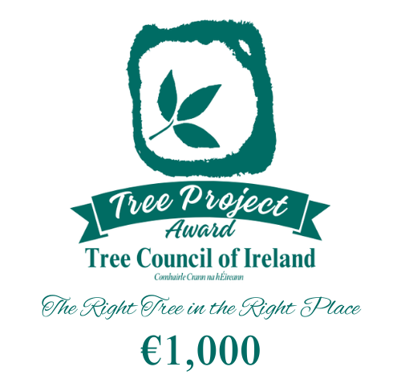


Supervalu Tidy Towns Competition 2026
The Tree Project Award is an initiative that values the positive influence of trees on the overall ambience of a
town or village. It places importance not only on the initial planting but also on the ongoing maintenance and establishment of trees throughout their lifespan. This award recognises the TidyTowns Committee that through
their hard work has fostered an urban woodland atmosphere within their community.
The project may equally focus on the preservation of old and established trees, acknowledging their natural, historical, cultural, botanical, or landscape significance. The size and scope of the undertaken project, along
with the tangible benefits it brings to the community, will be carefully evaluated.

The following criteria will be considered for the award:
- Trees must be in a public place, e.g. a street, an open space, a school, church grounds.
- The trees may be existing or newly planted. If new trees, they must be appropriate to the site in species, cultivar suitability, shape, size and colour.
- Trees must be located appropriately within the site.
- Trees must be well maintained with regard to watering, weed control, staking, tree ties, tree guards (if necessary) and appropriate surgery carried out where necessary.
- A clear plan for renewal of older trees should be in place.
- The project should contain an element of raising awareness of trees within the community.
For more information, please visit www.treecouncil.ie/supervalu-tree-project-award

How to Enter:
To apply for the award, please use the Tree Project Award entry form and attach at least 4 images illustrating
the conditions before and after the project was carried out. These images will serve as visual evidence of the project's impact and transformation.
All entries should be forwarded by email only to: tidytowns@treecouncil.ie

Closing Date:
Please check the TidyTowns website (www.tidytowns.ie) for updates.
Tidy Towns Competition Terms and Conditions apply as appropriate.

ENTRY FORM

Remember to include at least 4 images illustrating the conditions before and after the project was carried out. (Additional images can be emailed separately if required.)

Nominated Area: | Click or tap here to enter text.
Specific Location: | Click or tap here to enter text.
Project Leader: (person/group/local authority, etc.): | Click or tap here to enter text.
Nominating Group/Person: | Click or tap here to enter text.
Contact Address: | Click or tap here to enter text.
Phone No: | Click or tap here to enter text.
Email: | Click or tap here to enter text.



Applicants are encouraged to provide comprehensive details about the project, emphasising key aspects such as planning, execution, community involvement, and the ongoing maintenance plan. The judging panel will assess the applications based on the merit of the project, its significance to the community, and the overall positive impact on the urban environment. Please include:
- Site description
- Details of tree species, sizes, numbers, suitability and works undertaken etc.
- Contribution of the tree project to the community and to the physical landscape of the town or village
- Activities to raise community awareness of the tree project.
Click or tap here to enter text.

