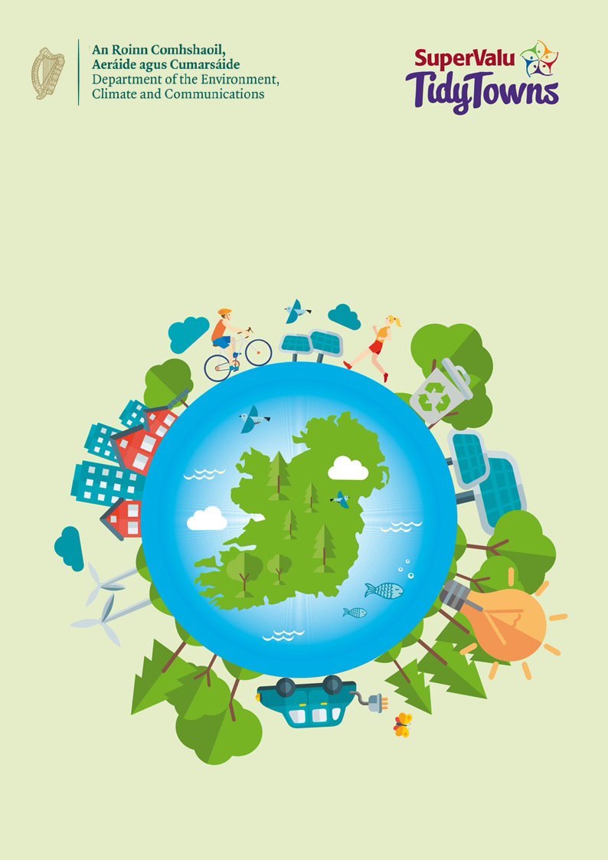
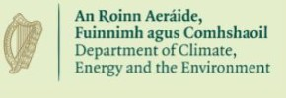

The Sustainable Development Goals Awards
The Sustainable Development Goals Awards

About the award
The Sustainable Development Goals (SDGs) Tidy Towns Special Awards are sponsored by the Department of Environment, Climate and Communications. The overall aim of this award is to recognise the impact local communities can make in implementing and living the SDGs. The purpose of this award is to celebrate communities who are taking climate action, raising awareness of the SDGs within their communities and working collaboratively across their and other communities to bring the SDGs to their everyday life.

The SDGs are a call for action by all countries - developed and developing - as a global partnership. They recognise that ending poverty and other deprivations must go hand-in-hand with strategies that improve health and education, reduce inequality, and spur economic growth – all while tackling climate change and working to preserve our ecosystem. The goals aim to achieve decent lives for all on a healthy planet by 2030. Positive, empowering community actions are key to meeting the SDGs.

Competition
Each committee should highlight actions linked to one or more of the Goals taking place within their community along with the steps taken to successfully undertake their project. A summary as to how awareness of these actions has been shared with the wider community should be provided, eg. engagement with other local community organisations, schools, local authorities, etc.

The activity may be a one off project or an ongoing activity which you wish to develop.

Prizes
Four Prizes will be awarded:
1. €2,000 for the best entry from a village/small town (category A to D)
2. €2,000 for the best entry from a large town or urban centre (Category E to H)
3. One overall runner-up prize of €1,000
4. A special Youth Award of €1,000.

It is important to recognise the key role of the younger generation. To support this there is an additional award of €1,000 for the greatest contribution from either a large or small town which includes input from younger members of the community. Marks will be awarded for the scale of action taken, for the methods used to raise awareness within your community and externally and efforts made to engage with groups outside of the Tidy Towns organisation. This can include within your area or nationally.

Application Process
Entry Process
Entries must be submitted by 5 p.m. on Monday 9th June 2026. Late entries will not be accepted. Entries should be emailed to SDGs@DCEE.gov.ie

Further Information
Further information can be obtained by emailing SDGs@DCEE.gov.ie
About You

Name of Tidy Towns Committee
County
Contact Name
Phone number
Email address

Category
Please indicate which award you are applying for:
Village/Small Town
(Tidy Town main category A, B, C or D)
Large Town/Urban Centre
(Tidy Town main category E, F, G or H)

Terms and conditions
All entries must be submitted on this official entry form. Supplementary materials such as photographs, screenshots of social media posts (ideally showing levels of engagement), and digital or printed copies of leaflets, posters, etc., can be sent separately by e-mail to SDGs@DCEE.gov.ie, using the Committee name as reference.

Late entries will not be accepted.
The decision of the judges will be final, and no correspondence will be entered into.
The judges reserve the right not to award one or more prizes if entries are not of a sufficiently high standard.

About Your Entry

Overall Planning and Vision (40 points)
Please give a summary of the action you have taken within your community to promote climate initiatives. (Max 400 words).

Raising Awareness (30 points)
Please give a summary as to how your group raised awareness within the community and encouraged members of the community to become involved in your initiatives and actions. (Max 400 words)

Network Building (30 points)
Please highlight how you worked with other groups in your community to help deliver this action. Did you engage with local schools, sports clubs, Local Authorities, Men’s Sheds etc. (Max 400 words)

