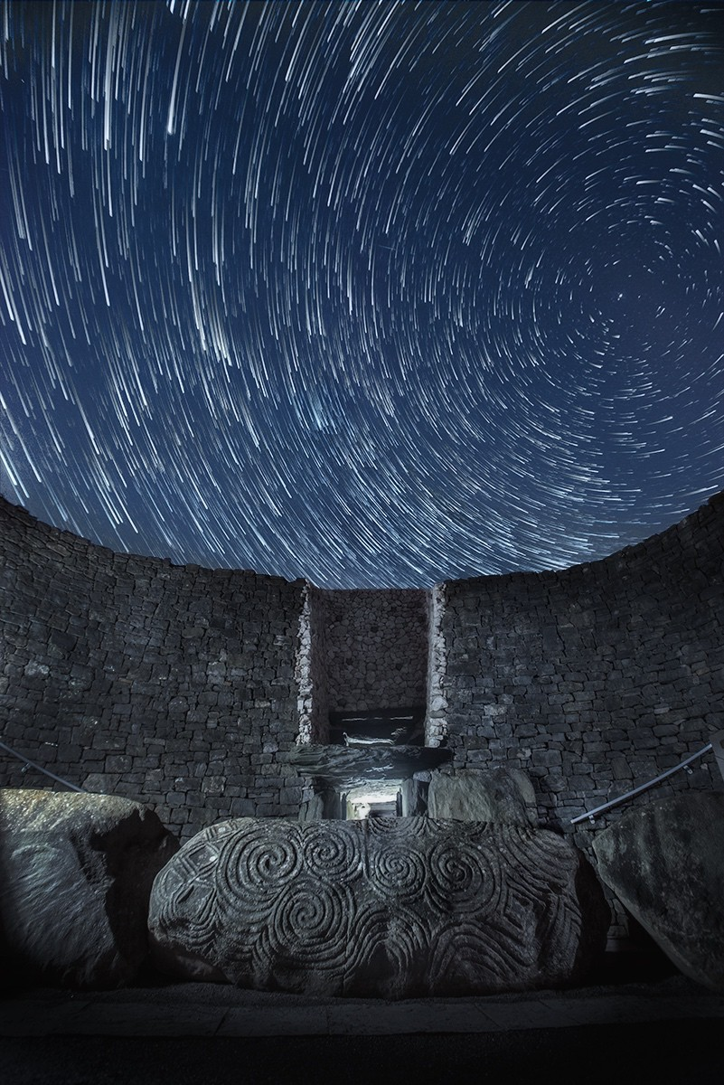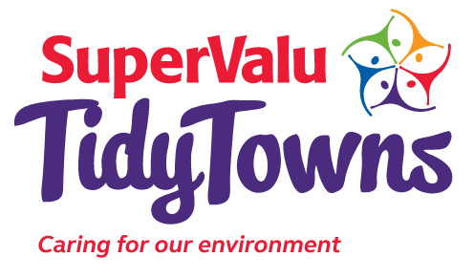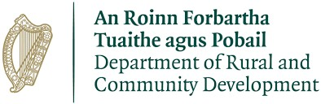
The

“
Dark Sky

Ireland
”

Special
Award

Photo

credit: Ken Williams

The ‘Dark Sky Ireland’ Special Award

About the award
The ‘Dark Sky Ireland’ TidyTowns Special Award is sponsored by Dark Sky Ireland. The overall aim of this award is to recognise practical, community led actions to reduce light pollution and protect dark skies. The purpose of this award is to celebrate communities who have taken action, raised awareness within their communities and worked collaboratively across their and other communities to co-create solutions that protect dark skies at night.

The award celebrates projects that demonstrate how responsible outdoor lighting can promote the United Nations Sustainable Development Goals identified by Dark Sky Ireland (a Sustainable Development Champion Organisation 2025-27).

Light pollution is a significant threat to healthy ecosystems and biodiversity as well as human wellbeing, it wastes energy and obscures a view of a natural night sky overhead. Fortunately it is one of the easiest environmental pollutants to fix. We have some suggestions on how to do this in the TidyTowns Infographic “Reducing Light Pollution in your
Community” and in the guide to Protecting Nocturnal Pollinators by the National Biodiversity Data Centre (see Resources).

Each committee should highlight the actions they have taken within their community and how they have spread awareness of light pollution with the wider community.

Committees should also highlight efforts made to engage other local community organisations in their efforts.

Competition
We are looking for TidyTowns Committees to demonstrate steps you have taken to address the issue of light pollution, how you have shared information on it, and how you have collaborated in your community and with others to protect dark skies.

With our ‘Dark Sky Ireland’ Special Award for TidyTowns, we are interested to hear about initiatives where you have:

- Taken proactive action in your community to raise awareness of dark skies. This can range from planting a Moon Garden to attract nocturnal pollinators, to retrofitting light fixtures with dark sky friendly lighting strategies in your locality.

- Raised awareness of your actions throughout the community. Did you spread the word through social media, local or national media? Or did you host an innovative event, talk or a workshop?

- Undertaken a lighting audit or citizen science project in your community to understand how much artificial light is used at night and assess whether the sources are dark sky friendly.

- Networked with other groups in the community or outside your TidyTowns. Did you engage with other community groups to deliver your project such as a local school, sports club, or youth organisations?

Prizes
One overall prize of €1,000 be awarded to a TidyTowns Committee for impact and project merit.
In addition, two prizes of €750 will be awarded to two
TidyTowns Committees; one from the Large Town/Large Urban Centre categories and one from the Village/Small Town categories. An additional two ‘highly commended’ prizes of €250 each will be awarded. No more than one prize can be awarded per TidyTowns Committee .

Marks will be awarded for the scale of action taken, for the methods used to raise awareness within the community and externally, and efforts made to engage with groups outside of the TidyTowns organisation. This can include within your area or across the country.

Entry Process

Entries must be submitted by 5 p.m. on Monday June 8th 2026.

Late entries will not be accepted. Entries should be emailed to: competition@darksky.ie

[Please include “TidyTowns 2026 Entry” in the Subject line]

About You

Further Information
Further information can be obtained by emailing
info@darksky.ie / www.DarkSky.ie

Resources:
https://www.tidytowns.ie/app/uploads/2025/01/Dark
-Skies-Ireland-REDUCING-LIGHT-POLLUTION.pdf

https://pollinators.ie/wp-
content/uploads/2023/09/AIPP-Nocturnal-Guide-
2023-WEB.pdf

Name of TidyTowns Committee
County
Contact Name
Phone number
Email address

Category
Please indicate which award you are applying for:
Village/Small Town
(TidyTowns main category A, B, C or D)
Large Town/Large Urban Centre
(TidyTowns main category E, F, G or H)

Terms and conditions
All entries must be submitted on this official entry form. Supplementary materials such as photographs, screenshots of social media posts (ideally showing levels of engagement), and digital or printed copies of
leaflets, posters, etc., can be sent separately by e-mail to competition@darksky.ie Late entries will not be accepted.
The decision of the judges will be final, and no correspondence will be entered into.
The judges reserve the right not to award one or more prizes if entries are not of a sufficiently high standard.

About Your Entry

Overall Planning and Vision (40 points)
Please give a summary of the action you have taken within your community to promote dark sky initiatives. (Max 400 words).

Raising Awareness (20 points)
Please give a summary as to how your group raised awareness within the community and encouraged members of the community to become involved in your initiatives and actions. (Max 400 words)

Auditing or Surveys (20 points)
Please give a summary as any involvement your group had in surveys such as Citizen Science projects, surveys or audits on the level of artificial lighting at night in your community. (Max 400 words)

Network Building (20 points)
Please highlight how you worked with other groups in your community to help deliver this action. Did you engage with local schools, sports clubs, Local Authorities, Men’s Sheds etc. (Max 400 words)

