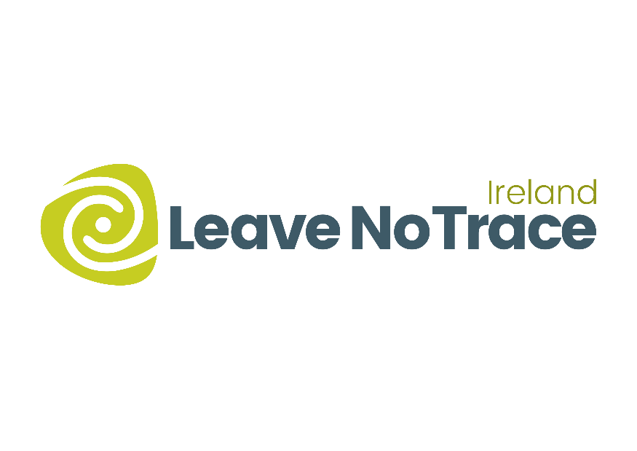

Leave No Trace Ireland TidyTowns Award 2025
Entry Form
Section A
Name of Group and County:
Contact name and phone number:
Email address:
Postal Address:
Data Protection
I confirm that my contact details as above may be used in communications relating to the Leave No Trace Ireland Tidy Towns Award. Any personal information which I provide in this way is not made available to any third parties, saved as required by law, and is used only in line with the purpose for which I provided it. Any personal information which I provide will be treated in accordance with the General Data Protection Regulation.
Please tick your consent to process your data for this application
Please tick your consent here if you wish to receive updates from Leave No Trace Ireland

Section B
1. Outline what actions have been taken to raise awareness of the Leave No Trace Ireland principles in outdoor areas or events. (30 marks)

2. Outline how your committee engaged other organisations in the community i.e., business, volunteers to deliver the above actions. (20 marks)

3. What impact have your activities promoting the ethos of Leave No Trace in your community had on the local environment? How has your community promoted this? (30 marks)

4. Briefly highlight any future plans you have to incorporate Leave No Trace Principles in your community. (20 marks)

All entrants are also eligible to FREE Community Membership of Leave No Trace Ireland. If you would like this membership, please sign up online here.

Please forward your application form to tracey@leavenotraceireland.org

