Young Persons in TidyTowns 2025
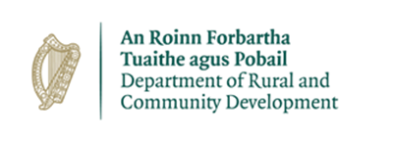
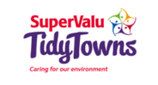
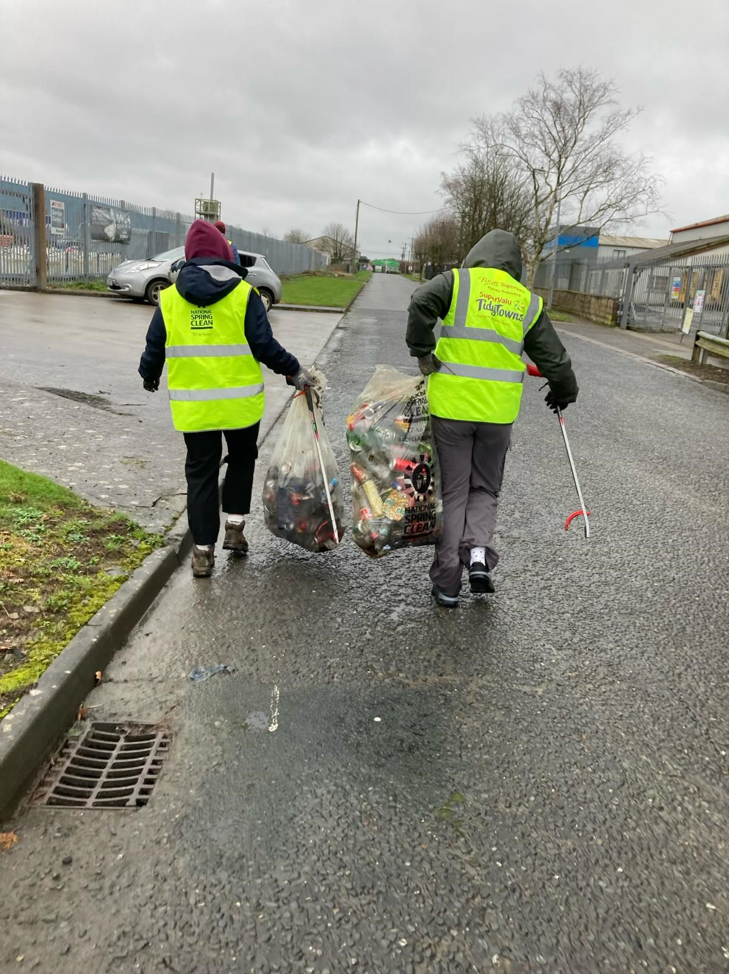



The Department of Rural and Community Development aims to promote and to support vibrant, inclusive and sustainable communities. Our young people play a key role in teaching society how to develop sustainably and how to make people feel that they belong.
We are delighted to announce a special award for 2025 titled “Young Persons in TidyTowns Award”. Entries under the Young Persons Award should demonstrate how the TidyTowns groups encourage and facilitate engagement with the 16 to 24 age group and how this age group then contribute to local TidyTowns activities.
Prize fund of €5,000. €1,000 will be awarded to the best entry in each of the four regions with an additional overall prize of €1,000.
Entries should be submitted to TidyTowns@drcd.gov.ie using the Young Persons Award entry form. Photographs can be used to support your entry. Entry to this award is not open to schools.

ENTRY FORM
Group Name:

Group contact name:

Group contact address:

Group contact email:

Group contact number:

Yes No
Does your group currently have young persons involved in your TidyTowns activities? ☐ ☐
Does your group currently participate in the Gaisce President’s Award? ☐ ☐

Signed: _______________________ Date: __________________________
1: Ask your members in the 16-24 age group, what does being part of the TidyTowns group mean to them (Insert quotes if available)

2: Describe Initiatives undertaken by your group to encourage greater involvement from those in your community aged between 16 and 24.

3. Describe Initiatives undertaken whereby young persons in your community are encouraged or afforded the opportunity to have an active leadership role in the community.

4. What benefits do you think involving persons aged 16 to 24 might bring to your TidyTowns group?




