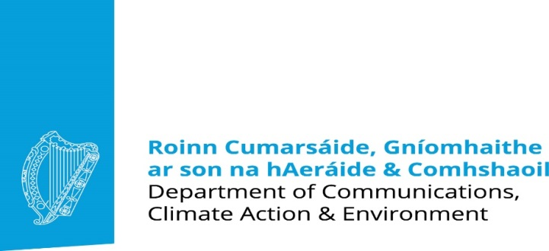
Clean Air Award
Tidy Towns Competition 2018
Communities and Tidy Towns Committees can play a vital role in raising awareness of the importance of clean air for people’s health, and provide a local community voice to highlight the need to address local sources of air pollution. Enter this year’s competition, and help make a difference to your community’s air quality and health.
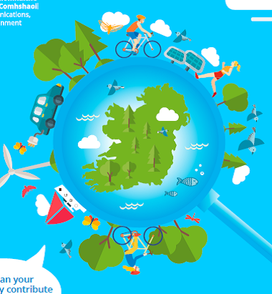
A prize of €2,000 will be awarded to the Committee which has demonstrated the greatest difference in terms of the promotion of good air quality in ways readily replicable in other, equally committed, communities.
Two runner up prizes of €500 are also available.

AWARD
The Clean Air Award, sponsored by the Department of Communications, Climate Action and Environment, aims to encourage communities to promote awareness of the importance of clean air for human health and the environment. In particular, the award will recognise projects and activities that raise awareness of the potential impact that local choices can have on the air that we breathe. Such choices include whether we choose smoky or clean fuel for our home heating and the extent of our car use. Ireland is moving towards a low emission, low carbon future. How can your community contribute to this journey?
To be in with a chance of winning, please let us know how your activities will contribute to these aims, in a manner which could be easily reproduced by other communities to spread the benefits of clean air nationwide.

COMPETITION
We would like to see the promotion of education and awareness within your community about air quality and clean air issues. Let us know how your community has made a difference or intends to do so.
Entrants for 2018 should demonstrate the following:
- A message that shows understanding of how air pollution, especially from local sources, impacts on human health. E.g. posters, information leaflets, webpages, community talks, audio/video interviews on the street.
- As some activities that have been pursued for climate reasons can have a detrimental effect on air quality, projects that demonstrate an appreciation of how air quality and climate strategies can be reconciled will attract merit, e.g. shift away from solid fuel use entirely to cleaner heating systems such as electric heat pumps or gas.
- The use of innovative methods of presenting the message, informing and educating the community, e.g. social media platforms.
- The overall number of people and sectors in the wider community reached with your Clean Air message, e.g. a better insulated house results in less need for home heating (solid fuel, oil or gas) which results in less air pollution. The SEAI provides free upgrades for eligible members of the community who may be in energy poverty. Could your Tidy Towns help inform these sections of your community about free upgrades?
- Evidence of a change in community perception and attitude concerning awareness of the Clean Air message e.g. Interviews with different groups on what they perceive as local air pollution issues.
- Engagement with the local authority on clean air issues, e.g. encouraging public electric car charge points, or promoting environmental enforcement, for example, in relation to illegal waste burning, illegal fuel sales, etc.

DETAILS
A prize of €2,000 will be awarded to the Committee which has demonstrated the greatest difference in terms of the promotion of good air quality in ways readily replicable other, equally committed, communities. Two runner up prizes of €500 are also available.
Entries should be typed on A4 paper and should be emailed to TidyTowns@drcd.gov.ie, or else posted to the Tidy Towns Unit, Department of Rural and Community Development, Government Buildings, Ballina, Mayo.
Closing date is 23rd May 2018.

TIDY TOWNS COMMITTEE NAME:

CONTACT NAME:

PHONE NUMBER:

EMAIL ADDRESS:

POSTAL ADDRESS:

HOW HAS YOUR COMMUNITY PROMOTED AWARENESS OF CLEAN AIR:

Tidy Towns Competition Terms and Conditions apply as appropriate.

