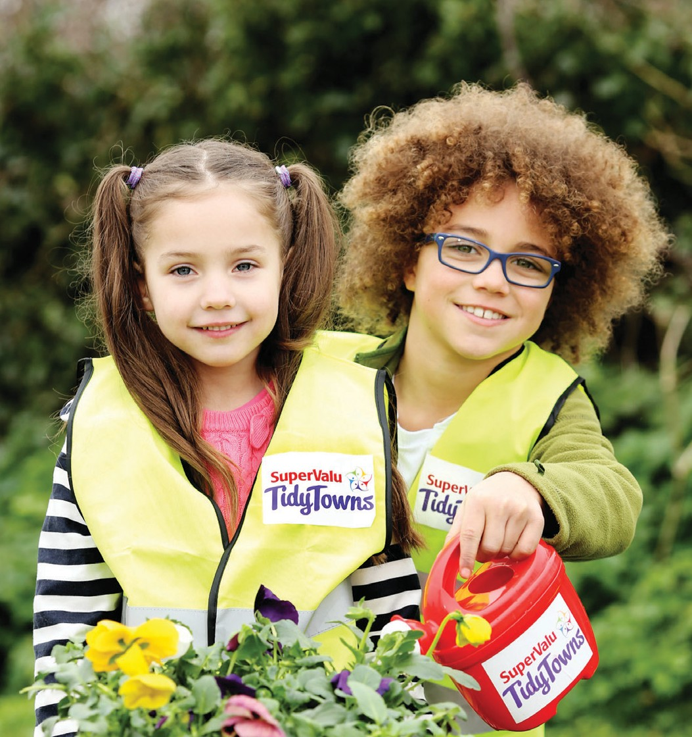Special Award to recognise the way that you include all of your community, on an inter- generational and inter-cultural basis,
in your TidyTowns committee and in the work you do.
Prize €2,000

This award recognises the benefits that embracing diversity and working across the generations brings to your community. It rewards the intergenerational and intercultural aspects of your committee. The strength of a community lies in how it works together to establish a place where all are welcome, where all are encouraged to participate, and where all feel at home.
Strong communities work together to gain the most from what all members of their community have to offer,
regardless of age, ethnicity or ability. As our communities become more diverse the need to understand and appreciate other cultures becomes increasingly important. This award is to recognise all that you, as TidyTowns committees, do to encourage involvement from members of your community.

Who can enter the competition?
Any TidyTowns Committee, Junior TidyTowns Committee, subcommittee or group working closely with a TidyTowns committee. It is not necessary that your community is very diverse; this award rewards how you include all who live there, making it as inclusive a competition as possible.
Only one entry from each town or village will be accepted.

How will the winner be chosen?
A panel of independent adjudicators will assess all entries. The last stage of adjudication will involve a prearranged visit by an adjudicator to the shortlisted finalists. All entrants must have an appropriate Child Protection Policy in place. This is the responsibility of the TidyTowns committee. For Child First guidelines and training information please contact Túsla at 01
6352854 or the Department of Children and Youth Affairs website.

Village / Town / City / Island: Contact Name: Address: Contact Details: TidyTowns Committee name: Are you a member of the TidyTowns committee? If not, what is your role with TidyTowns? What is the population of your community? How many members on your TidyTowns Committee ?
Age profile of members – both committee and those who volunteer to carry out work for TidyTowns; under 18 18 – 40 40+

Do you have people from different cultures living in your community, if so are they active on your committee or the work you do?

Do you issue invitations to your AGM, if so who do you invite?

Do you have sub committees; eg Young TidyTowns Committee, Community Involvement and Planning Committee, Tidiness and Litter Committee, Built Environment Committee or subcommittee based on any of the other categories in the SuperValu TidyTowns Competition?

Have you a policy of actively recruiting youth and new members to your committee? If so, how do you go about this?

Have you made efforts to include other residents in your committee and your work?

If so, how have you included them?

How do you communicate with your community?

What work have you carried out that involves input from the larger community?

Have you carried out initiatives which clearly demonstrate an inclusive approach across nationalities, cultures and across the age bands?

Examples of projects which involve your community at large or which shows intergenerational and intercultural participation might include but are not restricted to: Art Projects, Poetry Trails, Ecology Trails, Sculpture Trails, Heritage Trails, Fairy Trails, Sensory Gardens, Educational Gardens, Culture Gardens, International Gardens.
By submitting an application you are confirming that you are adhering to child protection legislation. For further information on your responsibilities to safeguard your underage volunteers please contact Túsla at 01 6352854 or the Department of Children and Youth Affairs website.

Please return your entry form to TidyTowns Unit, Department of Rural and Community Development, Government Offices,
Ballina, Co. Mayo, F26 E8N6
If you have any queries please contact the TidyTowns Unit at 096 24309

Closing Date Wednesday 23rd May 2018

